UNIT 1 · LESSON 2 STANDARD 6.NS.4

Greatest Common Factor
Student Notes Packet
Name: ______________________ Date: ____________ Period: ________

Today's Goals
Content: I can find the greatest common factor (GCF) of two numbers by listing or comparing their factors.
Language: I can explain how I found the GCF using the words factor, common factor, divisible, and greatest common factor.

Key Vocabulary
Look at the picture, read the word, then read what it means.
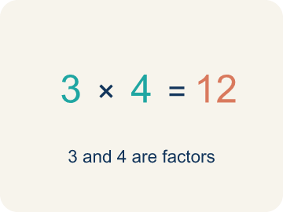 | Factor Factor  A number that divides another number with nothing left over.  Example: Factors of 12: 1, 2, 3, 4, 6, 12 — each divides 12 with no remainder
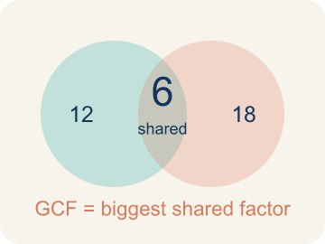 | Greatest Common Factor Máximo común divisor  The biggest number that divides two or more numbers evenly.  Example: Factors of 12: {1, 2, 3, 4, 6, 12}. Factors of 18: {1, 2, 3, 6, 9, 18}. Shared: 1, 2, 3, 6. GCF = 6
Common factor Factor común
A number that divides two or more numbers evenly.
Example: 8 and 12 both divide evenly by 1, 2, and 4 — those are their common factors
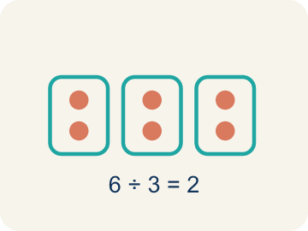 | Divisible Divisible  A number you can divide evenly, with nothing left over.  Example: 15 ÷ 3 = 5 with no remainder, so 15 is divisible by 3
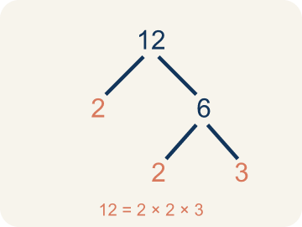 | Prime factorization Factorización prima  Writing a number as prime numbers multiplied together. It helps you find the GCF.  Example: 12 = 2 × 2 × 3 and 18 = 2 × 3 × 3. Shared primes: 2 × 3 = 6 = GCF

Guided Notes
Fill in each blank as we go. Use the Word Bank to help you.
WORD BANK
Factor • Greatest Common Factor • Common factor • Divisible • Prime factorization

1. A number that divides evenly into another number with no remainder is a ___.
2. __________ — The biggest number that divides two or more numbers evenly.
3. A factor that two or more numbers share is a ___ factor.
4. A number that can be divided by another with no remainder is ___ by that number.
5. __________ — Writing a number as prime numbers multiplied together. It helps you find the GCF.

Worked Example

Watch & Read I Do — follow along with your teacher
Space Station Supply Sort
Mission Control needs to organize 24 food packs and 36 water containers into equal groups for the crew pods. Each pod must get the same number of food packs AND the same number of water containers. What is the largest number of pods they can fill equally?

Think about:
• What two quantities need to be divided equally?
• What numbers could divide into both 24 and 36?
• What's the biggest number of equal groups we can make?
• What if we had 24 food packs and 40 water containers instead?

Solved Example I Do — watch each step
Problem: What is the GCF of 8 and 12?
A) 4
B) 2
C) 8
D) 24
Step 1: Factors of 8: 1, 2, 4, 8.
Step 2: Factors of 12: 1, 2, 3, 4, 6, 12.
Step 3: The largest common factor is 4.
Answer: A. 4

Guided Practice

Solve Together We Do — work with your class
Problem: Which pair of numbers has a GCF of 5?
A) 15 and 25
B) 10 and 12
C) 6 and 15
D) 8 and 20
Step 1:

Step 2:

Step 3:

Answer:

A baker is making gift boxes with cookies and brownies. She has 48 cookies and 32 brownies. She wants every box to have the same number of cookies and the same number of brownies, with none left over.
How does the GCF help the baker? How many boxes can she make?

Sentence frame: The baker can make ___ boxes because the GCF of 48 and 32 is ___.

Turn & Talk discuss with a partner
1. [Launch] Mission Control must split 24 food packs and 36 water containers into equal crew pods, with each pod getting the same of each. Why won't the answer just be 24 or 36?
Start with: The number of pods must be a factor of both ___ and ___.
El número de cápsulas debe ser un factor de ___ y de ___.
Word bank: factor, common factor, divisible, greatest common factor, equal groups
2. [Explore] How did you find the factors that 24 and 36 share, and how did you decide which one is the GCF?
Start with: The common factors are ___.
Los factores comunes son ___.
Word bank: factor, common factor, greatest common factor, divisible, prime factorization
3. [Connect] The baker has 48 cookies and 32 brownies and wants identical boxes with none left over. How does the GCF tell her the most boxes she can make?
Start with: The baker can make ___ boxes because the GCF of 48 and 32 is ___.
La panadera puede hacer ___ cajas porque el MCD de 48 y 32 es ___.
Word bank: greatest common factor, factor, divide, equal, remainder
4. [Reflect] How is the greatest common factor different from the least common multiple, and how can you tell which one a problem needs?
Start with: The GCF is the largest number that ___, but the LCM is the smallest number that ___.
El MCD es el número más grande que ___, pero el mcm es el número más pequeño que ___.
Word bank: greatest common factor, common factor, divisible, factor, equal groups
5. [Practice] During practice on Greatest Common Factor, what strategy did you use when a problem felt tricky?
Start with: The common factors are ___.
Los factores comunes son ___.
Word bank: Factor, Greatest Common Factor, Common factor, Divisible

Independent Practice

On Your Own You Do — show your work
Solve each problem. Show your thinking in the work box.
1. What is the GCF of 14 and 21?
A) 7
B) 14
C) 3
D) 1

2. What is the GCF of 9 and 15?
A) 3
B) 1
C) 9
D) 45

3. A teacher has 36 pencils and 48 erasers. She wants to make identical supply bags with no items left over. What is the greatest number of bags she can make?
A) 12 bags
B) 6 bags
C) 4 bags
D) 36 bags

4. Mission Control must split 24 oxygen tanks and 36 ration packs into identical crew pods with none left over. What is the GCF of 24 and 36?
A) 12
B) 6
C) 8
D) 72

Exit Ticket
Answer on your own. This shows what you learned today.
★ What is the GCF of 18 and 27?
A) 9
B) 3
C) 6
D) 18

