Greatest Common Factor — Homework
Lesson 1-2 • Standard 6.NOS.4
Name: ______________________ Period: ______ Date: ____________

Today's Goals
Content: I can find the greatest common factor (GCF) of two numbers by listing or comparing their factors.
Language: I can explain how I found the GCF using the words factor, common factor, divisible, and greatest common factor.

Key Words
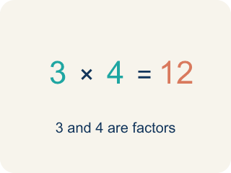
Factor (Factor) — A number that divides another number with nothing left over.
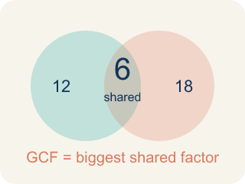
Greatest Common Factor (Máximo común divisor) — The biggest number that divides two or more numbers evenly.
Common factor (Factor común) — A number that divides two or more numbers evenly.
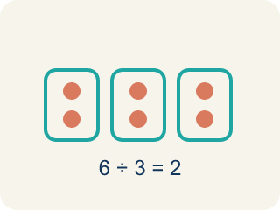
Divisible (Divisible) — A number you can divide evenly, with nothing left over.
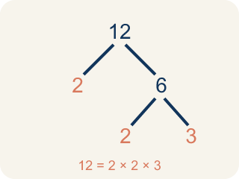
Prime factorization (Factorización prima) — Writing a number as prime numbers multiplied together. It helps you find the GCF.

Practice
Show your work. Use the blank space under each problem.
1. What is the GCF of 8 and 12?
A. 4
B. 2
C. 8
D. 24
______________________________________________________________________
2. Which pair of numbers has a GCF of 5?
A. 15 and 25
B. 10 and 12
C. 6 and 15
D. 8 and 20
______________________________________________________________________
3. Match each pair of numbers to their GCF.
Item | Answer choices
____ GCF(6, 9) | F. 7
____ GCF(12, 18) | E. 5
____ GCF(16, 24) | D. 10
____ GCF(20, 30) | C. 8
____ GCF(15, 35) | B. 6
____ GCF(14, 21) | A. 3
______________________________________________________________________
4. Use prime factorization to find the GCF.
Numbers | Prime Factorization | Shared Prime Factors | GCF
18 and 24 | 18 = 2 × 3 × 3, 24 = 2 × 2 × 2 × 3 | 2 × 3
30 and 45 | 30 = 2 × 3 × 5, 45 = 3 × 3 × 5 | 3 × 5
28 and 42 | 28 = 2 × 2 × 7, 42 = 2 × 3 × 7 | 2 × 7
______________________________________________________________________
5. A teacher has 36 pencils and 48 erasers. She wants to make identical supply bags with no items left over. What is the greatest number of bags she can make?
A. 12 bags
B. 6 bags
C. 4 bags
D. 36 bags
______________________________________________________________________
6. Sort: which pairs have a GCF greater than 1, and which are relatively prime (GCF = 1)?
Groups: GCF Greater Than 1 | Relatively Prime (GCF = 1)
• 8 and 12 (GCF = 4) → __________________
• 6 and 15 (GCF = 3) → __________________
• 10 and 25 (GCF = 5) → __________________
• 7 and 11 (GCF = 1) → __________________
• 8 and 15 (GCF = 1) → __________________
• 9 and 14 (GCF = 1) → __________________
______________________________________________________________________
7. onLevel — Spot the Common Mistake
Step 1 (Read): A student is working on Greatest Common Factor.
Step 2 (Attempt): They ignored the rule: The GCF is the largest number that divides BOTH numbers with no remainder.
Step 3 (Check): The answer does not match the math rule from class.
Which step has the mistake? Explain and fix it:
______________________________________________________________________
______________________________________________________________________
______________________________________________________________________
8. Mission Control must split 24 oxygen tanks and 36 ration packs into identical crew pods with none left over. What is the GCF of 24 and 36?
A. 12
B. 6
C. 8
D. 72
______________________________________________________________________
9. The astronaut crew has 40 solar cells and 60 battery cells to load into matching storage bins with nothing left over. What is the GCF of 40 and 60?
A. 20
B. 10
C. 4
D. 120
______________________________________________________________________
10. Each crew pod needs the same number of each supply with none left over. Match each supply pair to the greatest number of equal pods (the GCF).
Item | Answer choices
____ Pods from 18 tanks & 27 packs | D. 5
____ Pods from 21 tanks & 28 packs | C. 16
____ Pods from 32 tanks & 48 packs | B. 7
____ Pods from 25 tanks & 35 packs | A. 9
______________________________________________________________________

Answer Key (Teacher)
1. A. 4
Factors of 8: 1, 2, 4, 8. Factors of 12: 1, 2, 3, 4, 6, 12. The largest common factor is 4.
Watch for: A common mistake in Greatest Common Factor is skipping the key idea: "The GCF is the largest number that divides BOTH numbers with no remainder." — always check your work against this rule before you submit.
2. A. 15 and 25
15 = 3 × 5, 25 = 5 × 5. Both share the factor 5, and 5 is the largest shared factor.
Watch for: A common mistake in Greatest Common Factor is skipping the key idea: "The GCF is the largest number that divides BOTH numbers with no remainder." — always check your work against this rule before you submit.
3. Matches:
GCF(6, 9) → 3
GCF(12, 18) → 6
GCF(16, 24) → 8
GCF(20, 30) → 10
GCF(15, 35) → 5
GCF(14, 21) → 7

4. Use prime factorization to find the GCF.
18 and 24 → 6
30 and 45 → 15
28 and 42 → 14

5. A. 12 bags
GCF(36, 48) = 12. She can make 12 bags, each with 3 pencils and 4 erasers.
Watch for: A common mistake in Greatest Common Factor is skipping the key idea: "The GCF is the largest number that divides BOTH numbers with no remainder." — always check your work against this rule before you submit.
6. Correct groups:
8 and 12 (GCF = 4) → GCF Greater Than 1
6 and 15 (GCF = 3) → GCF Greater Than 1
10 and 25 (GCF = 5) → GCF Greater Than 1
7 and 11 (GCF = 1) → Relatively Prime (GCF = 1)
8 and 15 (GCF = 1) → Relatively Prime (GCF = 1)
9 and 14 (GCF = 1) → Relatively Prime (GCF = 1)

7. onLevel — Spot the Common Mistake
The mistake is in Step 2.
Correct work: Follow the key idea: The GCF is the largest number that divides BOTH numbers with no remainder.
8. A. 12
Factors of 24: 1, 2, 3, 4, 6, 8, 12, 24. Factors of 36: 1, 2, 3, 4, 6, 9, 12, 18, 36. The greatest shared factor is 12, so 12 pods can be filled equally.
Watch for: A common mistake in Greatest Common Factor is skipping the key idea: "The GCF is the largest number that divides BOTH numbers with no remainder." — always check your work against this rule before you submit.
9. A. 20
Factors of 40: 1, 2, 4, 5, 8, 10, 20, 40. Factors of 60: 1, 2, 3, 4, 5, 6, 10, 12, 15, 20, 30, 60. The greatest shared factor is 20, so 20 bins can be filled equally.
Watch for: A common mistake in Greatest Common Factor is skipping the key idea: "The GCF is the largest number that divides BOTH numbers with no remainder." — always check your work against this rule before you submit.
10. Matches:
Pods from 18 tanks & 27 packs → 9
Pods from 21 tanks & 28 packs → 7
Pods from 32 tanks & 48 packs → 16
Pods from 25 tanks & 35 packs → 5

