UNIT 1 · LESSON 3 STANDARD 6.NS.4

Least Common Multiple
Student Notes Packet
Name: ______________________ Date: ____________ Period: ________

Today's Goals
Content: I can find the least common multiple (LCM) of two numbers by listing or comparing their multiples.
Language: I can explain how I found the LCM using the words multiple, common multiple, skip counting, and least common multiple.

Key Vocabulary
Look at the picture, read the word, then read what it means.
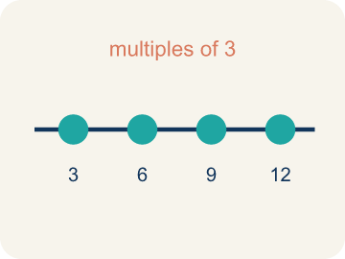 | Multiple Múltiplo  What you get when you multiply a number by 1, 2, 3, and so on.  Example: Multiples of 4: 4, 8, 12, 16, 20 — found by multiplying 4 × 1, 4 × 2, 4 × 3, ...
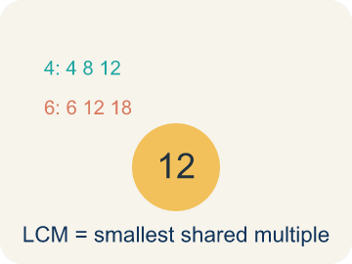 | Least common multiple Mínimo común múltiplo  The smallest number that two or more numbers both go into.  Example: Multiples of 4: 4, 8, 12, 16, 20, 24. Multiples of 6: 6, 12, 18, 24. First match: 12 → LCM = 12
Common multiple Múltiplo común
A number that two or more numbers both go into.
Example: 12, 24, and 36 are all common multiples of both 3 and 4
Skip counting Conteo salteado
Counting by a number, like 2, 4, 6, to list its multiples.
Example: Skip count by 6: 6, 12, 18, 24, 30 — each jump adds 6
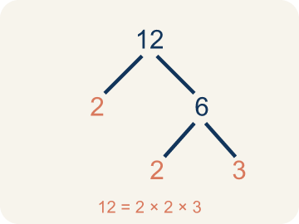 | Prime factorization Factorización prima  Writing a number as prime numbers multiplied together. It helps you find the LCM.  Example: 4 = 2 × 2, 6 = 2 × 3. LCM uses the highest power of each prime: 2² × 3 = 12

Guided Notes
Fill in each blank as we go. Use the Word Bank to help you.
WORD BANK
Multiple • Least common multiple • Common multiple • Skip counting • Prime factorization

1. The product of a number and any whole number is a ___ of that number.
2. __________ — The smallest number that two or more numbers both go into.
3. A multiple that two or more numbers share is a ___ multiple.
4. Counting forward by a number other than 1, like 6, 12, 18, is called ___.
5. __________ — Writing a number as prime numbers multiplied together. It helps you find the LCM.

Worked Example

Watch & Read I Do — follow along with your teacher
Space Station Shift Scheduler
Astronaut Reyes checks the oxygen system every 4 hours. Astronaut Chen checks the water recycler every 6 hours. They both start their shifts at 6:00 AM. When is the next time both astronauts will be checking their systems at the same time?

Think about:
• How often does each astronaut check their system?
• What times will each astronaut be doing checks?
• When will both schedules line up at the same time?
• Will their schedules ever line up more than once?

Solved Example I Do — watch each step
Problem: What is the LCM of 3 and 5?
A) 15
B) 3
C) 5
D) 30
Step 1: Multiples of 3: 3, 6, 9, 12, 15, ...
Step 2: Multiples of 5: 5, 10, 15, ...
Step 3: The smallest common multiple is 15.
Answer: A. 15

Guided Practice

Solve Together We Do — work with your class
Problem: What is the LCM of 6 and 8?
A) 24
B) 48
C) 14
D) 6
Step 1:

Step 2:

Step 3:

Answer:

Hot dogs come in packs of 8 and buns come in packs of 6. You want to buy the exact same number of hot dogs and buns with none left over.
How does the LCM help you figure out the fewest hot dogs and buns to buy so they come out even?

Sentence frame: I need to buy ___ hot dogs and ___ buns because the LCM of 8 and 6 is ___.

Turn & Talk discuss with a partner
1. [Launch] Astronaut Reyes checks oxygen every 4 hours and Chen checks water every 6 hours, both starting at 6:00 AM. Why isn't the next shared check simply 10 hours later (4 + 6)?
Start with: Their checks line up at a ___ of both 4 and 6.
Sus revisiones coinciden en un ___ de 4 y de 6.
Word bank: multiple, common multiple, least common multiple, skip counting, schedule
2. [Explore] You skip counted the multiples of 4 and 6. How did you find the least common multiple from your lists?
Start with: The multiples of 4 are ___ and the multiples of 6 are ___.
Los múltiplos de 4 son ___ y los múltiplos de 6 son ___.
Word bank: multiple, common multiple, least common multiple, skip counting, smallest
3. [Connect] Hot dogs come in packs of 8 and buns in packs of 6. How does the LCM help you buy the fewest of each so none are left over?
Start with: I need to buy ___ hot dogs and ___ buns because the LCM of 8 and 6 is ___.
Necesito comprar ___ hot dogs y ___ panes porque el mcm de 8 y 6 es ___.
Word bank: least common multiple, multiple, common multiple, packs, none left over
4. [Reflect] How do you decide whether a real-world problem needs the LCM or the GCF?
Start with: I use the LCM when ___, but the GCF when ___.
Uso el mcm cuando ___, pero el MCD cuando ___.
Word bank: least common multiple, common multiple, multiple, skip counting, greatest common factor
5. [Practice] During practice on Least Common Multiple, what strategy did you use when a problem felt tricky?
Start with: The multiples of 4 are ___ and the multiples of 6 are ___.
Los múltiplos de 4 son ___ y los múltiplos de 6 son ___.
Word bank: Multiple, Least common multiple, Common multiple, Skip counting

Independent Practice

On Your Own You Do — show your work
Solve each problem. Show your thinking in the work box.
1. What is the LCM of 4 and 10?
A) 20
B) 40
C) 10
D) 2

2. What is the LCM of 2 and 7?
A) 14
B) 7
C) 2
D) 9

3. Two buses leave the station at 8:00 AM. Bus A returns every 15 minutes and Bus B returns every 20 minutes. When is the next time both buses are at the station together?
A) 9:00 AM (60 minutes later)
B) 8:30 AM (30 minutes later)
C) 8:40 AM (40 minutes later)
D) 9:20 AM (80 minutes later)

4. Stop 1 — Oxygen Bay: The oxygen scrubber cycles every 4 minutes and the air filter cycles every 6 minutes. They both just ran together. After how many minutes do they next run together?
A) 12
B) 10
C) 24
D) 6

Exit Ticket
Answer on your own. This shows what you learned today.
★ What is the LCM of 9 and 12?
A) 36
B) 108
C) 3
D) 72

