UNIT 1 · LESSON 4 STANDARD 6.NS.2

Divide Multi-Digit Numbers
Student Notes Packet
Name: ______________________ Date: ____________ Period: ________

Today's Goals
Content: I can divide multi-digit whole numbers and explain the meaning of the quotient and remainder.
Language: I can explain my division using the words dividend, divisor, quotient, and remainder.

Key Vocabulary
Look at the picture, read the word, then read what it means.
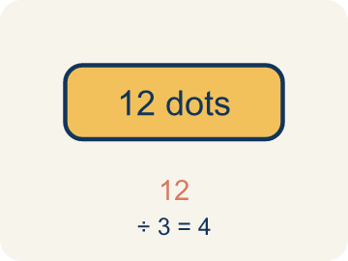 | Dividend Dividendo  The number you are splitting up in a division problem.  Example: In 156 ÷ 12 = 13, the dividend is 156 — it is the total being split up
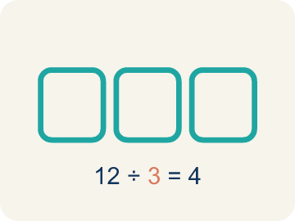 | Divisor Divisor  The number you split by in a division problem.  Example: In 156 ÷ 12 = 13, the divisor is 12 — it is the size of each group
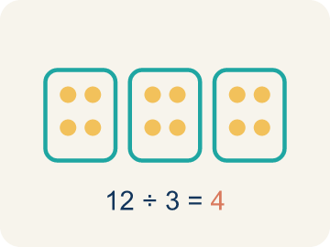 | Quotient Cociente  The answer when you divide.  Example: In 156 ÷ 12 = 13, the quotient is 13 — there are 13 groups
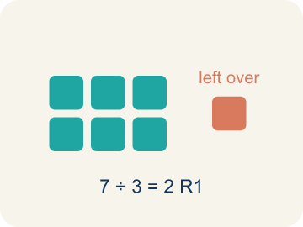 | Remainder Residuo  What is left over when a number does not divide evenly.  Example: 17 ÷ 5 = 3 R 2 means 3 groups of 5 with 2 left over
Partial quotients Cocientes parciales
A way to divide by breaking the problem into smaller, easier steps.
Example: 1,344 ÷ 12: first 12 × 100 = 1,200, then 12 × 12 = 144. Quotient = 100 + 12 = 112

Guided Notes
Fill in each blank as we go. Use the Word Bank to help you.
WORD BANK
Dividend • Divisor • Quotient • Remainder • Partial quotients

1. In 84 ÷ 7, the number 84 being divided is the ___.
2. In 84 ÷ 7, the number 7 that we divide by is the ___.
3. The answer to a division problem is called the ___.
4. When a number does not divide evenly, the amount left over is the ___.
5. Breaking division into easier chunks and adding the pieces uses ___.

Worked Example

Watch & Read I Do — follow along with your teacher
Space Station Supply Division
The space station has 1,344 nutrition bars that must be divided equally among 12 crew sections for a 4-week rotation. How many bars does each section receive?

Think about:
• What total amount needs to be divided?
• How many groups are the supplies being split into?
• Will each section get the same amount with none left over?
• What strategy would you use to divide such a large number?

Solved Example I Do — watch each step
Problem: What is 936 ÷ 12?
A) 78
B) 87
C) 68
D) 76
Step 1: 12 × 78 = 936.
Step 2: You can verify: 12 × 70 = 840, 12 × 8 = 96, 840 + 96 = 936.
Answer: A. 78

Guided Practice

Solve Together We Do — work with your class
Problem: What is 2,485 ÷ 5?
A) 497
B) 487
C) 507
D) 496
Step 1:

Step 2:

Answer:

A school is ordering 1,680 pencils to distribute equally to 24 classrooms for the school year.
How does multi-digit division help the school figure out how many pencils each classroom gets?

Sentence frame: Each classroom gets ___ pencils because 1,680 ÷ 24 = ___.

Turn & Talk discuss with a partner
1. [Launch] The station must divide 1,344 nutrition bars equally among 12 crew sections. Before dividing, about how many bars should each section get, and how do you know?
Start with: Each section gets about ___ bars because 1,344 is close to ___.
Cada sección recibe unas ___ barras porque 1,344 está cerca de ___.
Word bank: dividend, divisor, quotient, estimate, partial quotients
2. [Explore] You used partial quotients for 1,344 ÷ 12. What steps did you use, and how do they build to the final quotient?
Start with: First I took 12 × ___ = 1,200, then 12 × ___ = 144.
Primero usé 12 × ___ = 1,200, luego 12 × ___ = 144.
Word bank: partial quotients, dividend, divisor, quotient, remainder
3. [Connect] A school divides 1,680 pencils equally among 24 classrooms. How does multi-digit division tell each classroom's share, and how can you check it?
Start with: Each classroom gets ___ pencils because 1,680 ÷ 24 = ___.
Cada salón recibe ___ lápices porque 1,680 ÷ 24 = ___.
Word bank: dividend, divisor, quotient, partial quotients, equally
4. [Reflect] In a division problem, what is the difference between the quotient and the remainder, and what does each one tell you?
Start with: The quotient tells me ___, and the remainder tells me ___.
El cociente me dice ___, y el residuo me dice ___.
Word bank: quotient, remainder, dividend, divisor, divide
5. [Practice] During practice on Divide Multi-Digit Numbers, what strategy did you use when a problem felt tricky?
Start with: First I took 12 × ___ = 1,200, then 12 × ___ = 144.
Primero usé 12 × ___ = 1,200, luego 12 × ___ = 144.
Word bank: Dividend, Divisor, Quotient, Remainder

Independent Practice

On Your Own You Do — show your work
Solve each problem. Show your thinking in the work box.
1. What is 756 ÷ 9?
A) 84
B) 83
C) 94
D) 86

2. What is 1,125 ÷ 9?
A) 125
B) 115
C) 135
D) 124

3. A warehouse has 2,184 items to pack into boxes of 14. How many boxes are needed?
A) 156 boxes
B) 146 boxes
C) 166 boxes
D) 155 boxes

4. What is 4,896 ÷ 12?
A) 408
B) 48
C) 480
D) 380

Exit Ticket
Answer on your own. This shows what you learned today.
★ What is 2,352 ÷ 16?
A) 147
B) 137
C) 157
D) 146

