UNIT 1 · LESSON 6 STANDARD 6.NS.3

Multiply Decimals
Student Notes Packet
Name: ______________________ Date: ____________ Period: ________

Today's Goals
Content: I can multiply decimals and place the decimal point correctly in the product.
Language: I can explain my work using the words product, decimal point, estimate, and decimal places.

Key Vocabulary
Look at the picture, read the word, then read what it means.
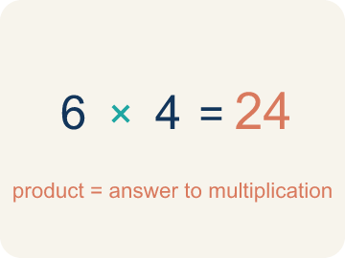 | Product Producto  The answer when you multiply.  Example: 4 × 7 = 28, so the product is 28
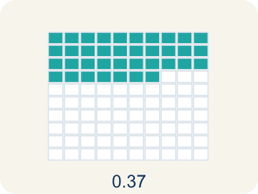 | Decimal point Punto decimal  The dot that splits the whole number from the part after it.  Example: In 3.25, the decimal point separates 3 (ones) from 25 (tenths and hundredths)
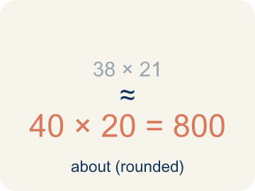 | Estimate Estimar  A close answer you get by rounding first.  Example: 3.7 × 4.2: round to 4 × 4 = 16, so the exact answer should be near 16
Place value Valor posicional
What a digit is worth based on where it sits in a number.
Example: In 0.36: the 3 is in the tenths place (0.3) and the 6 is in the hundredths place (0.06)
Decimal places Cifras decimales
How many digits come after the decimal point.
Example: 3.4 (1 place) × 2.6 (1 place) = 8.84 (2 places total)

Guided Notes
Fill in each blank as we go. Use the Word Bank to help you.
WORD BANK
Product • Decimal point • Estimate • Place value • Decimal places

1. The answer to a multiplication problem is the ___.
2. The dot that separates whole numbers from parts of a whole is the ___.
3. Finding an answer that is close but not exact, to check if a product is reasonable, is to ___.
4. The value a digit has based on its position is its ___.
5. To place the point in a product, I count the total number of ___ in both factors.

Worked Example

Watch & Read I Do — follow along with your teacher
Space Station Material Costs
The station needs 4.5 meters of heat shielding that costs $12.60 per meter. Commander Diaz needs to calculate the total cost before submitting the supply order. What is the total cost of the shielding?

Think about:
• What two quantities are being multiplied?
• How many total decimal places do the two factors have?
• How can estimating help you check if your answer is reasonable?
• Where does the decimal point go in the product?

Solved Example I Do — watch each step
Problem: What is 3.4 × 2.6?
A) 8.84
B) 88.4
C) 0.884
D) 8.48
Step 1: 34 × 26 = 884.
Step 2: There are 2 total decimal places (1 + 1), so place the decimal to get 8.84.
Answer: A. 8.84

Guided Practice

Solve Together We Do — work with your class
Problem: What is 0.7 × 1.5?
A) 1.05
B) 10.5
C) 0.105
D) 1.50
Step 1:

Step 2:

Answer:

A family is buying 3.5 pounds of deli meat that costs $6.80 per pound at the grocery store.
How do you multiply decimals to find the total cost? How can estimation help you check?

Sentence frame: The total cost is $___ because 3.5 × $6.80 = $___, and I can estimate by rounding to ___ × ___ = ___.

Turn & Talk discuss with a partner
1. [Launch] The station needs 4.5 meters of heat shielding at $12.60 per meter. About how much will it cost, and how did you estimate before multiplying?
Start with: I estimate about $___ because 4.5 is close to ___ and $12.60 is close to ___.
Estimo unos $___ porque 4.5 está cerca de ___ y $12.60 está cerca de ___.
Word bank: product, decimal point, estimate, place value, decimal places
2. [Explore] When you multiplied 4.5 × 12.60, how did you decide where to put the decimal point in the product?
Start with: I counted ___ decimal places in the factors.
Conté ___ lugares decimales en los factores.
Word bank: product, decimal point, estimate, place value, decimal places
3. [Connect] A family buys 3.5 pounds of deli meat at $6.80 per pound. How do you multiply the decimals to find the total cost, and how can estimating check it?
Start with: The total cost is $___ because I multiplied ___ × ___.
El costo total es $___ porque multipliqué ___ × ___.
Word bank: product, decimal point, estimate, place value, decimal places
4. [Reflect] How is placing the decimal point in a product different from lining up decimals when adding? Why don't you line up the points to multiply?
Start with: To multiply I ___ the decimal places, but to add I ___ the decimal points.
Para multiplicar ___ los lugares decimales, pero para sumar ___ los puntos decimales.
Word bank: product, decimal point, estimate, place value, decimal places
5. [Practice] During practice on Multiply Decimals, what strategy did you use when a problem felt tricky?
Start with: I counted ___ decimal places in the factors.
Conté ___ lugares decimales en los factores.
Word bank: Product, Decimal point, Estimate, Place value

Independent Practice

On Your Own You Do — show your work
Solve each problem. Show your thinking in the work box.
1. What is 5.3 × 4?
A) 21.2
B) 2.12
C) 212
D) 20.12

2. Which estimate is closest to 4.8 × 3.2?
A) 5 × 3 = 15
B) 4 × 3 = 12
C) 5 × 4 = 20
D) 48 × 32 = 1,536

3. A car travels 55.5 miles per hour for 2.4 hours. How far does it go?
A) 133.2 miles
B) 13.32 miles
C) 1,332 miles
D) 57.9 miles

4. A customer orders 3 taco baskets at $4.25 each. What is the total before tax?
A) $12.75
B) $12.15
C) $1.275
D) $127.50

Exit Ticket
Answer on your own. This shows what you learned today.
★ What is 4.6 × 2.3?
A) 10.58
B) 105.8
C) 1.058
D) 10.48

