Volume with Whole Number Edges — Homework
Lesson 10-1-flagship • Standard 6.GR.2
Name: ______________________ Period: ______ Date: ____________

Today's Goals
Content: I can find the volume of a rectangular prism with whole-number edges using length × width × height.
Language: I can explain my work using the words volume, rectangular prism, cubic units, and edge.

Key Words

Volume (Volumen) — How much space is inside a solid shape.
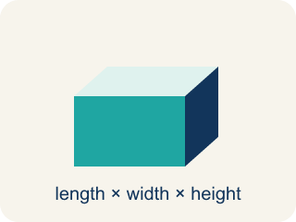
Rectangular prism (Prisma rectangular) — A solid box shape with six flat rectangle sides.
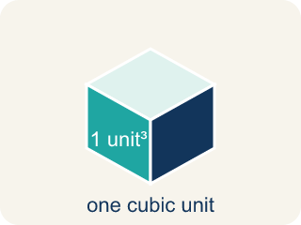
Cubic units (Unidades cúbicas) — The units used to measure space inside, like cubic inches.
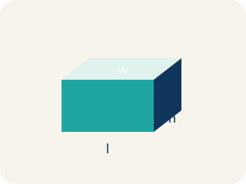
Length, width, height (Largo, ancho, altura) — How long, how wide, and how tall a box is.

Net (Plantilla (desarrollo plano)) — A flat shape that folds up into a solid.
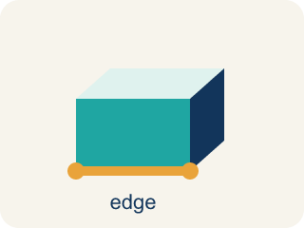
Edge (Arista) — The line where two flat sides of a solid meet.

Practice
Show your work. Use the blank space under each problem.
1. What is the volume of a rectangular prism with l = 7 in, w = 3 in, h = 4 in?
A. 84 in³
B. 14 in³
C. 84 in²
D. 42 in³
______________________________________________________________________
2. A time capsule box has a volume of 120 cm³. Its length is 10 cm and width is 4 cm. What is its height?
A. 3 cm
B. 6 cm
C. 4 cm
D. 12 cm
______________________________________________________________________
3. Complete the table. Find the missing dimension or volume for each time capsule.
Capsule | Length | Width | Height | Volume
Capsule X | 9 in | 5 in | 2 in
Capsule Y | 6 ft | 4 ft |  | 168 ft³
Capsule Z | 12 cm |  | 5 cm | 360 cm³
______________________________________________________________________
4. Two storage bins: Bin A is 8 × 6 × 5 inches. Bin B is 9 × 4 × 7 inches. Which holds more and by how much?
A. Bin B by 12 in³
B. Bin A by 12 in³
C. Bin B by 24 in³
D. They hold the same
______________________________________________________________________
5. Sort each item into the correct group.
• undefined → __________________
• undefined → __________________
• undefined → __________________
• undefined → __________________
• undefined → __________________
______________________________________________________________________
6. onLevel — Spot the Common Mistake
Step 1 (Read): A student is working on Volume with Whole Number Edges.
Step 2 (Attempt): They ignored the rule: To find the volume of a box, multiply all three edges: V = length × width × height.
Step 3 (Check): The answer does not match the math rule from class.
Which step has the mistake? Explain and fix it:
______________________________________________________________________
______________________________________________________________________
______________________________________________________________________
7. Blueprint 1: A time capsule box measures 4 in long, 3 in wide, and 2 in tall. How many unit cubes does it hold?
A. 24 cubic inches
B. 9 cubic inches
C. 14 cubic inches
D. 24 square inches
______________________________________________________________________
8. Blueprint 2: A capsule must hold exactly 72 cubic inches. Its length is 6 in and its width is 4 in. What height does the engineer need?
A. 3 in
B. 12 in
C. 62 in
D. 9 in
______________________________________________________________________
9. Sort each time capsule box by whether it holds MORE or LESS than the 24-cubic-inch standard capsule. Multiply l × w × h first.
Groups: Holds MORE than 24 in³ | Holds LESS than 24 in³
• 4 × 3 × 3 = 36 in³ → __________________
• 5 × 4 × 2 = 40 in³ → __________________
• 6 × 5 × 1 = 30 in³ → __________________
• 2 × 3 × 3 = 18 in³ → __________________
• 4 × 2 × 2 = 16 in³ → __________________
• 5 × 2 × 2 = 20 in³ → __________________
______________________________________________________________________
10. Match each set of time capsule dimensions to its correct volume. Use V = l × w × h.
Item | Answer choices
____ 3 × 3 × 3 | E. 80 in³
____ 5 × 2 × 4 | D. 42 in³
____ 6 × 4 × 2 | C. 48 in³
____ 7 × 3 × 2 | B. 40 in³
____ 8 × 5 × 2 | A. 27 in³
______________________________________________________________________

Answer Key (Teacher)
1. A. 84 in³
V = l × w × h = 7 × 3 × 4 = 84 cubic inches.
Watch for: A common mistake in Volume with Whole Number Edges is skipping the key idea: "To find the volume of a box, multiply all three edges: V = length × width × height." — always check your work against this rule before you submit.
2. A. 3 cm
V = l × w × h → 120 = 10 × 4 × h → 120 = 40h → h = 3 cm.
Watch for: A common mistake in Volume with Whole Number Edges is skipping the key idea: "To find the volume of a box, multiply all three edges: V = length × width × height." — always check your work against this rule before you submit.
3. Complete the table. Find the missing dimension or volume for each time capsule.
Capsule X — Volume: 90 in³
Capsule Y — Height: 7 ft
Capsule Z — Width: 6 cm

4. A. Bin B by 12 in³
Bin A: 8 × 6 × 5 = 240 in³. Bin B: 9 × 4 × 7 = 252 in³. Bin B holds 12 in³ more.
Watch for: A common mistake in Volume with Whole Number Edges is skipping the key idea: "To find the volume of a box, multiply all three edges: V = length × width × height." — always check your work against this rule before you submit.
5. Correct groups:
undefined → undefined
undefined → undefined
undefined → undefined
undefined → undefined
undefined → undefined

6. onLevel — Spot the Common Mistake
The mistake is in Step 2.
Correct work: Follow the key idea: To find the volume of a box, multiply all three edges: V = length × width × height.
7. A. 24 cubic inches
V = l × w × h = 4 × 3 × 2 = 24 cubic inches. The box fills 2 layers of 12 cubes each (4 × 3 = 12, then × 2 = 24).
Watch for: A common mistake in Volume with Whole Number Edges is skipping the key idea: "To find the volume of a box, multiply all three edges: V = length × width × height." — always check your work against this rule before you submit.
8. A. 3 in
V = l × w × h → 72 = 6 × 4 × h → 72 = 24 × h → h = 72 ÷ 24 = 3 in.
Watch for: A common mistake in Volume with Whole Number Edges is skipping the key idea: "To find the volume of a box, multiply all three edges: V = length × width × height." — always check your work against this rule before you submit.
9. Correct groups:
4 × 3 × 3 = 36 in³ → Holds MORE than 24 in³
5 × 4 × 2 = 40 in³ → Holds MORE than 24 in³
6 × 5 × 1 = 30 in³ → Holds MORE than 24 in³
2 × 3 × 3 = 18 in³ → Holds LESS than 24 in³
4 × 2 × 2 = 16 in³ → Holds LESS than 24 in³
5 × 2 × 2 = 20 in³ → Holds LESS than 24 in³

10. Matches:
3 × 3 × 3 → 27 in³
5 × 2 × 4 → 40 in³
6 × 4 × 2 → 48 in³
7 × 3 × 2 → 42 in³
8 × 5 × 2 → 80 in³

