UNIT 10 · LESSON 1 STANDARD 6.G.2

Volume with Whole Number Edges
Student Notes Packet
Name: ______________________ Date: ____________ Period: ________

Today's Goals
Content: I can find the volume of a rectangular prism with whole-number edges using length × width × height.
Language: I can explain my work using the words volume, rectangular prism, cubic units, and edge.

Key Vocabulary
Look at the picture, read the word, then read what it means.
 | Volume Volumen  How much space is inside a solid shape.  Example: A box 3 × 2 × 4 holds 24 unit cubes, so V = 24 cubic units
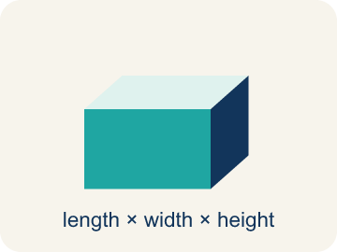 | Rectangular prism Prisma rectangular  A solid box shape with six flat rectangle sides.  Example: A cereal box or shoe box — it has length, width, and height
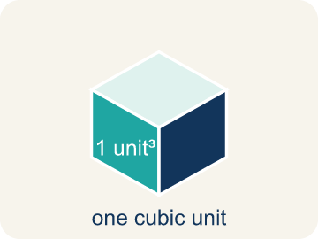 | Cubic units Unidades cúbicas  The units used to measure space inside, like cubic inches.  Example: A tiny cube that is 1 in × 1 in × 1 in = 1 in³ (one cubic inch)
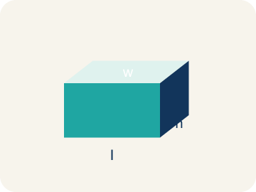 | Length, width, height Largo, ancho, altura  How long, how wide, and how tall a box is.  Example: V = l × w × h: for a box 5 × 3 × 2, volume = 30 cubic units
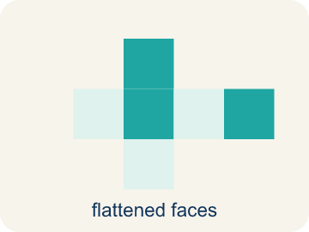 | Net Plantilla (desarrollo plano)  A flat shape that folds up into a solid.  Example: A cross-shaped pattern of 6 rectangles folds into a rectangular box
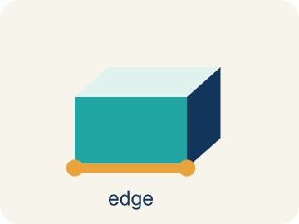 | Edge Arista  The line where two flat sides of a solid meet.  Example: A cube has 12 edges — 4 along the top, 4 along the bottom, 4 vertical

Guided Notes
Fill in each blank as we go. Use the Word Bank to help you.
WORD BANK
Volume • Rectangular prism • Cubic units • Length, width, height • Net • Edge

1. The amount of space inside a three-dimensional solid is its ___.
2. A solid with six rectangular faces, like a box, is a ___.
3. The unit used to measure volume, like cubic centimeters, is ___.
4. The three edge measurements of a rectangular prism are its ___.
5. A flat pattern that folds up into a solid is a ___.
6. A line segment where two faces of a solid meet is an ___.

Worked Example

Watch & Read I Do — follow along with your teacher
Time Capsule Project
Your team is building time capsule containers to store class memories. Each container is a rectangular prism, and you need to figure out how much each one can hold. That means calculating the volume using whole number dimensions!

Think about:
• What three measurements do you need to find the volume of a box?
• What does volume tell us about a container?
• How is volume different from the area of one face?
• If two containers have the same volume, must they have the same shape?
• What happens to the volume if you double just one dimension?

Solved Example I Do — watch each step
Problem: What is the volume of a rectangular prism with l = 7 in, w = 3 in, h = 4 in?
A) 84 in³
B) 14 in³
C) 84 in²
D) 42 in³
Step 1: V = l × w × h = 7 × 3 × 4 = 84 cubic inches.
Answer: A. 84 in³

Guided Practice

Solve Together We Do — work with your class
Problem: A time capsule box has a volume of 120 cm³. Its length is 10 cm and width is 4 cm. What is its height?
A) 3 cm
B) 6 cm
C) 4 cm
D) 12 cm
Step 1:

Step 2:

Answer:

A moving company uses rectangular boxes. A large box is 24 inches long, 18 inches wide, and 18 inches tall. A medium box is 18 inches long, 14 inches wide, and 12 inches tall.
How many more cubic inches does the large box hold than the medium box?

Sentence frame: The large box volume is ___ in³ because V = ___ × ___ × ___. The medium box volume is ___ in³. The large box holds ___ more cubic inches.

Turn & Talk discuss with a partner
1. [Launch] Your time capsule container is a rectangular prism. To find how much it can hold, why do you need three measurements (length, width, and height) instead of just one or two?
Start with: I need three measurements because volume fills space in ___ directions.
Necesito tres medidas porque el volumen llena el espacio en ___ direcciones.
Word bank: volume, length, width, height, rectangular prism
2. [Explore] Container C is 8 × 3 × 4 and Container B is 5 × 5 × 2. How did you count or multiply the unit cubes to find each volume, and which holds more?
Start with: I found the volume by multiplying ___ × ___ × ___, which equals ___ cubic units.
Hallé el volumen multiplicando ___ × ___ × ___, que es ___ unidades cúbicas.
Word bank: volume, cubic units, length, width, height, rectangular prism
3. [Connect] A moving company's large box is 24 × 18 × 18 in and its medium box is 18 × 14 × 12 in. Talk through how you would find how many more cubic inches the large box holds.
Start with: The large box volume is ___ in³ because 24 × 18 × 18 = ___.
El volumen de la caja grande es ___ in³ porque 24 × 18 × 18 = ___.
Word bank: volume, cubic units, rectangular prism, length, width, height
4. [Reflect] A classmate found the volume of a box and wrote the answer as 220 in². How would you correct the units, and how do you explain why volume uses cubic units?
Start with: The units should be ___ instead of in² because volume measures ___.
Las unidades deben ser ___ en lugar de in² porque el volumen mide ___.
Word bank: volume, cubic units, area, rectangular prism, edge
5. [Practice] During practice on Volume with Whole Number Edges, what strategy did you use when a problem felt tricky?
Start with: I found the volume by multiplying ___ × ___ × ___, which equals ___ cubic units.
Hallé el volumen multiplicando ___ × ___ × ___, que es ___ unidades cúbicas.
Word bank: Volume, Rectangular prism, Cubic units, Length, width, height

Independent Practice

On Your Own You Do — show your work
Solve each problem. Show your thinking in the work box.
1. Which unit is used for volume?
A) Cubic inches (in³)
B) Square inches (in²)
C) Inches (in)
D) Degrees (°)

2. Two storage bins: Bin A is 8 × 6 × 5 inches. Bin B is 9 × 4 × 7 inches. Which holds more and by how much?
A) Bin B by 12 in³
B) Bin A by 12 in³
C) Bin B by 24 in³
D) They hold the same

3. A time capsule box is 5 units long, 3 units wide, and 2 units tall. How many unit cubes fill it?
A) 30 cubic units
B) 10 cubic units
C) 15 cubic units
D) 25 cubic units

4. You stack unit cubes in a capsule: each layer has 6 cubes, and there are 4 layers. What is the volume?
A) 24 cubic units
B) 10 cubic units
C) 12 cubic units
D) 18 cubic units

Exit Ticket
Answer on your own. This shows what you learned today.
★ A rectangular prism has l = 11 in, w = 5 in, h = 4 in. What is the volume?
A) 220 in³
B) 55 in³
C) 220 in²
D) 200 in³

