UNIT 10 · LESSON 2 STANDARD 6.G.2

Volume of Rectangular Prisms
Student Notes Packet
Name: ______________________ Date: ____________ Period: ________

Today's Goals
Content: I can find the volume of a rectangular prism, including ones with fractional edge lengths, using base area × height.
Language: I can explain my work using the words volume, rectangular prism, dimensions, and base area.

Key Vocabulary
Look at the picture, read the word, then read what it means.
 | Volume Volumen  How much space is inside a solid shape.  Example: A box 2 × 1.5 × 1 = 3 ft³ — it holds 3 cubic feet of stuff
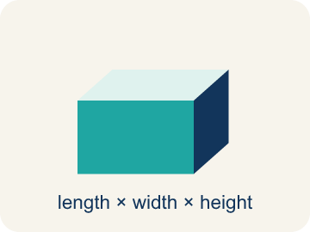 | Rectangular prism Prisma rectangular  A solid box shape with six flat rectangle sides.  Example: A tissue box, a fish tank, a brick — all rectangular prisms
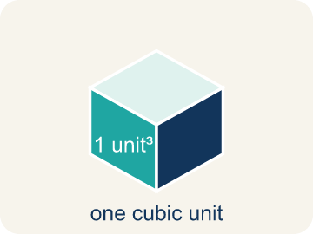 | Cubic units Unidades cúbicas  The units used to measure space inside, like cubic inches.  Example: 1 ft³ = a cube that is 1 foot on every edge
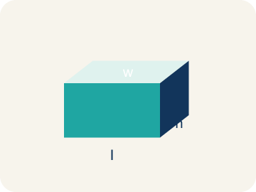 | Dimensions Dimensiones  How long, how wide, and how tall a shape is.  Example: A box with dimensions 4 × 3 × 2 means l = 4, w = 3, h = 2
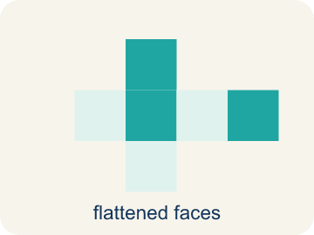 | Net Plantilla (desarrollo plano)  A flat shape that folds up into a solid.  Example: Cut a cereal box along its edges, unfold it flat — that is the net
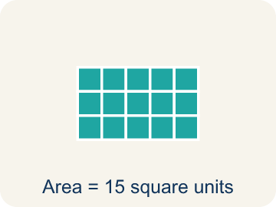 | Base area Área de la base  The area of the bottom of a solid. Volume = base area × height.  Example: If the base is 6 × 4 = 24 cm² and h = 3, then V = 24 × 3 = 72 cm³

Guided Notes
Fill in each blank as we go. Use the Word Bank to help you.
WORD BANK
Volume • Rectangular prism • Cubic units • Dimensions • Net • Base area

1. The amount of space inside a three-dimensional solid is its ___.
2. A solid with six rectangular faces is a ___.
3. The unit used to measure volume is ___.
4. The measurements of length, width, and height of a solid are its ___.
5. A flat pattern that folds into a solid is a ___.
6. The area of the bottom face of a prism, multiplied by height to find volume, is the ___.

Worked Example

Watch & Read I Do — follow along with your teacher
Time Capsule Project
Your class is building a time capsule to bury on school grounds. The capsule is a rectangular prism that is 2 feet long, 1.5 feet wide, and 1 foot tall. You need to figure out how much stuff can fit inside — that means calculating the volume!

Think about:
• What are the three measurements of the time capsule?
• What does volume measure — length, area, or space inside?
• How is volume different from area?
• What if we made the capsule taller but narrower — would the volume change?
• What units do we use for volume versus area?

Solved Example I Do — watch each step
Problem: What is the volume of a rectangular prism with l = 4 in, w = 3 in, h = 5 in?
A) 60 in³
B) 12 in³
C) 60 in²
D) 24 in³
Step 1: V = l × w × h = 4 × 3 × 5 = 60 cubic inches.
Answer: A. 60 in³

Guided Practice

Solve Together We Do — work with your class
Problem: A box has a volume of 36 cm³. Its length is 6 cm and width is 3 cm. What is the height?
A) 2 cm
B) 6 cm
C) 3 cm
D) 12 cm
Step 1:

Step 2:

Answer:

An aquarium store sells fish tanks. A small tank is 24 inches long, 12 inches wide, and 16 inches tall. One gallon of water takes up about 231 cubic inches.
How many gallons of water does the small tank hold?

Sentence frame: The tank's volume is ___ in³ because V = ___ × ___ × ___. It holds about ___ gallons because ___ ÷ 231 ≈ ___.

Turn & Talk discuss with a partner
1. [Launch] Your time capsule is 2 ft long, 1.5 ft wide, and 1 ft tall — one edge is a fraction. Does having a fractional edge change how you find the volume? Why or why not?
Start with: A fractional edge ___ change the method because I still multiply ___ × ___ × ___.
Una arista fraccionaria ___ cambia el método porque sigo multiplicando ___ × ___ × ___.
Word bank: volume, dimensions, rectangular prism, base area, cubic units
2. [Explore] Capsule A (2 × 1.5 × 1) and Capsule B (3 × 1 × 1) both have a volume of 3 ft³. How did your multiplication produce the same volume from different dimensions?
Start with: Both capsules have V = ___ ft³ because ___ × ___ × ___ = ___ × ___ × ___.
Ambas cápsulas tienen V = ___ ft³ porque ___ × ___ × ___ = ___ × ___ × ___.
Word bank: volume, dimensions, rectangular prism, base area, cubic units
3. [Connect] A fish tank is 24 in long, 12 in wide, and 16 in tall, and one gallon takes about 231 cubic inches. Talk through how you would find how many gallons it holds.
Start with: The tank's volume is ___ in³ because 24 × 12 × 16 = ___.
El volumen del tanque es ___ in³ porque 24 × 12 × 16 = ___.
Word bank: volume, cubic units, rectangular prism, dimensions, base area
4. [Reflect] A classmate says a 5 × 3 × 2.5 m prism has volume 5 × 5.5 = 27.5 m³. How do you find and explain their mistake?
Start with: The mistake is that they ___ instead of multiplying 3 × 2.5.
El error es que ___ en lugar de multiplicar 3 × 2.5.
Word bank: volume, dimensions, rectangular prism, base area, cubic units
5. [Practice] During practice on Volume of Rectangular Prisms, what strategy did you use when a problem felt tricky?
Start with: Both capsules have V = ___ ft³ because ___ × ___ × ___ = ___ × ___ × ___.
Ambas cápsulas tienen V = ___ ft³ porque ___ × ___ × ___ = ___ × ___ × ___.
Word bank: Volume, Rectangular prism, Cubic units, Dimensions

Independent Practice

On Your Own You Do — show your work
Solve each problem. Show your thinking in the work box.
1. How is volume different from area?
A) Volume measures 3D space (cubic units); area measures 2D surface (square units)
B) Volume uses square units; area uses cubic units
C) Volume only applies to cubes; area applies to all shapes
D) There is no difference

2. Two boxes: Box A is 10 × 5 × 4 inches. Box B is 8 × 6 × 5 inches. Which has more volume and by how much?
A) Box B by 40 in³
B) Box A by 40 in³
C) Box B by 60 in³
D) They're equal

3. A time-capsule box measures 6 in long, 4 in wide, and 3 in tall. What is its volume?
A) 72 cubic in
B) 13 cubic in
C) 24 cubic in
D) 72 square in

4. Two storage boxes are ready to pack. Box A is 5 × 5 × 2 inches and Box B is 4 × 4 × 3 inches. Which box holds more?
A) Box A, because 50 cubic in is more than 48 cubic in
B) Box B, because 48 cubic in is more than 50 cubic in
C) They hold the same amount
D) Box B, because it is taller

Exit Ticket
Answer on your own. This shows what you learned today.
★ A rectangular prism has l = 7 ft, w = 2 ft, h = 3 ft. What is the volume?
A) 42 ft³
B) 24 ft³
C) 42 ft²
D) 12 ft³

