Volume of Rectangular Prisms — Homework
Lesson 10-2 • Standard 6.GR.2
Name: ______________________ Period: ______ Date: ____________

Today's Goals
Content: I can find the volume of a rectangular prism, including ones with fractional edge lengths, using base area × height.
Language: I can explain my work using the words volume, rectangular prism, dimensions, and base area.

Key Words

Volume (Volumen) — How much space is inside a solid shape.
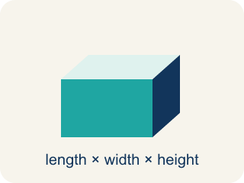
Rectangular prism (Prisma rectangular) — A solid box shape with six flat rectangle sides.
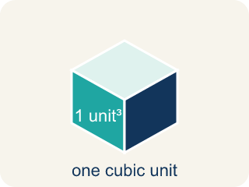
Cubic units (Unidades cúbicas) — The units used to measure space inside, like cubic inches.
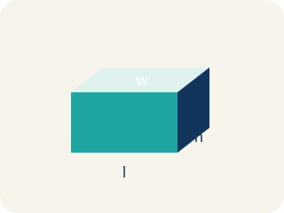
Dimensions (Dimensiones) — How long, how wide, and how tall a shape is.

Net (Plantilla (desarrollo plano)) — A flat shape that folds up into a solid.
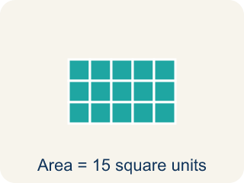
Base area (Área de la base) — The area of the bottom of a solid. Volume = base area × height.

Practice
Show your work. Use the blank space under each problem.
1. What is the volume of a rectangular prism with l = 4 in, w = 3 in, h = 5 in?
A. 60 in³
B. 12 in³
C. 60 in²
D. 24 in³
______________________________________________________________________
2. A box has a volume of 36 cm³. Its length is 6 cm and width is 3 cm. What is the height?
A. 2 cm
B. 6 cm
C. 3 cm
D. 12 cm
______________________________________________________________________
3. Find the missing dimension or volume for each container.
Container | Length | Width | Height | Volume
Box A | 12 in | 5 in | 3 in
Box B | 7 cm |  | 4 cm | 168 cm³
Box C |  | 8 ft | 5 ft | 240 ft³
______________________________________________________________________
4. Two boxes: Box A is 10 × 5 × 4 inches. Box B is 8 × 6 × 5 inches. Which has more volume and by how much?
A. Box B by 40 in³
B. Box A by 40 in³
C. Box B by 60 in³
D. They're equal
______________________________________________________________________
5. Sort each item into the correct group.
• undefined → __________________
• undefined → __________________
• undefined → __________________
• undefined → __________________
______________________________________________________________________
6. onLevel — Spot the Common Mistake
Step 1 (Read): A student is working on Volume of Rectangular Prisms.
Step 2 (Attempt): They ignored the rule: A fractional edge does not change the rule: still multiply length × width × height.
Step 3 (Check): The answer does not match the math rule from class.
Which step has the mistake? Explain and fix it:
______________________________________________________________________
______________________________________________________________________
______________________________________________________________________
7. A time-capsule box measures 6 in long, 4 in wide, and 3 in tall. What is its volume?
A. 72 cubic in
B. 13 cubic in
C. 24 cubic in
D. 72 square in
______________________________________________________________________
8. Two storage boxes are ready to pack. Box A is 5 × 5 × 2 inches and Box B is 4 × 4 × 3 inches. Which box holds more?
A. Box A, because 50 cubic in is more than 48 cubic in
B. Box B, because 48 cubic in is more than 50 cubic in
C. They hold the same amount
D. Box B, because it is taller
______________________________________________________________________
9. A keepsake box is 4 in long, 3 in wide, and 1½ in tall. What is its volume?
A. 18 cubic in
B. 8.5 cubic in
C. 12 cubic in
D. 36 cubic in
______________________________________________________________________
10. Match each box's dimensions to its correct volume.
Item | Answer choices
____ 2 × 3 × 4 | D. 30 cubic in
____ 5 × 2 × 2 | C. 27 cubic in
____ 3 × 3 × 3 | B. 20 cubic in
____ 6 × 1 × 5 | A. 24 cubic in
______________________________________________________________________

Answer Key (Teacher)
1. A. 60 in³
V = l × w × h = 4 × 3 × 5 = 60 cubic inches.
Watch for: A common mistake in Volume of Rectangular Prisms is skipping the key idea: "A fractional edge does not change the rule: still multiply length × width × height." — always check your work against this rule before you submit.
2. A. 2 cm
V = l × w × h → 36 = 6 × 3 × h → 36 = 18h → h = 2 cm.
Watch for: A common mistake in Volume of Rectangular Prisms is skipping the key idea: "A fractional edge does not change the rule: still multiply length × width × height." — always check your work against this rule before you submit.
3. Find the missing dimension or volume for each container.
Box A — Volume: 180 in³
Box B — Width: 6 cm
Box C — Length: 6 ft

4. A. Box B by 40 in³
Box A: 10 × 5 × 4 = 200 in³. Box B: 8 × 6 × 5 = 240 in³. Box B is bigger by 40 in³.
Watch for: A common mistake in Volume of Rectangular Prisms is skipping the key idea: "A fractional edge does not change the rule: still multiply length × width × height." — always check your work against this rule before you submit.
5. Correct groups:
undefined → undefined
undefined → undefined
undefined → undefined
undefined → undefined

6. onLevel — Spot the Common Mistake
The mistake is in Step 2.
Correct work: Follow the key idea: A fractional edge does not change the rule: still multiply length × width × height.
7. A. 72 cubic in
V = length × width × height = 6 × 4 × 3 = 72 cubic in. Volume uses cubic units.
Watch for: A common mistake in Volume of Rectangular Prisms is skipping the key idea: "A fractional edge does not change the rule: still multiply length × width × height." — always check your work against this rule before you submit.
8. A. Box A, because 50 cubic in is more than 48 cubic in
Box A: 5 × 5 × 2 = 50 cubic in. Box B: 4 × 4 × 3 = 48 cubic in. 50 > 48, so Box A holds more.
Watch for: A common mistake in Volume of Rectangular Prisms is skipping the key idea: "A fractional edge does not change the rule: still multiply length × width × height." — always check your work against this rule before you submit.
9. A. 18 cubic in
V = 4 × 3 × 1.5 = 12 × 1.5 = 18 cubic in. A fractional edge does not change the steps.
Watch for: A common mistake in Volume of Rectangular Prisms is skipping the key idea: "A fractional edge does not change the rule: still multiply length × width × height." — always check your work against this rule before you submit.
10. Matches:
2 × 3 × 4 → 24 cubic in
5 × 2 × 2 → 20 cubic in
3 × 3 × 3 → 27 cubic in
6 × 1 × 5 → 30 cubic in

