UNIT 10 · LESSON 4 STANDARD 6.G.4

Surface Area of Prisms
Student Notes Packet
Name: ______________________ Date: ____________ Period: ________

Today's Goals
Content: I can find the surface area of rectangular and triangular prisms.
Language: I can explain my work using the words surface area, rectangular prism, triangular prism, and face.

Key Vocabulary
Look at the picture, read the word, then read what it means.
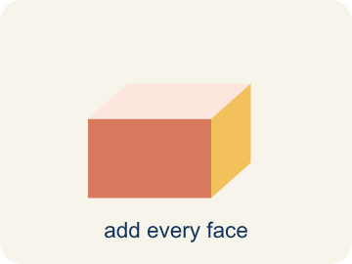 | Surface area Área de superficie  The total area of all the flat sides of a solid.  Example: Paint every outside surface of a box — the total painted area is the surface area
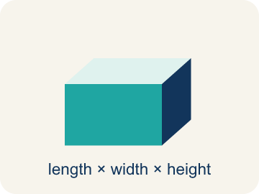 | Rectangular prism Prisma rectangular  A solid box shape with six flat rectangle sides.  Example: A box with 6 flat rectangle sides: top, bottom, front, back, left, right
Triangular prism Prisma triangular
A solid with two triangle ends and three flat rectangle sides.
Example: Shaped like a tent or a wedge of cheese — 2 triangle ends + 3 rectangle sides
Face Cara
One flat side of a solid shape.
Example: A triangular prism has 5 faces: 2 triangles + 3 rectangles
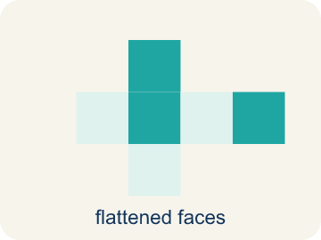 | Net Plantilla (desarrollo plano)  A flat shape that folds up into a solid.  Example: Unfold a triangular prism flat: you see 2 triangles and 3 rectangles side by side
Lateral face Cara lateral
The side faces of a solid, not the top or bottom.
Example: On a triangular prism, the 3 rectangles that wrap around the sides are lateral faces

Guided Notes
Fill in each blank as we go. Use the Word Bank to help you.
WORD BANK
Surface area • Rectangular prism • Triangular prism • Face • Net • Lateral face

1. The total area of all the faces of a solid is its ___.
2. A solid with six rectangular faces is a ___.
3. A solid with two triangular faces and three rectangular faces is a ___.
4. A flat surface of a solid figure is a ___.
5. A flat pattern that folds into a solid is a ___.
6. A side face of a prism that is not a base is a ___.

Worked Example

Watch & Read I Do — follow along with your teacher
Time Capsule Project
Your class is painting the outside of different time capsule shapes to protect them from weather. Some capsules are rectangular prisms and others are triangular prisms (wedge-shaped). To buy the right amount of paint, you need to calculate the surface area of each shape!

Think about:
• How many faces does a rectangular prism have? A triangular prism?
• What shapes make up the faces of a triangular prism?
• How is finding surface area different from finding volume?
• Which shape uses more paint — a rectangular or triangular prism of similar size?
• Why does surface area use square units instead of cubic units?

Solved Example I Do — watch each step
Problem: What is the surface area of a rectangular prism with l = 5 cm, w = 4 cm, h = 3 cm?
A) 94 cm²
B) 60 cm²
C) 94 cm³
D) 47 cm²
Step 1: SA = 2(5×4) + 2(5×3) + 2(4×3) = 40 + 30 + 24 = 94 cm².
Answer: A. 94 cm²

Guided Practice

Solve Together We Do — work with your class
Problem: How many faces does a triangular prism have?
A) 5
B) 4
C) 6
D) 3
Step 1:

Step 2:

Answer:

A carpenter builds wooden storage chests. A rectangular chest is 3 feet long, 2 feet wide, and 2 feet tall. Wood stain covers 50 square feet per can.
How much surface area needs staining, and how many cans of stain are needed?

Sentence frame: The chest's SA is ___ ft² because SA = 2(___×___) + 2(___×___) + 2(___×___) = ___ + ___ + ___ = ___. You need ___ can(s) because ___ ÷ 50 = ___.

Turn & Talk discuss with a partner
1. [Launch] Your class is painting two capsule shapes: a rectangular prism and a triangular prism. How is finding the surface area of each shape the same, and how is it different?
Start with: Both surface areas are found by adding the areas of all the ___.
Ambas áreas de superficie se hallan sumando las áreas de todas las ___.
Word bank: surface area, rectangular prism, triangular prism, face, lateral face
2. [Explore] For the triangular prism (base 6, height 4, length 10, slant sides 5), how did you account for the triangular bases AND the rectangular lateral faces?
Start with: The two triangular bases together are 2 × (½ × 6 × 4) = ___.
Las dos bases triangulares juntas son 2 × (½ × 6 × 4) = ___.
Word bank: surface area, triangular prism, lateral face, face, net
3. [Connect] A carpenter stains a chest that is 3 ft × 2 ft × 2 ft, and one can covers 50 ft². Talk through how to find the surface area and how many cans are needed.
Start with: The chest's surface area is ___ ft² because SA = 2(3×2) + 2(3×2) + 2(2×2).
El área de superficie del cofre es ___ ft² porque SA = 2(3×2) + 2(3×2) + 2(2×2).
Word bank: surface area, rectangular prism, face, lateral face, net
4. [Reflect] A classmate wrote SA = 2(12×7) + 2(12×5) + (7×5) = 323 cm² for a 12 × 7 × 5 prism. How do you find and fix their mistake?
Start with: The mistake is that the last pair (7×5) was not multiplied by ___.
El error es que el último par (7×5) no se multiplicó por ___.
Word bank: surface area, rectangular prism, face, lateral face, net
5. [Practice] During practice on Surface Area of Prisms, what strategy did you use when a problem felt tricky?
Start with: The two triangular bases together are 2 × (½ × 6 × 4) = ___.
Las dos bases triangulares juntas son 2 × (½ × 6 × 4) = ___.
Word bank: Surface area, Rectangular prism, Triangular prism, Face

Independent Practice

On Your Own You Do — show your work
Solve each problem. Show your thinking in the work box.
1. A triangular prism has two triangular bases each with area 12 cm² and three rectangular faces with areas 30 cm², 40 cm², and 40 cm². What is the total surface area?
A) 134 cm²
B) 110 cm²
C) 122 cm²
D) 134 cm³

2. A triangular prism has triangular bases with base 6 in and height 4 in. The prism is 10 in long and the two slant sides of the triangle are each 5 in. What is the surface area?
A) 184 in²
B) 160 in²
C) 124 in²
D) 184 in³

3. A rectangular time capsule box measures 3 in by 4 in by 5 in. How much wrapping paper covers its surface (no overlap)?
A) 94 in²
B) 60 in²
C) 47 in²
D) 94 in³

4. A rectangular capsule crate is 6 cm long, 5 cm wide, and 4 cm tall. How much cardboard is needed to cover all its faces?
A) 148 cm²
B) 120 cm²
C) 74 cm²
D) 148 cm³

Exit Ticket
Answer on your own. This shows what you learned today.
★ A rectangular prism has l = 8 ft, w = 6 ft, h = 3 ft. What is the surface area?
A) 180 ft²
B) 144 ft²
C) 180 ft³
D) 90 ft²

