Surface Area of Prisms — Homework
Lesson 10-4 • Standard 6.GR.4
Name: ______________________ Period: ______ Date: ____________

Today's Goals
Content: I can find the surface area of rectangular and triangular prisms.
Language: I can explain my work using the words surface area, rectangular prism, triangular prism, and face.

Key Words
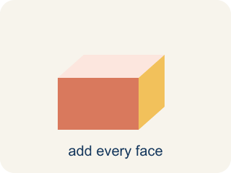
Surface area (Área de superficie) — The total area of all the flat sides of a solid.
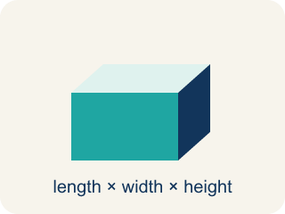
Rectangular prism (Prisma rectangular) — A solid box shape with six flat rectangle sides.
Triangular prism (Prisma triangular) — A solid with two triangle ends and three flat rectangle sides.
Face (Cara) — One flat side of a solid shape.
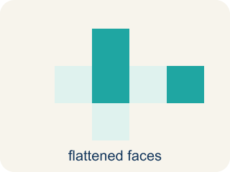
Net (Plantilla (desarrollo plano)) — A flat shape that folds up into a solid.
Lateral face (Cara lateral) — The side faces of a solid, not the top or bottom.

Practice
Show your work. Use the blank space under each problem.
1. What is the surface area of a rectangular prism with l = 5 cm, w = 4 cm, h = 3 cm?
A. 94 cm²
B. 60 cm²
C. 94 cm³
D. 47 cm²
______________________________________________________________________
2. How many faces does a triangular prism have?
A. 5
B. 4
C. 6
D. 3
______________________________________________________________________
3. Calculate the surface area of each rectangular prism time capsule.
Capsule | Length | Width | Height | Surface Area
Capsule E | 12 in | 8 in | 5 in
Capsule F | 9 cm | 6 cm | 6 cm
Capsule G | 15 ft | 4 ft | 3 ft
______________________________________________________________________
4. A triangular prism has triangular bases with base 6 in and height 4 in. The prism is 10 in long and the two slant sides of the triangle are each 5 in. What is the surface area?
A. 184 in²
B. 160 in²
C. 124 in²
D. 184 in³
______________________________________________________________________
5. Sort each item into the correct group.
• undefined → __________________
• undefined → __________________
• undefined → __________________
• undefined → __________________
______________________________________________________________________
6. onLevel — Spot the Common Mistake
Step 1 (Read): A student is working on Surface Area of Prisms.
Step 2 (Attempt): They ignored the rule: No matter the prism, find the area of every face and add them all together.
Step 3 (Check): The answer does not match the math rule from class.
Which step has the mistake? Explain and fix it:
______________________________________________________________________
______________________________________________________________________
______________________________________________________________________
7. A rectangular time capsule box measures 3 in by 4 in by 5 in. How much wrapping paper covers its surface (no overlap)?
A. 94 in²
B. 60 in²
C. 47 in²
D. 94 in³
______________________________________________________________________
8. A rectangular capsule crate is 6 cm long, 5 cm wide, and 4 cm tall. How much cardboard is needed to cover all its faces?
A. 148 cm²
B. 120 cm²
C. 74 cm²
D. 148 cm³
______________________________________________________________________
9. A wedge-shaped (triangular prism) capsule has triangle ends with base 8 in and height 6 in. The prism is 10 in long, and the triangle's three sides are 8 in, 6 in, and 10 in. How much wrapping paper covers it?
A. 288 in²
B. 240 in²
C. 48 in²
D. 288 in³
______________________________________________________________________
10. A capsule crew sorts wrapping jobs by how much paper each prism needs. Order these from LEAST surface area to GREATEST.
Groups: Least → Greatest wrapping paper
• Cube capsule 4×4×4: SA = 96 in² → __________________
• Rect capsule 3×4×5: SA = 94 in² → __________________
• Rect capsule 6×5×4: SA = 148 in² → __________________
• Tri capsule (ends 8×6, length 10): SA = 288 in² → __________________
______________________________________________________________________

Answer Key (Teacher)
1. A. 94 cm²
SA = 2(5×4) + 2(5×3) + 2(4×3) = 40 + 30 + 24 = 94 cm².
Watch for: A common mistake in Surface Area of Prisms is skipping the key idea: "No matter the prism, find the area of every face and add them all together." — always check your work against this rule before you submit.
2. A. 5
A triangular prism has 5 faces: 2 triangular bases and 3 rectangular lateral faces.
Watch for: A common mistake in Surface Area of Prisms is skipping the key idea: "No matter the prism, find the area of every face and add them all together." — always check your work against this rule before you submit.
3. Calculate the surface area of each rectangular prism time capsule.
Capsule E — Surface Area: 392 in²
Capsule F — Surface Area: 288 cm²
Capsule G — Surface Area: 234 ft²

4. A. 184 in²
Triangular bases: 2 × (½ × 6 × 4) = 24 in². Three rectangular faces: 6(10) + 5(10) + 5(10) = 60 + 50 + 50 = 160 in². SA = 24 + 160 = 184 in².
Watch for: A common mistake in Surface Area of Prisms is skipping the key idea: "No matter the prism, find the area of every face and add them all together." — always check your work against this rule before you submit.
5. Correct groups:
undefined → undefined
undefined → undefined
undefined → undefined
undefined → undefined

6. onLevel — Spot the Common Mistake
The mistake is in Step 2.
Correct work: Follow the key idea: No matter the prism, find the area of every face and add them all together.
7. A. 94 in²
SA = 2(lw + lh + wh) = 2(3×4 + 3×5 + 4×5) = 2(12 + 15 + 20) = 2(47) = 94 in².
Watch for: A common mistake in Surface Area of Prisms is skipping the key idea: "No matter the prism, find the area of every face and add them all together." — always check your work against this rule before you submit.
8. A. 148 cm²
SA = 2(6×5) + 2(6×4) + 2(5×4) = 60 + 48 + 40 = 148 cm².
Watch for: A common mistake in Surface Area of Prisms is skipping the key idea: "No matter the prism, find the area of every face and add them all together." — always check your work against this rule before you submit.
9. A. 288 in²
Two triangle ends: 2 × (½ × 8 × 6) = 48 in². Three rectangles: (8 + 6 + 10) × 10 = 24 × 10 = 240 in². SA = 48 + 240 = 288 in².
Watch for: A common mistake in Surface Area of Prisms is skipping the key idea: "No matter the prism, find the area of every face and add them all together." — always check your work against this rule before you submit.
10. Correct groups:
Cube capsule 4×4×4: SA = 96 in² → Least → Greatest wrapping paper
Rect capsule 3×4×5: SA = 94 in² → Least → Greatest wrapping paper
Rect capsule 6×5×4: SA = 148 in² → Least → Greatest wrapping paper
Tri capsule (ends 8×6, length 10): SA = 288 in² → Least → Greatest wrapping paper

