UNIT 10 · LESSON 5 STANDARD 6.G.4

Surface Area of Pyramids
Student Notes Packet
Name: ______________________ Date: ____________ Period: ________

Today's Goals
Content: I can find the surface area of a pyramid by adding the base area and the lateral faces.
Language: I can explain my work using the words pyramid, slant height, lateral face, and base.

Key Vocabulary
Look at the picture, read the word, then read what it means.
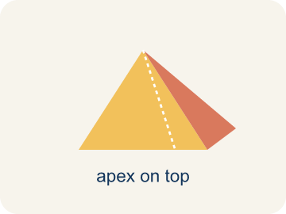 | Pyramid Pirámide  A solid with a flat bottom and triangle sides that meet at one point on top.  Example: Like the Great Pyramid of Giza — a square on the bottom, 4 triangles slanting up to a point
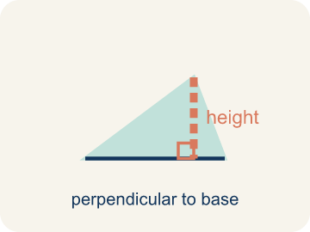 | Slant height Altura inclinada (apotema)  The height of a side triangle, measured along its slanted face.  Example: If you slide your finger from the bottom edge up the triangle face to the top point — that distance is the slant height
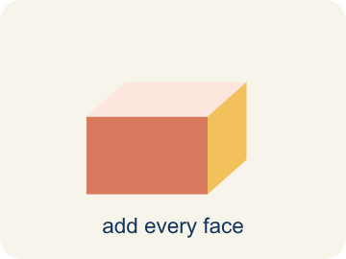 | Lateral face Cara lateral  A triangle side of a pyramid, not the bottom.  Example: A square pyramid has 4 lateral faces — one triangle for each side of the square base
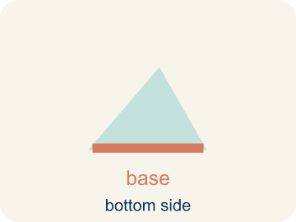 | Base Base  The flat bottom of a pyramid.  Example: A square pyramid sits on a square base; base area = side × side
Apex Ápice
The point at the top of a pyramid where the sides meet.
Example: The pointy top of a pyramid — all the slanted edges connect here
Lateral area Área lateral
The total area of just the side triangles, not the bottom.
Example: For a square pyramid: lateral area = 4 × (½ × base edge × slant height)

Guided Notes
Fill in each blank as we go. Use the Word Bank to help you.
WORD BANK
Pyramid • Slant height • Lateral face • Base • Apex • Lateral area

1. A solid with a polygon base and triangular faces meeting at one point is a ___.
2. The height of a triangular face of a pyramid, measured along the slanted side, is the ___.
3. A triangular side face of a pyramid is a ___.
4. The polygon on the bottom of a pyramid is the ___.
5. The single top point where the triangular faces of a pyramid meet is the ___.
6. The combined area of all the side faces, not counting the base, is the ___.

Worked Example

Watch & Read I Do — follow along with your teacher
Time Capsule Project
Your class is building a pyramid-shaped display to showcase the time capsule at the school entrance. The pyramid will be covered in gold leaf to make it shine. To figure out how much gold leaf you need, you must calculate the total surface area — the base plus all the triangular faces!

Think about:
• How many faces does a square pyramid have?
• What shape is the base? What shape are the side faces?
• What is the difference between the height of the pyramid and the slant height?
• Why do we use slant height instead of regular height for the triangular faces?
• Would a taller pyramid always need more gold leaf than a shorter one?

Solved Example I Do — watch each step
Problem: A square pyramid has a base edge of 5 in and a slant height of 7 in. What is the surface area?
A) 95 in²
B) 70 in²
C) 95 in³
D) 120 in²
Step 1: Base: 5 × 5 = 25 in².
Step 2: Each lateral face: ½ × 5 × 7 = 17.5 in².
Step 3: Four faces: 4 × 17.5 = 70 in².
Step 4: SA = 25 + 70 = 95 in².
Answer: A. 95 in²

Guided Practice

Solve Together We Do — work with your class
Problem: How many lateral (triangular) faces does a square pyramid have?
A) 4
B) 3
C) 5
D) 6
Step 1:

Step 2:

Step 3:

Answer:

A museum is building a square pyramid display case. The base edge is 3 feet and the slant height is 4 feet. The glass costs $12 per square foot.
How much will the glass for all 4 triangular sides cost? (The base is open — no glass needed.)

Sentence frame: Each triangular face has area = ½ × ___ × ___ = ___ ft². Four faces: 4 × ___ = ___ ft². Cost: ___ × $12 = $___.

Turn & Talk discuss with a partner
1. [Launch] A square pyramid time capsule display has a square base and four triangular faces that meet at a point on top. To find its surface area, which parts do you need to measure?
Start with: I need the area of the ___ plus the areas of the ___ triangular faces.
Necesito el área de la ___ más las áreas de las ___ caras triangulares.
Word bank: pyramid, base, lateral face, slant height, surface area
2. [Explore] For Display A (square base 6×6, slant height 8), how did you combine the base area and the four triangular faces to get the total surface area?
Start with: The base area is ___ × ___ = ___, and one triangular face is ½ × 6 × 8 = ___.
El área de la base es ___ × ___ = ___, y una cara triangular es ½ × 6 × 8 = ___.
Word bank: pyramid, base, lateral face, slant height, surface area
3. [Connect] A museum builds a square pyramid display case with base edge 3 ft and slant height 4 ft, and the base is open (no glass). Talk through how to find how much glass the 4 triangular sides need.
Start with: Each triangular face has area ½ × ___ × ___ = ___ ft².
Cada cara triangular tiene área ½ × ___ × ___ = ___ ft².
Word bank: pyramid, base, lateral face, slant height, surface area
4. [Reflect] A classmate found a square pyramid's surface area by adding only the four triangular faces. What did they forget, and how would you correct it?
Start with: They forgot to add the ___ area to the triangular faces.
Olvidaron sumar el área de la ___ a las caras triangulares.
Word bank: pyramid, base, lateral face, slant height, surface area
5. [Practice] During practice on Surface Area of Pyramids, what strategy did you use when a problem felt tricky?
Start with: The base area is ___ × ___ = ___, and one triangular face is ½ × 6 × 8 = ___.
El área de la base es ___ × ___ = ___, y una cara triangular es ½ × 6 × 8 = ___.
Word bank: Pyramid, Slant height, Lateral face, Base

Independent Practice

On Your Own You Do — show your work
Solve each problem. Show your thinking in the work box.
1. What is the area of one triangular face with base 8 in and slant height 6 in?
A) 24 in²
B) 48 in²
C) 14 in²
D) 24 in³

2. A square pyramid has a base area of 49 cm² and a total lateral area of 84 cm². What is the surface area?
A) 133 cm²
B) 84 cm²
C) 49 cm²
D) 133 cm³

3. Your first gift box is a square pyramid with a base edge of 7 in and a slant height of 9 in. How much wrapping paper (total surface area) covers it?
A) 175 in²
B) 126 in²
C) 144 in²
D) 175 in³

4. Before adding the base, you need the area of just one triangular face of a gift box with base edge 8 in and slant height 5 in. What is it?
A) 20 in²
B) 40 in²
C) 13 in²
D) 20 in³

Exit Ticket
Answer on your own. This shows what you learned today.
★ A square pyramid has a base edge of 6 in and a slant height of 5 in. What is the total surface area?
A) 96 in²
B) 60 in²
C) 96 in³
D) 36 in²

