Interpret Division of Fractions — Homework
Lesson 2-1-flagship • Standard 6.NOS.1
Name: ______________________ Period: ______ Date: ____________

Today's Goals
Content: I can use models to interpret what it means to divide by a fraction.
Language: I can explain a fraction division using the words dividend, divisor, quotient, reciprocal, and unit fraction.

Key Words
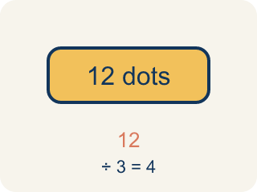
Dividend (Dividendo) — The number you are splitting up in a division problem.
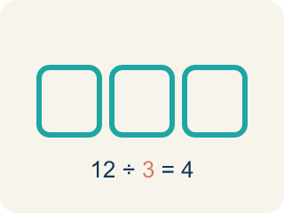
Divisor (Divisor) — The number you split by in a division problem.
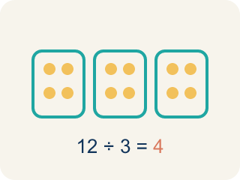
Quotient (Cociente) — The answer when you divide.
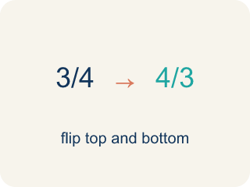
Reciprocal (Recíproco) — A fraction turned upside down.
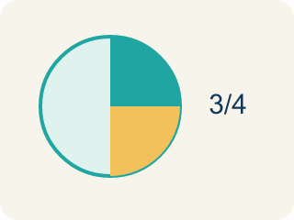
Unit fraction (Fracción unitaria) — A fraction with 1 on top, like 1/4.

Practice
Show your work. Use the blank space under each problem.
1. What does 3 ÷ 1/4 mean?
A. How many 1/4-size pieces fit into 3
B. 3 groups of 1/4
C. 3 minus 1/4
D. 1/4 of 3
______________________________________________________________________
2. Which expression means 'how many 1/3-size pieces are in 2'?
A. 2 ÷ 1/3
B. 2 × 1/3
C. 1/3 ÷ 2
D. 2 + 1/3
______________________________________________________________________
3. Match each division expression to its quotient.
Item | Answer choices
____ 5 ÷ 1/2 | F. 14
____ 6 ÷ 1/3 | E. 15
____ 2 ÷ 1/6 | D. 16
____ 4 ÷ 1/4 | C. 12
____ 3 ÷ 1/5 | B. 18
____ 7 ÷ 1/2 | A. 10
______________________________________________________________________
4. A shelf is 5 feet long. Books are each 1/4 foot wide. How many books fit on the shelf? Which expression represents this?
A. 5 ÷ 1/4 = 20 books
B. 5 × 1/4 = 1 1/4 books
C. 1/4 ÷ 5 = 1/20 book
D. 5 + 1/4 = 5 1/4 books
______________________________________________________________________
5. onLevel — Spot the Common Mistake
Step 1 (Read): A student is working on Interpret Division of Fractions.
Step 2 (Attempt): They ignored the rule: Dividing by a fraction smaller than 1 gives an answer BIGGER than what you started with, because many tiny pieces fit inside.
Step 3 (Check): The answer does not match the math rule from class.
Which step has the mistake? Explain and fix it:
______________________________________________________________________
______________________________________________________________________
______________________________________________________________________
6. Clue 1 — The case file says a 3-cup bottle of fingerprint dust must be poured into evidence vials that each hold 1/4 cup. Which question does 3 ÷ 1/4 ask?
A. How many 1/4-cup vials fit into 3 cups
B. What is 1/4 of 3 cups
C. What is 3 cups minus 1/4 cup
D. How many 3-cup bottles fit into 1/4 cup
______________________________________________________________________
7. Clue 2 — A roll of evidence tape is 8 feet long. The lab marks it into 1/4-foot sections. How many sections are made, and which expression proves it?
A. 8 ÷ 1/4 = 32 sections
B. 8 × 1/4 = 2 sections
C. 1/4 ÷ 8 = 1/32 section
D. 8 + 1/4 = 8 1/4 sections
______________________________________________________________________
8. Clue 3 — Sort each suspect statement into the correct evidence locker: does the expression match the story, or is it a false lead?
Groups: Solid Evidence (expression fits the story) | False Lead (wrong operation)
• 5 feet of rope cut into 1/3-foot pieces → 5 ÷ 1/3 = 15 → __________________
• 4 cups of powder poured into 1/6-cup scoops → 4 ÷ 1/6 = 24 → __________________
• 9 yards of tape marked into 1/2-yard sections → 9 ÷ 1/2 = 18 → __________________
• 7 feet of wire cut into 1/4-foot pieces → 7 × 1/4 = 1 3/4 → __________________
• 6 cups split into 1/4-cup vials → 1/4 ÷ 6 = 1/24 → __________________
• Finding how many 1/5-pieces fit in 3 → 3 + 1/5 = 3 1/5 → __________________
______________________________________________________________________
9. Clue 4 — Match each detective question to the quotient that closes the case.
Item | Answer choices
____ How many 1/4-cup vials fill 6 cups? | D. 50
____ How many 1/2-foot pieces in 8 feet? | C. 28
____ How many 1/4-foot sections in 7 feet? | B. 16
____ How many 1/5-cup scoops in 10 cups? | A. 24
______________________________________________________________________
10. Clue 5 — Detective Reyes pours 5 quarts of evidence solution into beakers that each hold 1/3 quart. She wants to know how many beakers she fills. What does the quotient of 5 ÷ 1/3 tell her in this story?
A. The number of 1/3-quart beakers she can fill, which is 15
B. The number of quarts in one beaker, which is 1/3
C. How much solution is left over, which is 5
D. How many quarts each beaker loses, which is 3
______________________________________________________________________

Answer Key (Teacher)
1. A. How many 1/4-size pieces fit into 3
3 ÷ 1/4 asks: how many 1/4-size pieces fit into 3? The answer is 12, because each whole has 4 fourths, and 3 × 4 = 12.
Watch for: A common mistake in Interpret Division of Fractions is skipping the key idea: "Dividing by a fraction smaller than 1 gives an answer BIGGER than what you started with, because many tiny pieces fit inside." — always check your work against this rule before you submit.
2. A. 2 ÷ 1/3
Finding how many 1/3-size pieces fit into 2 is represented by 2 ÷ 1/3. The answer is 6.
Watch for: A common mistake in Interpret Division of Fractions is skipping the key idea: "Dividing by a fraction smaller than 1 gives an answer BIGGER than what you started with, because many tiny pieces fit inside." — always check your work against this rule before you submit.
3. Matches:
5 ÷ 1/2 → 10
6 ÷ 1/3 → 18
2 ÷ 1/6 → 12
4 ÷ 1/4 → 16
3 ÷ 1/5 → 15
7 ÷ 1/2 → 14

4. A. 5 ÷ 1/4 = 20 books
You are finding how many 1/4-foot pieces fit into 5 feet, which is 5 ÷ 1/4 = 5 × 4 = 20 books.
Watch for: A common mistake in Interpret Division of Fractions is skipping the key idea: "Dividing by a fraction smaller than 1 gives an answer BIGGER than what you started with, because many tiny pieces fit inside." — always check your work against this rule before you submit.
5. onLevel — Spot the Common Mistake
The mistake is in Step 2.
Correct work: Follow the key idea: Dividing by a fraction smaller than 1 gives an answer BIGGER than what you started with, because many tiny pieces fit inside.
6. A. How many 1/4-cup vials fit into 3 cups
Dividing by a fraction asks how many of that piece fit inside the whole. 3 ÷ 1/4 = 12, so the dust fills 12 vials.
Watch for: A common mistake in Interpret Division of Fractions is skipping the key idea: "Dividing by a fraction smaller than 1 gives an answer BIGGER than what you started with, because many tiny pieces fit inside." — always check your work against this rule before you submit.
7. A. 8 ÷ 1/4 = 32 sections
Each foot holds 4 fourths, so 8 feet hold 8 × 4 = 32 sections. The matching expression is 8 ÷ 1/4 = 32.
Watch for: A common mistake in Interpret Division of Fractions is skipping the key idea: "Dividing by a fraction smaller than 1 gives an answer BIGGER than what you started with, because many tiny pieces fit inside." — always check your work against this rule before you submit.
8. Correct groups:
5 feet of rope cut into 1/3-foot pieces → 5 ÷ 1/3 = 15 → Solid Evidence (expression fits the story)
4 cups of powder poured into 1/6-cup scoops → 4 ÷ 1/6 = 24 → Solid Evidence (expression fits the story)
9 yards of tape marked into 1/2-yard sections → 9 ÷ 1/2 = 18 → Solid Evidence (expression fits the story)
7 feet of wire cut into 1/4-foot pieces → 7 × 1/4 = 1 3/4 → False Lead (wrong operation)
6 cups split into 1/4-cup vials → 1/4 ÷ 6 = 1/24 → False Lead (wrong operation)
Finding how many 1/5-pieces fit in 3 → 3 + 1/5 = 3 1/5 → False Lead (wrong operation)

9. Matches:
How many 1/4-cup vials fill 6 cups? → 24
How many 1/2-foot pieces in 8 feet? → 16
How many 1/4-foot sections in 7 feet? → 28
How many 1/5-cup scoops in 10 cups? → 50

10. A. The number of 1/3-quart beakers she can fill, which is 15
5 ÷ 1/3 asks how many 1/3-quart beakers fit into 5 quarts. Each quart holds 3 thirds, so 5 × 3 = 15 beakers.
Watch for: A common mistake in Interpret Division of Fractions is skipping the key idea: "Dividing by a fraction smaller than 1 gives an answer BIGGER than what you started with, because many tiny pieces fit inside." — always check your work against this rule before you submit.

