UNIT 2 · LESSON 1 STANDARD 6.NS.1

Interpret Division of Fractions
Student Notes Packet
Name: ______________________ Date: ____________ Period: ________

Today's Goals
Content: I can use models to interpret what it means to divide by a fraction.
Language: I can explain a fraction division using the words dividend, divisor, quotient, reciprocal, and unit fraction.

Key Vocabulary
Look at the picture, read the word, then read what it means.
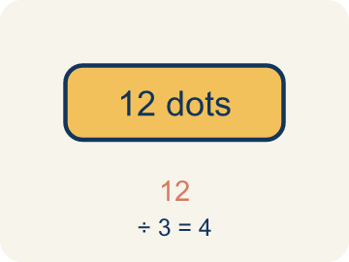 | Dividend Dividendo  The number you are splitting up in a division problem.  Example: In 3 ÷ 1/4 = 12, the dividend is 3 — it is the total being split
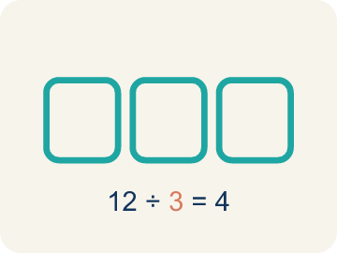 | Divisor Divisor  The number you split by in a division problem.  Example: In 3 ÷ 1/4 = 12, the divisor is 1/4 — it is the size of each piece
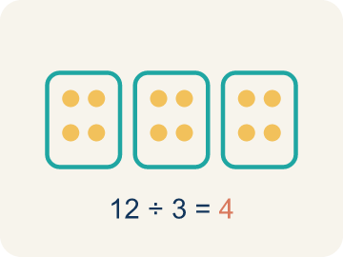 | Quotient Cociente  The answer when you divide.  Example: In 3 ÷ 1/4 = 12, the quotient is 12 — there are 12 quarter-size pieces in 3
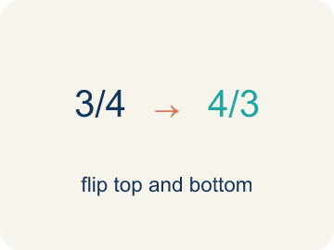 | Reciprocal Recíproco  A fraction turned upside down.  Example: The reciprocal of 1/4 is 4/1 = 4. Multiplying by the reciprocal gives the same result as dividing.
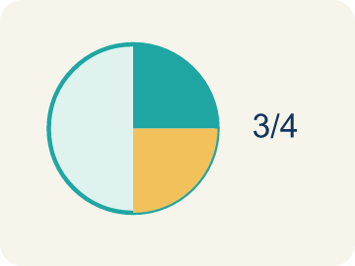 | Unit fraction Fracción unitaria  A fraction with 1 on top, like 1/4.  Example: 1/2, 1/3, 1/4, 1/5 — each represents one equal part of a whole

Guided Notes
Fill in each blank as we go. Use the Word Bank to help you.
WORD BANK
Dividend • Divisor • Quotient • Reciprocal • Unit fraction

1. In 6 ÷ 1/2, the number 6 being divided is the ___.
2. In 6 ÷ 1/2, the number 1/2 we divide by is the ___.
3. The answer to a division problem is the ___.
4. The fraction you get by flipping the numerator and denominator is the ___.
5. A fraction with a numerator of 1, like 1/5, is a ___.

Worked Example

Watch & Read I Do — follow along with your teacher
Detective Agency Case File
Agent Reyes finds a 3-foot strip of tape at the crime scene. The lab needs the tape cut into 1/4-foot sections for analysis. How many sections can be made? The answer cracks the code to the locked evidence vault.

Think about:
• What total length is being divided?
• What is the size of each section?
• Will the answer be greater than or less than 3?
• What does it mean to divide by a fraction?
• Why does dividing by 1/4 give a bigger number?

Solved Example I Do — watch each step
Problem: What does 3 ÷ 1/4 mean?
A) How many 1/4-size pieces fit into 3
B) 3 groups of 1/4
C) 3 minus 1/4
D) 1/4 of 3
Step 1: 3 ÷ 1/4 asks: how many 1/4-size pieces fit into 3?
Step 2: The answer is 12, because each whole has 4 fourths, and 3 × 4 = 12.
Answer: A. How many 1/4-size pieces fit into 3

Guided Practice

Solve Together We Do — work with your class
Problem: Which expression means 'how many 1/3-size pieces are in 2'?
A) 2 ÷ 1/3
B) 2 × 1/3
C) 1/3 ÷ 2
D) 2 + 1/3
Step 1:

Step 2:

Answer:

A detective has 6 yards of crime scene tape. She needs to mark off sections that are each 1/3 of a yard. She wants to know how many sections she can mark.
How does interpreting fraction division help the detective?

Sentence frame: The detective can mark ___ sections because 6 ÷ 1/3 = ___.

Turn & Talk discuss with a partner
1. [Launch] Agent Reyes cuts a 3-foot strip of tape into 1/4-foot sections. Before calculating, will the number of sections be more or less than 3? Why?
Start with: The number of sections will be ___ than 3 because ___.
El número de secciones será ___ que 3 porque ___.
Word bank: dividend, divisor, unit fraction
2. [Explore] What does 3 ÷ 1/4 actually mean? Show your partner with the bar model.
Start with: Dividing 3 by 1/4 means finding how many ___ fit into ___.
Dividir 3 entre 1/4 significa encontrar cuántos ___ caben en ___.
Word bank: dividend, divisor, quotient, unit fraction
3. [Connect] Where in cooking, sharing, or building might you divide a whole by a fraction?
Start with: In real life I divide by a fraction when ___.
En la vida real divido entre una fracción cuando ___.
Word bank: dividend, divisor, quotient
4. [Practice] During practice on Interpret Division of Fractions, what strategy did you use when a problem felt tricky?
Start with: Dividing 3 by 1/4 means finding how many ___ fit into ___.
Dividir 3 entre 1/4 significa encontrar cuántos ___ caben en ___.
Word bank: Dividend, Divisor, Quotient, Reciprocal

Independent Practice

On Your Own You Do — show your work
Solve each problem. Show your thinking in the work box.
1. A rope is 4 feet long. How many 1/2-foot pieces can be cut from it?
A) 8 pieces
B) 2 pieces
C) 4 pieces
D) 1/2 piece

2. What is 6 ÷ 1/5?
A) 30
B) 6/5
C) 5/6
D) 1

3. A shelf is 5 feet long. Books are each 1/4 foot wide. How many books fit on the shelf? Which expression represents this?
A) 5 ÷ 1/4 = 20 books
B) 5 × 1/4 = 1 1/4 books
C) 1/4 ÷ 5 = 1/20 book
D) 5 + 1/4 = 5 1/4 books

4. Agent Cole has 8 feet of evidence rope and cuts it into 1/3-foot pieces for tagging. What does 8 ÷ 1/3 mean?
A) How many 1/3-foot pieces fit into 8 feet
B) 1/3 of the 8 feet of rope
C) 8 feet shortened by 1/3 of a foot
D) 8 pieces that are each 1/3 foot long

Exit Ticket
Answer on your own. This shows what you learned today.
★ What does 5 ÷ 1/4 mean, and what is the quotient?
A) How many 1/4-size pieces fit into 5; quotient is 20
B) 5 groups of 1/4; quotient is 5/4
C) 1/4 of 5; quotient is 5/4
D) 5 minus 1/4; quotient is 4 3/4

