Interpret Division of Fractions — Homework
Lesson 2-1 • Standard 6.NOS.1
Name: ______________________ Period: ______ Date: ____________

Today's Goals
Content: I can use models to interpret what it means to divide by a fraction.
Language: I can explain a fraction division using the words dividend, divisor, quotient, reciprocal, and unit fraction.

Key Words
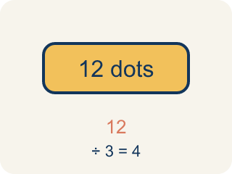
Dividend (Dividendo) — The number you are splitting up in a division problem.
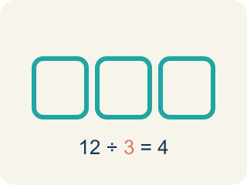
Divisor (Divisor) — The number you split by in a division problem.
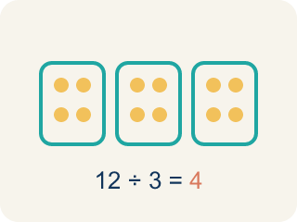
Quotient (Cociente) — The answer when you divide.
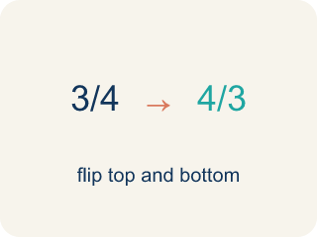
Reciprocal (Recíproco) — A fraction turned upside down.
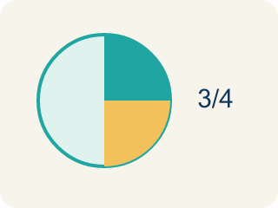
Unit fraction (Fracción unitaria) — A fraction with 1 on top, like 1/4.

Practice
Show your work. Use the blank space under each problem.
1. What does 3 ÷ 1/4 mean?
A. How many 1/4-size pieces fit into 3
B. 3 groups of 1/4
C. 3 minus 1/4
D. 1/4 of 3
______________________________________________________________________
2. Which expression means 'how many 1/3-size pieces are in 2'?
A. 2 ÷ 1/3
B. 2 × 1/3
C. 1/3 ÷ 2
D. 2 + 1/3
______________________________________________________________________
3. Match each division expression to its quotient.
Item | Answer choices
____ 5 ÷ 1/2 | F. 14
____ 6 ÷ 1/3 | E. 15
____ 2 ÷ 1/6 | D. 16
____ 4 ÷ 1/4 | C. 12
____ 3 ÷ 1/5 | B. 18
____ 7 ÷ 1/2 | A. 10
______________________________________________________________________
4. A shelf is 5 feet long. Books are each 1/4 foot wide. How many books fit on the shelf? Which expression represents this?
A. 5 ÷ 1/4 = 20 books
B. 5 × 1/4 = 1 1/4 books
C. 1/4 ÷ 5 = 1/20 book
D. 5 + 1/4 = 5 1/4 books
______________________________________________________________________
5. onLevel — Spot the Common Mistake
Step 1 (Read): A student is working on Interpret Division of Fractions.
Step 2 (Attempt): They ignored the rule: Dividing by a fraction smaller than 1 gives an answer BIGGER than what you started with, because many tiny pieces fit inside.
Step 3 (Check): The answer does not match the math rule from class.
Which step has the mistake? Explain and fix it:
______________________________________________________________________
______________________________________________________________________
______________________________________________________________________
6. Agent Cole has 8 feet of evidence rope and cuts it into 1/3-foot pieces for tagging. What does 8 ÷ 1/3 mean?
A. How many 1/3-foot pieces fit into 8 feet
B. 1/3 of the 8 feet of rope
C. 8 feet shortened by 1/3 of a foot
D. 8 pieces that are each 1/3 foot long
______________________________________________________________________
7. Picture clue: a 5-inch fingerprint strip is split into 1/6-inch slivers under the microscope. Which division does the picture show, and what is the count?
A. 5 ÷ 1/6 = 30 slivers
B. 5 ÷ 6 = 5/6 of a sliver
C. 1/6 ÷ 5 = 1/30 sliver
D. 5 × 1/6 = 5/6 of an inch
______________________________________________________________________
8. Match each detective story to the fraction-division expression and quotient that solves it.
Item | Answer choices
____ A 9-yard trail of footprints is marked off in 1/3-yard steps. | E. 8 ÷ 1/5 = 40
____ A 7-foot crime-scene barrier is taped into 1/4-foot zones. | D. 6 ÷ 1/6 = 36
____ A 10-cup batch of fingerprint powder is bottled in 1/2-cup jars. | C. 10 ÷ 1/2 = 20
____ A 6-foot wire of evidence is cut into 1/6-foot samples. | B. 7 ÷ 1/4 = 28
____ An 8-meter surveillance reel is logged in 1/5-meter clips. | A. 9 ÷ 1/3 = 27
______________________________________________________________________
9. A detective must label each story: is the question asking 'how many groups (pieces)?' or 'how big is each share?'
Groups: Asking: How Many Groups (Pieces)? | Asking: How Big Is Each Share?
• How many 1/4-foot pieces fit into 9 feet of tape? (9 ÷ 1/4) → __________________
• How many 1/3-yard steps fit into 9 yards of footprints? (9 ÷ 1/3) → __________________
• How many 1/5-meter clips are in an 8-meter reel? (8 ÷ 1/5) → __________________
• 6 feet of wire shared equally among 3 agents — how long is each share? → __________________
• 12 photos sorted equally into 4 case files — how many per file? → __________________
• 20 minutes of footage split evenly across 5 suspects — how long is each clip? → __________________
______________________________________________________________________
10. Level 2 Extension — Which Question Is Being Asked?
Step 1 (Case file): A 9-foot strip of evidence tape is cut into 1/4-foot pieces. How many pieces?
Step 2 (Detective writes): This is 1/4 ÷ 9 — split the 1/4-foot piece among 9 sections.
Step 3 (Detective's answer): 1/36 of a foot per piece
Which step has the mistake? Explain and fix it:
______________________________________________________________________
______________________________________________________________________
______________________________________________________________________

Answer Key (Teacher)
1. A. How many 1/4-size pieces fit into 3
3 ÷ 1/4 asks: how many 1/4-size pieces fit into 3? The answer is 12, because each whole has 4 fourths, and 3 × 4 = 12.
Watch for: A common mistake in Interpret Division of Fractions is skipping the key idea: "Dividing by a fraction smaller than 1 gives an answer BIGGER than what you started with, because many tiny pieces fit inside." — always check your work against this rule before you submit.
2. A. 2 ÷ 1/3
Finding how many 1/3-size pieces fit into 2 is represented by 2 ÷ 1/3. The answer is 6.
Watch for: A common mistake in Interpret Division of Fractions is skipping the key idea: "Dividing by a fraction smaller than 1 gives an answer BIGGER than what you started with, because many tiny pieces fit inside." — always check your work against this rule before you submit.
3. Matches:
5 ÷ 1/2 → 10
6 ÷ 1/3 → 18
2 ÷ 1/6 → 12
4 ÷ 1/4 → 16
3 ÷ 1/5 → 15
7 ÷ 1/2 → 14

4. A. 5 ÷ 1/4 = 20 books
You are finding how many 1/4-foot pieces fit into 5 feet, which is 5 ÷ 1/4 = 5 × 4 = 20 books.
Watch for: A common mistake in Interpret Division of Fractions is skipping the key idea: "Dividing by a fraction smaller than 1 gives an answer BIGGER than what you started with, because many tiny pieces fit inside." — always check your work against this rule before you submit.
5. onLevel — Spot the Common Mistake
The mistake is in Step 2.
Correct work: Follow the key idea: Dividing by a fraction smaller than 1 gives an answer BIGGER than what you started with, because many tiny pieces fit inside.
6. A. How many 1/3-foot pieces fit into 8 feet
Dividing by 1/3 asks how many 1/3-foot pieces fit into 8 feet. Each foot holds 3 thirds, so 8 × 3 = 24 pieces.
Watch for: A common mistake in Interpret Division of Fractions is skipping the key idea: "Dividing by a fraction smaller than 1 gives an answer BIGGER than what you started with, because many tiny pieces fit inside." — always check your work against this rule before you submit.
7. A. 5 ÷ 1/6 = 30 slivers
How many 1/6-inch slivers fit into 5 inches? Each inch holds 6 sixths, so 5 × 6 = 30 slivers.
Watch for: A common mistake in Interpret Division of Fractions is skipping the key idea: "Dividing by a fraction smaller than 1 gives an answer BIGGER than what you started with, because many tiny pieces fit inside." — always check your work against this rule before you submit.
8. Matches:
A 9-yard trail of footprints is marked off in 1/3-yard steps. → 9 ÷ 1/3 = 27
A 7-foot crime-scene barrier is taped into 1/4-foot zones. → 7 ÷ 1/4 = 28
A 10-cup batch of fingerprint powder is bottled in 1/2-cup jars. → 10 ÷ 1/2 = 20
A 6-foot wire of evidence is cut into 1/6-foot samples. → 6 ÷ 1/6 = 36
An 8-meter surveillance reel is logged in 1/5-meter clips. → 8 ÷ 1/5 = 40

9. Correct groups:
How many 1/4-foot pieces fit into 9 feet of tape? (9 ÷ 1/4) → Asking: How Many Groups (Pieces)?
How many 1/3-yard steps fit into 9 yards of footprints? (9 ÷ 1/3) → Asking: How Many Groups (Pieces)?
How many 1/5-meter clips are in an 8-meter reel? (8 ÷ 1/5) → Asking: How Many Groups (Pieces)?
6 feet of wire shared equally among 3 agents — how long is each share? → Asking: How Big Is Each Share?
12 photos sorted equally into 4 case files — how many per file? → Asking: How Big Is Each Share?
20 minutes of footage split evenly across 5 suspects — how long is each clip? → Asking: How Big Is Each Share?

10. Level 2 Extension — Which Question Is Being Asked?
The mistake is in Step 2.
Correct work: The story asks 'how many 1/4-foot pieces fit into 9 feet,' so the dividend is the whole (9) and the divisor is the piece size (1/4): 9 ÷ 1/4. The detective swapped the dividend and divisor. The correct answer is 9 × 4 = 36 pieces.

