UNIT 2 · LESSON 2 STANDARD 6.NS.1

Divide Whole Numbers by Fractions
Student Notes Packet
Name: ______________________ Date: ____________ Period: ________

Today's Goals
Content: I can divide a whole number by a fraction by multiplying by the reciprocal.
Language: I can explain my steps using the words fraction, reciprocal, quotient, and Keep, Change, Flip.

Key Vocabulary
Look at the picture, read the word, then read what it means.
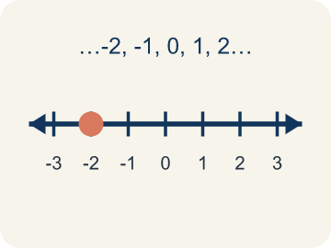 | Whole Number Número entero  A counting number with no fraction or decimal, like 0, 1, 2, 3.  Example: 4 is a whole number; as a fraction it is 4/1
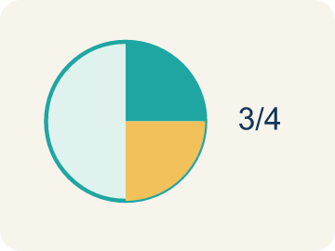 | Fraction Fracción  A number that shows part of a whole, like 3/4.  Example: 1/2 means 1 out of 2 equal parts — like cutting a sandwich in half and taking one piece
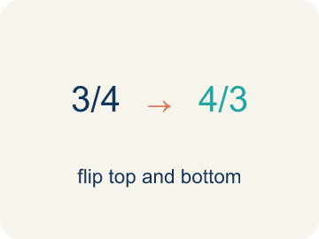 | Reciprocal Recíproco  A fraction turned upside down.  Example: The reciprocal of 2/3 is 3/2. Flip the fraction to divide: 6 ÷ 2/3 = 6 × 3/2
Keep, Change, Flip Mantener, cambiar, invertir
A way to divide fractions: keep the first, change ÷ to ×, flip the second.
Example: 6 ÷ 1/3 → Keep 6, Change ÷ to ×, Flip 1/3 to 3/1 → 6 × 3 = 18
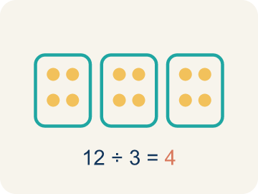 | Quotient Cociente  The answer when you divide.  Example: In 4 ÷ 1/2 = 8, the quotient is 8

Guided Notes
Fill in each blank as we go. Use the Word Bank to help you.
WORD BANK
Whole Number • Fraction • Reciprocal • Keep, Change, Flip • Quotient

1. A counting number like 0, 1, 2, or 3 with no fraction or decimal part is a ___.
2. A number that shows part of a whole, like 3/4, is a ___.
3. The fraction you get by flipping a fraction upside down is its ___.
4. To divide by a fraction, I ___: keep the first number, change ÷ to ×, and flip the second fraction.
5. The answer to a division problem is the ___.

Worked Example

Watch & Read I Do — follow along with your teacher
Detective Agency Case File
Agent Park has 4 pounds of evidence powder. Each testing bag holds exactly 1/2 pound. He needs to prepare as many testing bags as possible before the lab deadline. How many bags can he fill?

Think about:
• How much total powder does Agent Park have?
• How much goes into each bag?
• Will the number of bags be more or less than 4?
• Why does dividing by 1/2 give a number larger than 4?
• How is dividing by a fraction related to multiplying?

Solved Example I Do — watch each step
Problem: What is 6 ÷ 1/3?
A) 18
B) 2
C) 6/3
D) 3
Step 1: 6 ÷ 1/3 = 6 × 3/1 = 18.
Step 2: There are 18 thirds in 6 wholes.
Answer: A. 18

Guided Practice

Solve Together We Do — work with your class
Problem: What is 3 ÷ 1/5?
A) 15
B) 3/5
C) 5/3
D) 8
Step 1:

Step 2:

Answer:

A detective has 10 feet of rope to section off a crime scene. Each section needs to be 1/4 of a foot long for detailed evidence markers. How many markers can the detective set up?
How does dividing a whole number by a fraction help the detective?

Sentence frame: The detective can set up ___ markers because 10 ÷ 1/4 = ___.

Turn & Talk discuss with a partner
1. [Launch] Agent Park has 4 pounds of evidence powder and fills bags that hold 1/2 pound each. How many bags can he fill, and how do you know?
Start with: 1/2 pound fits into 4 pounds a total of ___ times.
1/2 libra cabe en 4 libras un total de ___ veces.
Word bank: whole number, fraction, quotient
2. [Explore] How does 'Keep, Change, Flip' turn 6 ÷ 1/3 into a multiplication problem?
Start with: I keep ___, change the sign to ___, and flip ___ to ___.
Mantengo ___, cambio el signo a ___, y volteo ___ a ___.
Word bank: reciprocal, Keep, Change, Flip, quotient
3. [Connect] When would dividing a whole number by a fraction help you in real life?
Start with: Dividing a whole number by a fraction is useful when ___.
Dividir un número entero entre una fracción es útil cuando ___.
Word bank: whole number, fraction, reciprocal
4. [Practice] During practice on Divide Whole Numbers by Fractions, what strategy did you use when a problem felt tricky?
Start with: I keep ___, change the sign to ___, and flip ___ to ___.
Mantengo ___, cambio el signo a ___, y volteo ___ a ___.
Word bank: Whole Number, Fraction, Reciprocal, Keep, Change, Flip

Independent Practice

On Your Own You Do — show your work
Solve each problem. Show your thinking in the work box.
1. What is 10 ÷ 1/4?
A) 40
B) 2.5
C) 14
D) 10/4

2. What is 5 ÷ 1/2?
A) 10
B) 5/2
C) 2.5
D) 7

3. What is 6 ÷ 2/3?
A) 9
B) 4
C) 12
D) 2/18

4. Detective Park has 4 cups of flour. Each batch of evidence-cookies needs 1/2 cup. How many batches can he make?
A) 8
B) 2
C) 4
D) 6

Exit Ticket
Answer on your own. This shows what you learned today.
★ What is 9 ÷ 1/3?
A) 27
B) 3
C) 9/3
D) 1/27

