UNIT 2 · LESSON 3 STANDARD 6.NS.1

Divide Fractions
Student Notes Packet
Name: ______________________ Date: ____________ Period: ________

Today's Goals
Content: I can divide a fraction by a fraction by multiplying by the reciprocal and simplifying.
Language: I can explain my steps using the words dividend, divisor, reciprocal, quotient, and simplify.

Key Vocabulary
Look at the picture, read the word, then read what it means.
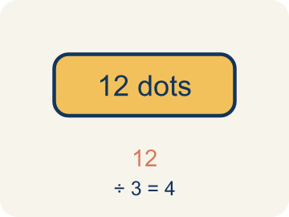 | Dividend Dividendo  The number you are splitting up in a division problem.  Example: In 3/4 ÷ 1/2, the dividend is 3/4 — the total amount being split
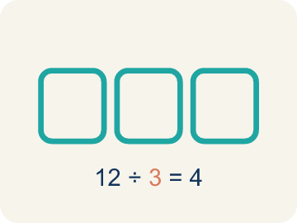 | Divisor Divisor  The number you split by in a division problem.  Example: In 3/4 ÷ 1/2, the divisor is 1/2 — the size of each group
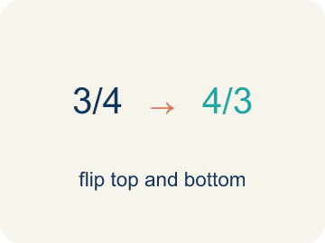 | Reciprocal Recíproco  A fraction turned upside down.  Example: The reciprocal of 2/3 is 3/2. To divide by 2/3, multiply by 3/2.
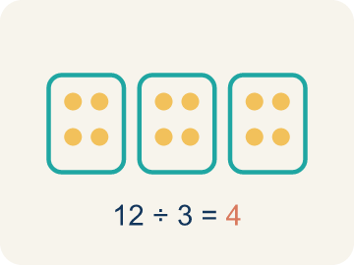 | Quotient Cociente  The answer when you divide.  Example: In 3/4 ÷ 1/4 = 3, the quotient is 3 — three 1/4-size pieces fit into 3/4
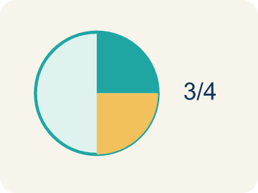 | Simplify Simplificar  To make a fraction smaller using the same parts, like 2/4 = 1/2.  Example: 8/12 → GCF is 4 → 8÷4 / 12÷4 = 2/3

Guided Notes
Fill in each blank as we go. Use the Word Bank to help you.
WORD BANK
Dividend • Divisor • Reciprocal • Quotient • Simplify

1. In 3/4 ÷ 1/2, the fraction 3/4 being divided is the ___.
2. In 3/4 ÷ 1/2, the fraction 1/2 we divide by is the ___.
3. To divide by 1/2, I multiply by its ___, which is 2.
4. The answer to a division problem is the ___.
5. Writing a fraction in its smallest equal form, like 4/8 = 1/2, is to ___ it.

Worked Example

Watch & Read I Do — follow along with your teacher
Detective Agency Case File
Agent Rivera is dividing a 3/4-pound evidence bag into portions that each weigh 1/8 pound. She needs to know exactly how many portions she can make for testing. Can you solve the case?

Think about:
• What is the total weight being divided?
• What is the size of each portion?
• Will the answer be more or less than 1?
• How is dividing fractions different from multiplying them?
• Why does 'keep, change, flip' work?

Solved Example I Do — watch each step
Problem: What is the reciprocal of 3/5?
A) 5/3
B) 3/5
C) 5/5
D) 1/3
Step 1: To find the reciprocal, flip the fraction.
Step 2: The reciprocal of 3/5 is 5/3.
Answer: A. 5/3

Guided Practice

Solve Together We Do — work with your class
Problem: What is 1/2 ÷ 1/4?
A) 2
B) 1/8
C) 4
D) 1/2
Step 1:

Step 2:

Answer:

A carpenter has a board that is 5/6 of a foot long. She needs to cut pieces that are each 1/12 of a foot. She wants to know how many pieces she can cut from the board.
How does dividing fractions help the carpenter?

Sentence frame: The carpenter can cut ___ pieces because 5/6 ÷ 1/12 = ___.

Turn & Talk discuss with a partner
1. [Launch] Agent Rivera splits a 3/4-pound evidence bag into 1/8-pound portions. Will she get more or fewer than 1 portion? Estimate before solving.
Start with: She will get ___ than 1 portion because ___.
Ella obtendrá ___ que 1 porción porque ___.
Word bank: dividend, divisor, quotient
2. [Explore] Why do we multiply by the reciprocal when we divide one fraction by another?
Start with: I flipped the divisor to its reciprocal because ___.
Volteé el divisor a su recíproco porque ___.
Word bank: reciprocal, divisor, quotient, simplify
3. [Connect] How could dividing fractions help you share food or materials fairly?
Start with: Dividing fractions helps when ___.
Dividir fracciones ayuda cuando ___.
Word bank: dividend, divisor, simplify
4. [Practice] During practice on Divide Fractions, what strategy did you use when a problem felt tricky?
Start with: I flipped the divisor to its reciprocal because ___.
Volteé el divisor a su recíproco porque ___.
Word bank: Dividend, Divisor, Reciprocal, Quotient

Independent Practice

On Your Own You Do — show your work
Solve each problem. Show your thinking in the work box.
1. What is 3/4 ÷ 1/8?
A) 6
B) 3/32
C) 8/3
D) 24

2. What is 2/3 ÷ 1/3?
A) 2
B) 2/9
C) 1/2
D) 6

3. A recipe needs 2/3 cup of sugar. You only have a 1/6-cup scoop. How many scoops do you need?
A) 4 scoops
B) 3 scoops
C) 6 scoops
D) 2 scoops

4. What is (3/4) ÷ (1/2)?
A) 3/2
B) 3/8
C) 1/2
D) 2/3

Exit Ticket
Answer on your own. This shows what you learned today.
★ What is 4/5 ÷ 2/5?
A) 2
B) 8/25
C) 2/5
D) 10/5

