UNIT 2 · LESSON 4 STANDARD 6.NS.1

Divide Mixed Numbers
Student Notes Packet
Name: ______________________ Date: ____________ Period: ________

Today's Goals
Content: I can divide mixed numbers by first changing them to improper fractions.
Language: I can explain my steps using the words mixed number, improper fraction, convert, reciprocal, and simplify.

Key Vocabulary
Look at the picture, read the word, then read what it means.
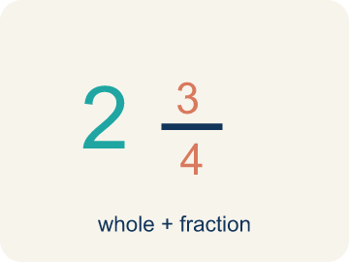 | Mixed Number Número mixto  A whole number plus a fraction, like 2 1/3.  Example: 2 1/3 means 2 wholes and 1/3 more — picture 2 full circles and 1/3 of another
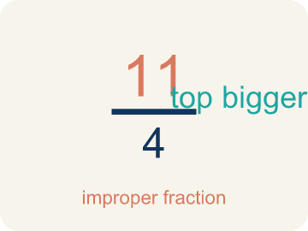 | Improper Fraction Fracción impropia  A fraction where the top is bigger than or equal to the bottom, like 7/4.  Example: 7/3 is improper because 7 > 3. It equals 2 1/3 as a mixed number.
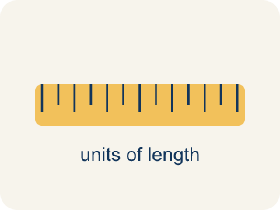 | Convert Convertir  To change a number to a new form but keep the same value.  Example: 2 1/3 → multiply 2 × 3 = 6, add 1 → 7/3. Same value, different form.
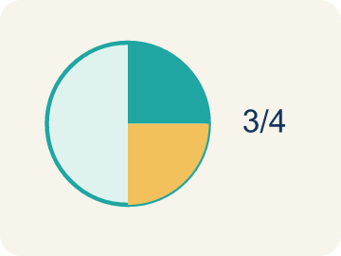 | Simplify Simplificar  To make a fraction smaller using the same parts, like 2/4 = 1/2.  Example: 8/6: GCF is 2 → 8÷2 / 6÷2 = 4/3 = 1 1/3
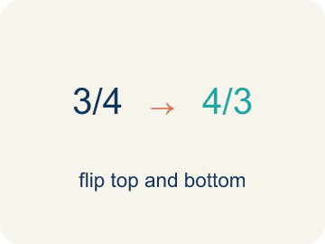 | Reciprocal Recíproco  A fraction turned upside down. You use it in keep-change-flip.  Example: The reciprocal of 3/4 is 4/3. To divide by 3/4, multiply by 4/3.

Guided Notes
Fill in each blank as we go. Use the Word Bank to help you.
WORD BANK
Mixed Number • Improper Fraction • Convert • Simplify • Reciprocal

1. A number with a whole number and a fraction, like 2 1/3, is a ___.
2. A fraction whose numerator is greater than or equal to its denominator, like 7/3, is an ___.
3. Changing a mixed number into an improper fraction is to ___ it.
4. Writing a fraction in its smallest equal form is to ___ it.
5. To divide by a fraction, I multiply by its ___.

Worked Example

Watch & Read I Do — follow along with your teacher
Detective Agency Case File
Agent Chen is mapping a suspect's route. The total distance is 3 1/2 miles, and each segment between landmarks is 1/4 mile. She needs to know how many segments are on the route to place surveillance cameras at every landmark.

Think about:
• What is the total distance of the route?
• How long is each segment?
• Will the number of segments be more or less than 3?
• Why do we need to convert mixed numbers before dividing?
• Can you divide mixed numbers without converting first?

Solved Example I Do — watch each step
Problem: What is 1 1/2 ÷ 3/4?
A) 2
B) 1 1/8
C) 3/4
D) 9/8
Step 1: 1 1/2 = 3/2.
Step 2: Then 3/2 ÷ 3/4 = 3/2 × 4/3 = 12/6 = 2.
Answer: A. 2

Guided Practice

Solve Together We Do — work with your class
Problem: Convert 3 2/5 to an improper fraction.
A) 17/5
B) 15/5
C) 6/5
D) 32/5
Step 1:

Step 2:

Answer:

A detective has a rope that is 5 1/4 feet long. She needs to cut it into pieces that are each 3/4 of a foot for tying evidence tags. How many pieces can she cut?
How does dividing mixed numbers help the detective?

Sentence frame: The detective can cut ___ pieces because 5 1/4 ÷ 3/4 = 21/4 × 4/3 = 84/12 = ___.

Turn & Talk discuss with a partner
1. [Launch] Agent Chen maps a 3 1/2-mile route divided into 1/4-mile segments. Why can't she just divide 3 1/2 by 1/4 while it is still a mixed number?
Start with: I cannot divide yet because 3 1/2 is a ___ and I need an ___.
No puedo dividir todavía porque 3 1/2 es un ___ y necesito una ___.
Word bank: mixed number, improper fraction, convert
2. [Explore] Walk your partner through how you changed the mixed numbers before dividing.
Start with: First I converted ___ into the improper fraction ___.
Primero convertí ___ en la fracción impropia ___.
Word bank: mixed number, improper fraction, reciprocal, simplify
3. [Connect] When would dividing mixed numbers come up in a real project, like building or cooking?
Start with: I would divide mixed numbers when ___.
Dividiría números mixtos cuando ___.
Word bank: mixed number, improper fraction, convert
4. [Practice] During practice on Divide Mixed Numbers, what strategy did you use when a problem felt tricky?
Start with: First I converted ___ into the improper fraction ___.
Primero convertí ___ en la fracción impropia ___.
Word bank: Mixed Number, Improper Fraction, Convert, Simplify

Independent Practice

On Your Own You Do — show your work
Solve each problem. Show your thinking in the work box.
1. What is 2 1/4 ÷ 3/4?
A) 3
B) 1 1/2
C) 9/16
D) 2 1/3

2. What is 3 1/2 ÷ 1/4?
A) 14
B) 3 1/8
C) 7/8
D) 13/4

3. A recipe makes 2 1/4 batches of cookies. Each batch uses 3/4 cup of butter. How many cups of butter are needed in total?
A) 3 cups
B) 1 1/2 cups
C) 2 cups
D) 6 cups

4. Mission 1: The stakeout shift is 4 1/2 hours long. Each agent covers a 1 1/2-hour watch. How many agent watches fill one shift?
A) 3
B) 6
C) 2 1/2
D) 4 1/2

Exit Ticket
Answer on your own. This shows what you learned today.
★ What is 2 2/3 ÷ 2/3?
A) 4
B) 2/3
C) 8/3
D) 1 7/9

