UNIT 2 · LESSON 5 STANDARD 6.NS.1

Fraction Division Problem Solving
Student Notes Packet
Name: ______________________ Date: ____________ Period: ________

Today's Goals
Content: I can solve real-world problems by writing and solving fraction division equations.
Language: I can explain my reasoning using the words model, equation, solution, and reasonableness.

Key Vocabulary
Look at the picture, read the word, then read what it means.
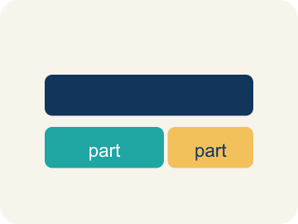 | Model Modelo  A picture or math way to show a problem so you can solve it.  Example: A bar model showing 3/4 split into 1/8-size pieces, or the equation 3/4 ÷ 1/8 = 6
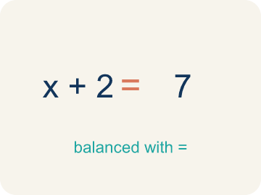 | Equation Ecuación  A math sentence with an equal sign showing both sides are the same.  Example: 3/4 ÷ 1/8 = 6 — the left side (division) equals the right side (answer)
Solution Solución
The answer to an equation or problem.
Example: In 3/4 ÷ 1/8 = 6, the solution is 6 portions
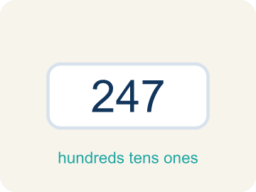 | Reasonableness Razonabilidad  Checking if your answer makes sense.  Example: 3 ÷ 1/4 = 12. Is 12 reasonable? Yes, because 1/4 is small so many pieces fit into 3.
Inverse operations Operaciones inversas
Two math actions that undo each other, like × and ÷.
Example: If 3/4 ÷ 1/8 = 6, then 6 × 1/8 = 6/8 = 3/4. Multiplication checks division.

Guided Notes
Fill in each blank as we go. Use the Word Bank to help you.
WORD BANK
Model • Equation • Solution • Reasonableness • Inverse operations

1. A drawing or diagram that shows a math situation is a ___.
2. A math sentence that says two amounts are equal, with an = sign, is an ___.
3. The value that makes an equation true is the ___.
4. Checking whether an answer makes sense for the problem is checking its ___.
5. Operations that undo each other, like multiplication and division, are ___.

Worked Example

Watch & Read I Do — follow along with your teacher
Detective Agency Case File
Agent Torres is closing the biggest case of the year. She has 2/3 of a gallon of fingerprint dust left and each test uses 1/6 of a gallon. Before the evidence expires, she needs to figure out exactly how many tests she can run. Can you write the equation and solve it?

Think about:
• What is the total amount of fingerprint dust?
• How much does each test use?
• What operation will help solve this problem?
• How do you decide which number is the dividend and which is the divisor?
• How can you check if your answer is reasonable?

Solved Example I Do — watch each step
Problem: A ribbon is 4/5 of a yard long. Each bow uses 1/10 of a yard. Which equation finds how many bows can be made?
A) 4/5 ÷ 1/10
B) 1/10 ÷ 4/5
C) 4/5 × 1/10
D) 4/5 + 1/10
Step 1: The total (4/5 yard) is divided into groups of 1/10 yard each.
Step 2: The equation is 4/5 ÷ 1/10 = 4/5 × 10/1 = 40/5 = 8 bows.
Answer: A. 4/5 ÷ 1/10

Guided Practice

Solve Together We Do — work with your class
Problem: A detective has 1/2 gallon of solution. Each test uses 1/8 gallon. How many tests can be run?
A) 4
B) 1/16
C) 16
D) 1/4
Step 1:

Step 2:

Answer:

A forensic chemist has 5/6 of a liter of testing solution. Each DNA test requires 1/12 of a liter. She needs to figure out how many tests she can run before the solution runs out.
How does setting up a fraction division equation help solve this real-world problem?

Sentence frame: The chemist can run ___ tests because 5/6 ÷ 1/12 = ___.

Turn & Talk discuss with a partner
1. [Launch] Agent Torres has 2/3 gallon of fingerprint dust and each test uses 1/6 gallon. How do you decide which number is the dividend and which is the divisor?
Start with: The total, ___, is the dividend because ___.
El total, ___, es el dividendo porque ___.
Word bank: equation, model, solution
2. [Explore] What clue in a word problem tells you to divide fractions instead of multiply?
Start with: The problem asked me to find ___, so I divided.
El problema me pidió encontrar ___, así que dividí.
Word bank: equation, solution, reasonableness
3. [Reflect] How can you check that a fraction-division answer is reasonable?
Start with: I can check my answer by ___.
Puedo verificar mi respuesta al ___.
Word bank: reasonableness, inverse operations, solution
4. [Practice] During practice on Fraction Division Problem Solving, what strategy did you use when a problem felt tricky?
Start with: The problem asked me to find ___, so I divided.
El problema me pidió encontrar ___, así que dividí.
Word bank: Model, Equation, Solution, Reasonableness

Independent Practice

On Your Own You Do — show your work
Solve each problem. Show your thinking in the work box.
1. A trail is 3/4 mile long. A jogger runs laps of 1/4 mile each. How many laps does the jogger complete?
A) 3 laps
B) 1/3 lap
C) 4 laps
D) 3/16 lap

2. A board is 5/6 foot long. Each shelf bracket needs 1/6 foot. How many brackets fit?
A) 5
B) 1/36
C) 6
D) 5/36

3. Marcus solved 2/3 ÷ 1/4 and got 8/3 = 2 2/3. He says 'That can't be right because I started with less than 1.' Is Marcus's math correct? Is his reasoning correct?
A) His math is correct (2 2/3), but his reasoning is wrong — dividing by a small fraction gives a larger result
B) His math and reasoning are both correct — the answer should be less than 1
C) His math is wrong — the answer should be 1/6
D) His math is wrong — the answer should be 8/12

4. Room 1 — Evidence Locker: Agent Torres has 7/8 pound of casting clay to lift footprints. Each cast uses 1/8 pound. How many casts can she make to unlock the door?
A) 7
B) 6
C) 8
D) 1/7

Exit Ticket
Answer on your own. This shows what you learned today.
★ A pipe is 3/4 meter long. Each connector piece is 3/8 meter. How many connectors fit on the pipe?
A) 2
B) 9/32
C) 3/2
D) 6

