Ratio Tables — Homework
Lesson 3-2 • Standard 6.AT.3a
Name: ______________________ Period: ______ Date: ____________

Today's Goals
Content: I can use a ratio table to find equivalent ratios.
Language: I can explain my table using the words ratio table, equivalent ratio, scale factor, and pattern.

Key Words
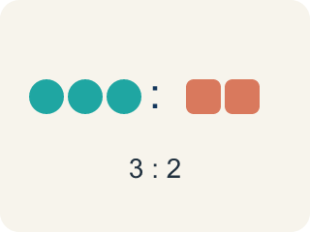
Ratio table (Tabla de razones) — A table of equal ratios that shows a pattern.
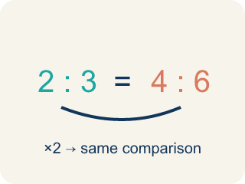
Equivalent ratio (Razón equivalente) — Two ratios that mean the same thing, like 1:2 and 2:4.
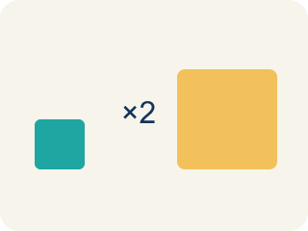
Scale factor (Factor de escala) — The number you multiply both parts of a ratio by to get an equal ratio.
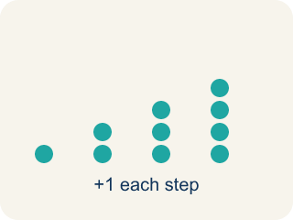
Pattern (Patrón) — A rule that numbers follow again and again.
Additive pattern (Patrón aditivo) — Adding the same amount to both parts of a ratio table to make new rows.

Practice
Show your work. Use the blank space under each problem.
1. A recipe uses 3 eggs for every 5 cups of flour. How many eggs are needed for 15 cups of flour?
A. 9
B. 6
C. 10
D. 12
______________________________________________________________________
2. Which row does NOT belong in a ratio table for 4:5?
A. 6:10
B. 8:10
C. 12:15
D. 16:20
______________________________________________________________________
3. Complete the ratio table for lemon juice to water in Chef Reyes's lemonade recipe (1 cup lemon juice for every 4 cups water).
Pitchers | Lemon Juice (cups) | Water (cups)
1 | 1 | 4
2
5
10
______________________________________________________________________
4. In a ratio table, the ratio of sugar to butter is 3:2. If you use 12 cups of sugar, how many cups of butter do you need?
A. 8
B. 6
C. 10
D. 9
______________________________________________________________________
5. Which rows belong in a ratio table for 3:4? Sort them into correct and incorrect.
Groups: Belongs in 3:4 Table | Does NOT Belong
• 6:8 → __________________
• 9:12 → __________________
• 15:20 → __________________
• 6:10 → __________________
• 12:14 → __________________
• 9:16 → __________________
______________________________________________________________________
6. A ratio table shows 5:8, 10:16, 15:24. What scale factor was used from the first row to the third row?
A. 3
B. 2
C. 5
D. 8
______________________________________________________________________
7. onLevel — Spot the Common Mistake
Step 1 (Read): A student is working on Ratio Tables.
Step 2 (Attempt): They ignored the rule: To keep a ratio the same, multiply both numbers by the same scale factor.
Step 3 (Check): The answer does not match the math rule from class.
Which step has the mistake? Explain and fix it:
______________________________________________________________________
______________________________________________________________________
______________________________________________________________________
8. The food truck sells tacos at a steady rate: 2 tacos cost $5. At that rate, how much do 6 tacos cost?
A. $15
B. $11
C. $12
D. $30
______________________________________________________________________
9. A smoothie recipe at the truck uses 4 cups of mango for every 3 cups of pineapple. How many cups of mango are needed for 9 cups of pineapple?
A. 12
B. 10
C. 13
D. 9
______________________________________________________________________
10. Match each food truck order to its missing ratio-table value.
Item | Answer choices
____ 3 burgers cost $12, so 5 burgers cost ___ | D. $12
____ Ratio table 7:2, partner of 21 is ___ | C. 36
____ Ratio table 5:6, partner of 30 in the first column is ___ | B. 6
____ 2 drinks cost $3, so 8 drinks cost ___ | A. $20
______________________________________________________________________

Answer Key (Teacher)
1. A. 9
The scale factor is 15 ÷ 5 = 3. Multiply the eggs by 3: 3 × 3 = 9 eggs.
Watch for: A common mistake in Ratio Tables is skipping the key idea: "To keep a ratio the same, multiply both numbers by the same scale factor." — always check your work against this rule before you submit.
2. A. 6:10
6:10 simplifies to 3:5, not 4:5. The other ratios (8:10, 12:15, 16:20) all simplify to 4:5.
Watch for: A common mistake in Ratio Tables is skipping the key idea: "To keep a ratio the same, multiply both numbers by the same scale factor." — always check your work against this rule before you submit.
3. Complete the ratio table for lemon juice to water in Chef Reyes's lemonade recipe (1 cup lemon juice for every 4 cups water).
2 — Lemon Juice (cups): 2
2 — Water (cups): 8
5 — Lemon Juice (cups): 5
5 — Water (cups): 20
10 — Lemon Juice (cups): 10
10 — Water (cups): 40

4. A. 8
Scale factor: 12 ÷ 3 = 4. Multiply butter by 4: 2 × 4 = 8 cups of butter.
Watch for: A common mistake in Ratio Tables is skipping the key idea: "To keep a ratio the same, multiply both numbers by the same scale factor." — always check your work against this rule before you submit.
5. Correct groups:
6:8 → Belongs in 3:4 Table
9:12 → Belongs in 3:4 Table
15:20 → Belongs in 3:4 Table
6:10 → Does NOT Belong
12:14 → Does NOT Belong
9:16 → Does NOT Belong

6. A. 3
From 5 to 15: 15 ÷ 5 = 3. From 8 to 24: 24 ÷ 8 = 3. The scale factor is 3.
Watch for: A common mistake in Ratio Tables is skipping the key idea: "To keep a ratio the same, multiply both numbers by the same scale factor." — always check your work against this rule before you submit.
7. onLevel — Spot the Common Mistake
The mistake is in Step 2.
Correct work: Follow the key idea: To keep a ratio the same, multiply both numbers by the same scale factor.
8. A. $15
6 tacos is 3 times 2 tacos, so multiply the cost by 3: $5 x 3 = $15.
Watch for: A common mistake in Ratio Tables is skipping the key idea: "To keep a ratio the same, multiply both numbers by the same scale factor." — always check your work against this rule before you submit.
9. A. 12
The scale factor is 9 div 3 = 3. Multiply the mango by 3: 4 x 3 = 12 cups.
Watch for: A common mistake in Ratio Tables is skipping the key idea: "To keep a ratio the same, multiply both numbers by the same scale factor." — always check your work against this rule before you submit.
10. Matches:
3 burgers cost $12, so 5 burgers cost ___ → $20
Ratio table 7:2, partner of 21 is ___ → 6
Ratio table 5:6, partner of 30 in the first column is ___ → 36
2 drinks cost $3, so 8 drinks cost ___ → $12

