Graph Ratio Tables — Homework
Lesson 3-3 • Standard 6.AT.3a
Name: ______________________ Period: ______ Date: ____________

Today's Goals
Content: I can graph the values from a ratio table as points on the coordinate plane.
Language: I can explain my graph using the words coordinate plane, ordered pair, origin, and proportional.

Key Words
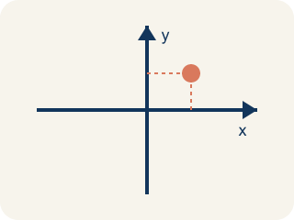
Coordinate plane (Plano cartesiano) — A grid with a line going across and a line going up to plot points.
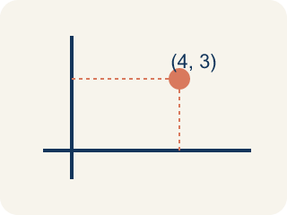
Ordered pair (Par ordenado) — Two numbers (x, y) that tell where a point is on a grid.
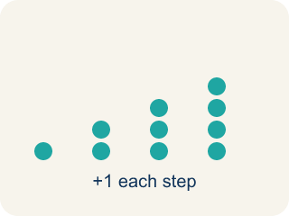
Linear pattern (Patrón lineal) — Points that make a straight line on a grid.
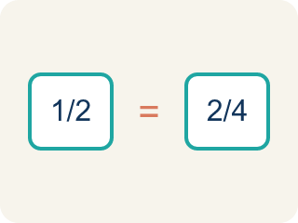
Proportional (Proporcional) — Two amounts that grow together at the same rate.
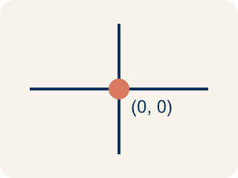
Origin (Origen) — The point (0, 0) where the two grid lines cross.

Practice
Show your work. Use the blank space under each problem.
1. A ratio table shows (2, 6), (4, 12), and (6, 18). Which ordered pair comes next if the pattern continues?
A. (8, 24)
B. (7, 20)
C. (8, 22)
D. (10, 24)
______________________________________________________________________
2. When you graph equivalent ratios, the points will always form what shape?
A. A straight line through the origin
B. A curved line
C. A zigzag
D. A circle
______________________________________________________________________
3. Points from a ratio table are plotted at (1, 4), (2, 8), and (3, 12). What is the ratio of y to x for each point?
A. 4:1
B. 1:4
C. 2:8
D. 3:4
______________________________________________________________________
4. Use the graph pattern y = 5x to complete the ratio table, then identify what the ordered pairs would be.
x | y | Ordered Pair
1 | 5 | (1, 5)
2
4
6
______________________________________________________________________
5. Two students graph ratio tables. Student A plots (1,2), (2,4), (3,6). Student B plots (1,3), (2,6), (3,9). Whose line is steeper?
A. Student B
B. Student A
C. Same steepness
D. Cannot tell
______________________________________________________________________
6. onLevel — Spot the Common Mistake
Step 1 (Read): A student is working on Graph Ratio Tables.
Step 2 (Attempt): They ignored the rule: The points from equal ratios form a straight line that passes through the origin (0, 0).
Step 3 (Check): The answer does not match the math rule from class.
Which step has the mistake? Explain and fix it:
______________________________________________________________________
______________________________________________________________________
______________________________________________________________________
7. The smoothie recipe is 1 cup of blueberries to 2 scoops of yogurt. If cups go on the x-axis and scoops on the y-axis, which ordered pair shows 3 cups of blueberries?
A. (3, 6)
B. (6, 3)
C. (3, 5)
D. (3, 3)
______________________________________________________________________
8. On the smoothie graph, every point follows the rule scoops = 2 × cups. Which equation describes the pattern between x (cups) and y (scoops)?
A. y = 2x
B. y = x + 2
C. y = x ÷ 2
D. x = 2y
______________________________________________________________________
9. Match each cups-to-scoops table row to the ordered pair you would plot (rule: y = 2x).
Item | Answer choices
____ 2 cups → 4 scoops | D. (6, 12)
____ 3 cups → 6 scoops | C. (5, 10)
____ 5 cups → 10 scoops | B. (3, 6)
____ 6 cups → 12 scoops | A. (2, 4)
______________________________________________________________________
10. The smoothie line follows the rule y = 2x (2 scoops per cup). Sort each ordered pair: is it ON the line or OFF the line?
Groups: ON the line (y = 2x) | OFF the line
• (1, 2) → __________________
• (4, 8) → __________________
• (5, 10) → __________________
• (2, 3) → __________________
• (3, 5) → __________________
• (1, 4) → __________________
______________________________________________________________________

Answer Key (Teacher)
1. A. (8, 24)
The pattern adds 2 to x and 6 to y each time. After (6, 18): x = 6+2 = 8, y = 18+6 = 24. The next point is (8, 24).
Watch for: A common mistake in Graph Ratio Tables is skipping the key idea: "The points from equal ratios form a straight line that passes through the origin (0, 0)." — always check your work against this rule before you submit.
2. A. A straight line through the origin
Equivalent ratios are proportional, so their graph is always a straight line that passes through the origin (0, 0).
Watch for: A common mistake in Graph Ratio Tables is skipping the key idea: "The points from equal ratios form a straight line that passes through the origin (0, 0)." — always check your work against this rule before you submit.
3. A. 4:1
For each point: 4÷1 = 4, 8÷2 = 4, 12÷3 = 4. The ratio of y to x is always 4:1.
Watch for: A common mistake in Graph Ratio Tables is skipping the key idea: "The points from equal ratios form a straight line that passes through the origin (0, 0)." — always check your work against this rule before you submit.
4. Use the graph pattern y = 5x to complete the ratio table, then identify what the ordered pairs would be.
2 — y: 10
2 — Ordered Pair: (2, 10)
4 — y: 20
4 — Ordered Pair: (4, 20)
6 — y: 30
6 — Ordered Pair: (6, 30)

5. A. Student B
Student A's ratio is 1:2 (y goes up 2 for each 1 in x). Student B's ratio is 1:3 (y goes up 3 for each 1 in x). A higher rate of change means a steeper line, so Student B's is steeper.
Watch for: A common mistake in Graph Ratio Tables is skipping the key idea: "The points from equal ratios form a straight line that passes through the origin (0, 0)." — always check your work against this rule before you submit.
6. onLevel — Spot the Common Mistake
The mistake is in Step 2.
Correct work: Follow the key idea: The points from equal ratios form a straight line that passes through the origin (0, 0).
7. A. (3, 6)
Cups (x) come first, scoops (y) second. 3 cups need 3 × 2 = 6 scoops, so the point is (3, 6).
Watch for: A common mistake in Graph Ratio Tables is skipping the key idea: "The points from equal ratios form a straight line that passes through the origin (0, 0)." — always check your work against this rule before you submit.
8. A. y = 2x
Each cup needs 2 scoops, so y (scoops) is always 2 times x (cups): y = 2x. For 4 cups, y = 2 × 4 = 8.
Watch for: A common mistake in Graph Ratio Tables is skipping the key idea: "The points from equal ratios form a straight line that passes through the origin (0, 0)." — always check your work against this rule before you submit.
9. Matches:
2 cups → 4 scoops → (2, 4)
3 cups → 6 scoops → (3, 6)
5 cups → 10 scoops → (5, 10)
6 cups → 12 scoops → (6, 12)

10. Correct groups:
(1, 2) → ON the line (y = 2x)
(4, 8) → ON the line (y = 2x)
(5, 10) → ON the line (y = 2x)
(2, 3) → OFF the line
(3, 5) → OFF the line
(1, 4) → OFF the line

