Compare Ratios — Homework
Lesson 3-5 • Standard 6.AT.3
Name: ______________________ Period: ______ Date: ____________

Today's Goals
Content: I can compare ratios by finding unit rates or using equivalent ratios.
Language: I can explain my comparison using the words unit rate, equivalent ratio, compare, and common denominator.

Key Words
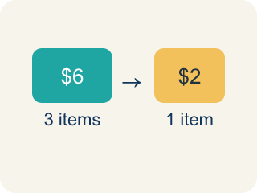
Unit rate (Tasa unitaria) — A rate for just 1 of something, like cost for 1 item.
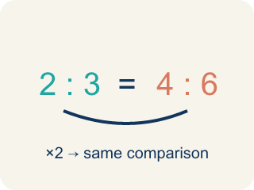
Equivalent ratio (Razón equivalente) — Two ratios that mean the same thing.
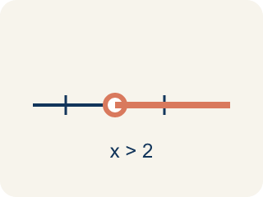
Compare (Comparar) — To look at ratios and see which is bigger, smaller, or equal.
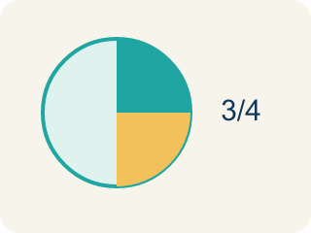
Simplify (Simplificar) — To make a ratio as small as possible while keeping the same comparison.
Common denominator (Denominador común) — A bottom number that two fractions can share so you can compare them.

Practice
Show your work. Use the blank space under each problem.
1. Chef A uses 2 cups of cheese for every 8 crackers. Chef B uses 3 cups of cheese for every 9 crackers. Who uses more cheese per cracker?
A. Chef B
B. Chef A
C. They use the same amount
D. Cannot determine
______________________________________________________________________
2. Which ratio is greater: 3:4 or 5:8?
A. 3:4
B. 5:8
C. They are equal
D. Cannot determine
______________________________________________________________________
3. Match each scenario to the correct answer: Which ratio is greater?
Groups: Correct Comparison | Incorrect Comparison
• 5:6 vs. 7:9 → 5:6 is greater → __________________
• 2:3 vs. 4:6 → they are equal → __________________
• 1:4 vs. 2:5 → 2:5 is greater → __________________
• 3:7 vs. 2:5 → 3:7 is greater → __________________
• 4:5 vs. 3:4 → 3:4 is greater → __________________
• 1:2 vs. 3:4 → they are equal → __________________
______________________________________________________________________
4. Store A sells 3 mangoes for $6. Store B sells 5 mangoes for $9. Which store offers a better price per mango?
A. Store B
B. Store A
C. Same price
D. Cannot determine
______________________________________________________________________
5. Two paint recipes both make green. Recipe A: 3 parts blue to 5 parts yellow. Recipe B: 4 parts blue to 7 parts yellow. Scale both to a common amount of yellow to compare which recipe is more blue.
Recipe | Blue Parts | Yellow Parts
Recipe A | 3 | 5
Recipe B | 4 | 7
Recipe A (scaled to 35) |  | 35
Recipe B (scaled to 35) |  | 35
______________________________________________________________________
6. onLevel — Spot the Common Mistake
Step 1 (Read): A student is working on Compare Ratios.
Step 2 (Attempt): They ignored the rule: Compare ratios fairly by making one part equal or by finding the unit rate.
Step 3 (Check): The answer does not match the math rule from class.
Which step has the mistake? Explain and fix it:
______________________________________________________________________
______________________________________________________________________
______________________________________________________________________
7. Chef Academy's snack bar sells 3 mini quiches for $6 or 5 mini quiches for $8. Which is the better deal per quiche?
A. 5 quiches for $8
B. 3 quiches for $6
C. They cost the same
D. Cannot determine
______________________________________________________________________
8. Two soup recipes use salt. Recipe A uses 4 tsp salt for 10 cups of broth. Recipe B uses 3 tsp salt for 8 cups of broth. Which soup is saltier per cup?
A. Recipe B
B. Recipe A
C. They are equally salty
D. Cannot determine
______________________________________________________________________
9. Chef Mara's lemon glaze uses 6 oz of lemon juice for 9 cupcakes. Chef Devi's uses 4 oz for 7 cupcakes. Whose glaze has more lemon per cupcake?
A. Chef Mara
B. Chef Devi
C. Same amount
D. Cannot determine
______________________________________________________________________
10. Match each Chef Academy ratio comparison to the correct winner.
Item | Answer choices
____ Smoothie A: 2 cups fruit for 6 cups water vs. Smoothie B: 3 cups fruit for 8 cups water — more fruity? | D. 3:4 (equals 6:8, greater than 5:8)
____ Bagels: 4 for $5 vs. 6 for $9 — better price per bagel? | C. Equal (both simplify to 3:5)
____ Trail mix: 6 oz nuts to 10 oz oats vs. 9 oz nuts to 15 oz oats — more nutty? | B. 4 for $5 ($1.25 < $1.50 per bagel)
____ Dressing: 3 tbsp oil to 4 tbsp vinegar vs. 5 tbsp oil to 8 tbsp vinegar — more oily? | A. Smoothie B (0.375 > 0.333 fruit per cup)
______________________________________________________________________

Answer Key (Teacher)
1. A. Chef B
Chef A: 2÷8 = 0.25 cups per cracker. Chef B: 3÷9 ≈ 0.33 cups per cracker. Chef B uses more cheese per cracker.
Watch for: A common mistake in Compare Ratios is skipping the key idea: "Compare ratios fairly by making one part equal or by finding the unit rate." — always check your work against this rule before you submit.
2. A. 3:4
Convert to the same denominator: 3:4 = 6:8. Since 6:8 > 5:8, the ratio 3:4 is greater.
Watch for: A common mistake in Compare Ratios is skipping the key idea: "Compare ratios fairly by making one part equal or by finding the unit rate." — always check your work against this rule before you submit.
3. Correct groups:
5:6 vs. 7:9 → 5:6 is greater → Correct Comparison
2:3 vs. 4:6 → they are equal → Correct Comparison
1:4 vs. 2:5 → 2:5 is greater → Correct Comparison
3:7 vs. 2:5 → 3:7 is greater → Incorrect Comparison
4:5 vs. 3:4 → 3:4 is greater → Incorrect Comparison
1:2 vs. 3:4 → they are equal → Incorrect Comparison

4. A. Store B
Store A: $6÷3 = $2.00 per mango. Store B: $9÷5 = $1.80 per mango. Store B has the better (lower) price per mango.
Watch for: A common mistake in Compare Ratios is skipping the key idea: "Compare ratios fairly by making one part equal or by finding the unit rate." — always check your work against this rule before you submit.
5. Two paint recipes both make green. Recipe A: 3 parts blue to 5 parts yellow. Recipe B: 4 parts blue to 7 parts yellow. Scale both to a common amount of yellow to compare which recipe is more blue.
Recipe A (scaled to 35) — Blue Parts: 21
Recipe B (scaled to 35) — Blue Parts: 20

6. onLevel — Spot the Common Mistake
The mistake is in Step 2.
Correct work: Follow the key idea: Compare ratios fairly by making one part equal or by finding the unit rate.
7. A. 5 quiches for $8
3 for $6 is $6 / 3 = $2.00 per quiche. 5 for $8 is $8 / 5 = $1.60 per quiche. $1.60 < $2.00, so 5 quiches for $8 is the better deal.
Watch for: A common mistake in Compare Ratios is skipping the key idea: "Compare ratios fairly by making one part equal or by finding the unit rate." — always check your work against this rule before you submit.
8. A. Recipe B
Recipe A: 4 / 10 = 0.4 tsp per cup. Recipe B: 3 / 8 = 0.375 tsp per cup. Since 0.4 > 0.375, Recipe A is saltier per cup.
Watch for: A common mistake in Compare Ratios is skipping the key idea: "Compare ratios fairly by making one part equal or by finding the unit rate." — always check your work against this rule before you submit.
9. A. Chef Mara
Chef Mara: 6 / 9 = 0.666... oz per cupcake. Chef Devi: 4 / 7 = 0.571... oz per cupcake. Since 0.67 > 0.57, Chef Mara's glaze has more lemon per cupcake.
Watch for: A common mistake in Compare Ratios is skipping the key idea: "Compare ratios fairly by making one part equal or by finding the unit rate." — always check your work against this rule before you submit.
10. Matches:
Smoothie A: 2 cups fruit for 6 cups water vs. Smoothie B: 3 cups fruit for 8 cups water — more fruity? → Smoothie B (0.375 > 0.333 fruit per cup)
Bagels: 4 for $5 vs. 6 for $9 — better price per bagel? → 4 for $5 ($1.25 < $1.50 per bagel)
Trail mix: 6 oz nuts to 10 oz oats vs. 9 oz nuts to 15 oz oats — more nutty? → Equal (both simplify to 3:5)
Dressing: 3 tbsp oil to 4 tbsp vinegar vs. 5 tbsp oil to 8 tbsp vinegar — more oily? → 3:4 (equals 6:8, greater than 5:8)

