Use Ratio Reasoning — Homework
Lesson 3-6 • Standard 6.AT.3
Name: ______________________ Period: ______ Date: ____________

Today's Goals
Content: I can use ratio reasoning to solve problems with proportions and scaling.
Language: I can explain my reasoning using the words proportion, scale, equivalent, and unit rate.

Key Words
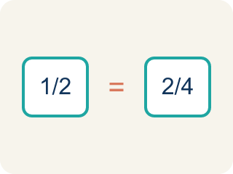
Proportion (Proporción) — A math sentence saying two ratios are equal.
Cross-multiply (Multiplicación cruzada) — Multiplying across two ratios to check if they are equal.
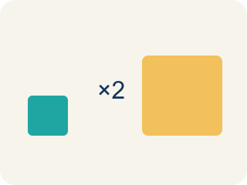
Scale (Escalar) — To multiply or divide both parts of a ratio by the same number.
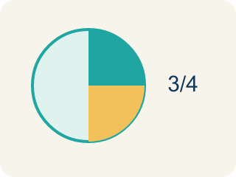
Equivalent (Equivalente) — Having the same value.
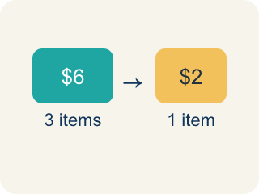
Unit rate (Tasa unitaria) — A rate for just 1 of something. You find it by dividing.

Practice
Show your work. Use the blank space under each problem.
1. A recipe uses 4 cups of broth for every 10 servings. How many cups of broth are needed for 30 servings?
A. 12
B. 8
C. 14
D. 40
______________________________________________________________________
2. Are the ratios 6:9 and 2:3 equivalent?
A. Yes, both simplify to 2:3
B. No, 6 ≠ 2
C. Yes, because 6 + 9 = 15
D. No, because 9 - 6 ≠ 3 - 2
______________________________________________________________________
3. Chef Reyes's appetizer uses 5 cups of tomatoes for every 3 cups of mozzarella. Scale the recipe for different group sizes.
Servings | Tomatoes (cups) | Mozzarella (cups)
8 | 5 | 3
16
40
120
______________________________________________________________________
4. A chef uses the proportion 3/7 = x/28 to scale a recipe. What is x?
A. 12
B. 14
C. 9
D. 21
______________________________________________________________________
5. For each proportion, sort whether it is set up correctly or incorrectly to solve '4 cups for 6 servings = ? cups for 18 servings'.
Groups: Correct Setup | Incorrect Setup
• 4/6 = x/18 → __________________
• 6/4 = 18/x → __________________
• 4/18 = x/6 → __________________
• 6/18 = x/4 → __________________
______________________________________________________________________
6. onLevel — Spot the Common Mistake
Step 1 (Read): A student is working on Use Ratio Reasoning.
Step 2 (Attempt): They ignored the rule: Find the scale factor, then multiply both parts; cross-multiply to check a proportion.
Step 3 (Check): The answer does not match the math rule from class.
Which step has the mistake? Explain and fix it:
______________________________________________________________________
______________________________________________________________________
______________________________________________________________________
7. Chef Reyes's pasta dough uses 2 eggs for every 3 cups of flour. For a banquet, the kitchen mixes 9 cups of flour. How many eggs are needed to keep the same ratio?
A. 6 eggs
B. 5 eggs
C. 8 eggs
D. 4 eggs
______________________________________________________________________
8. A marinara recipe uses 4 cups of tomatoes for every 6 servings. The chef needs 18 servings. How many cups of tomatoes should she use?
A. 12 cups
B. 10 cups
C. 16 cups
D. 9 cups
______________________________________________________________________
9. During a cooking-team relay, a chef plates 3 finished dishes for every 5 minutes she works. At the same rate, how many dishes will she plate in 20 minutes?
A. 12 dishes
B. 10 dishes
C. 15 dishes
D. 8 dishes
______________________________________________________________________
10. Match each kitchen problem to the smartest ratio-reasoning strategy.
Item | Answer choices
____ Find the cost of 1 onion when 6 onions cost $3 | D. Ratio table (add a column each time)
____ Scale a 5:3 tomato-to-cheese recipe up to 120 guests | C. Cross-multiply and compare products
____ Check if 4:6 and 6:9 are equivalent ratios | B. Scale factor (multiply both parts)
____ Show 2 cups broth per 5 servings for 5, 10, and 15 servings | A. Unit rate (divide $3 by 6)
______________________________________________________________________

Answer Key (Teacher)
1. A. 12
Scale factor: 30 ÷ 10 = 3. Multiply broth by 3: 4 × 3 = 12 cups.
Watch for: A common mistake in Use Ratio Reasoning is skipping the key idea: "Find the scale factor, then multiply both parts; cross-multiply to check a proportion." — always check your work against this rule before you submit.
2. A. Yes, both simplify to 2:3
Divide 6:9 by 3 to get 2:3. Since both ratios simplify to 2:3, they are equivalent.
Watch for: A common mistake in Use Ratio Reasoning is skipping the key idea: "Find the scale factor, then multiply both parts; cross-multiply to check a proportion." — always check your work against this rule before you submit.
3. Chef Reyes's appetizer uses 5 cups of tomatoes for every 3 cups of mozzarella. Scale the recipe for different group sizes.
16 — Tomatoes (cups): 10
16 — Mozzarella (cups): 6
40 — Tomatoes (cups): 25
40 — Mozzarella (cups): 15
120 — Tomatoes (cups): 75
120 — Mozzarella (cups): 45

4. A. 12
Scale factor: 28 ÷ 7 = 4. Multiply: 3 × 4 = 12. So x = 12.
Watch for: A common mistake in Use Ratio Reasoning is skipping the key idea: "Find the scale factor, then multiply both parts; cross-multiply to check a proportion." — always check your work against this rule before you submit.
5. Correct groups:
4/6 = x/18 → Correct Setup
6/4 = 18/x → Correct Setup
4/18 = x/6 → Incorrect Setup
6/18 = x/4 → Incorrect Setup

6. onLevel — Spot the Common Mistake
The mistake is in Step 2.
Correct work: Follow the key idea: Find the scale factor, then multiply both parts; cross-multiply to check a proportion.
7. A. 6 eggs
Scale factor: 9 cups divided by 3 cups = 3. Multiply the eggs by the same factor: 2 x 3 = 6 eggs.
Watch for: A common mistake in Use Ratio Reasoning is skipping the key idea: "Find the scale factor, then multiply both parts; cross-multiply to check a proportion." — always check your work against this rule before you submit.
8. A. 12 cups
Scale factor: 18 servings divided by 6 servings = 3. Multiply the tomatoes by 3: 4 x 3 = 12 cups.
Watch for: A common mistake in Use Ratio Reasoning is skipping the key idea: "Find the scale factor, then multiply both parts; cross-multiply to check a proportion." — always check your work against this rule before you submit.
9. A. 12 dishes
Scale factor: 20 minutes divided by 5 minutes = 4. Multiply the dishes by 4: 3 x 4 = 12 dishes.
Watch for: A common mistake in Use Ratio Reasoning is skipping the key idea: "Find the scale factor, then multiply both parts; cross-multiply to check a proportion." — always check your work against this rule before you submit.
10. Matches:
Find the cost of 1 onion when 6 onions cost $3 → Unit rate (divide $3 by 6)
Scale a 5:3 tomato-to-cheese recipe up to 120 guests → Scale factor (multiply both parts)
Check if 4:6 and 6:9 are equivalent ratios → Cross-multiply and compare products
Show 2 cups broth per 5 servings for 5, 10, and 15 servings → Ratio table (add a column each time)

