Ratio and Rate Problem Solving — Homework
Lesson 3-7 • Standard 6.AT.3
Name: ______________________ Period: ______ Date: ____________

Today's Goals
Content: I can solve real-world rate problems by finding and using unit rates.
Language: I can explain my solution using the words rate, unit rate, per, and proportion.

Key Words
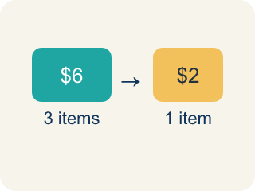
Rate (Tasa) — A ratio comparing two amounts with different units, like miles per hour.
Unit rate (Tasa unitaria) — A rate for just 1 of something, like cost for 1 item.
Per (Por) — For each one. Example: 5 dollars per book.
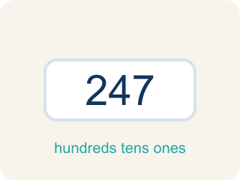
Problem solving (Resolución de problemas) — Using ratios and rates to find a missing amount.
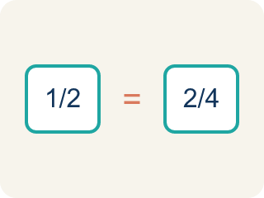
Proportion (Proporción) — A math sentence saying two ratios are equal. It helps find a missing number.

Practice
Show your work. Use the blank space under each problem.
1. A bakery makes 24 cookies in 3 batches. What is the unit rate of cookies per batch?
A. 8 cookies per batch
B. 3 cookies per batch
C. 24 cookies per batch
D. 6 cookies per batch
______________________________________________________________________
2. Apples cost $5 for 4 pounds. What is the cost per pound?
A. $1.25
B. $0.80
C. $1.50
D. $4.00
______________________________________________________________________
3. Team 2 frosts 5 cupcakes every 4 minutes. Complete the ratio table to find how many cupcakes they can frost in different times.
Minutes | Cupcakes Frosted
4 | 5
8
12
20
______________________________________________________________________
4. A car travels 150 miles in 3 hours. A bus travels 200 miles in 5 hours. Which vehicle is faster?
A. The car
B. The bus
C. Same speed
D. Cannot determine
______________________________________________________________________
5. Sort each rate problem by the strategy that works BEST to solve it.
Groups: Use Unit Rate | Use Ratio Table / Proportion
• Find cost per pound when 5 lb costs $12 → __________________
• If 3 shirts cost $24, find cost of 9 shirts → __________________
• A car goes 55 mph — how far in 4 hours? → __________________
• Scale a recipe from 4 servings to 20 servings → __________________
______________________________________________________________________
6. onLevel — Spot the Common Mistake
Step 1 (Read): A student is working on Ratio and Rate Problem Solving.
Step 2 (Attempt): They ignored the rule: Find the unit rate by dividing, then multiply it to find the amount you need.
Step 3 (Check): The answer does not match the math rule from class.
Which step has the mistake? Explain and fix it:
______________________________________________________________________
______________________________________________________________________
______________________________________________________________________
7. In the kitchen, 3 pizzas feed exactly 12 people. At the same rate, how many pizzas are needed to feed 20 people?
A. 5 pizzas
B. 4 pizzas
C. 6 pizzas
D. 8 pizzas
______________________________________________________________________
8. A line cook chops 8 carrots in 2 minutes. Working at the same steady rate, how many carrots can the cook chop in 7 minutes?
A. 28 carrots
B. 24 carrots
C. 32 carrots
D. 16 carrots
______________________________________________________________________
9. Match each kitchen rate to its correct unit rate. Decide what is being compared first.
Item | Answer choices
____ 24 cups of soup poured into 6 bowls | D. 15 ounces per jar
____ 30 dumplings served on 5 plates | C. 5 minutes per cake
____ Baking 9 cakes takes 45 minutes | B. 6 dumplings per plate
____ 60 ounces of sauce split into 4 jars | A. 4 cups per bowl
______________________________________________________________________
10. Level 2 Extension — Mixed review: A recipe uses 18 ounces of flour to make 3 loaves of bread. How many ounces of flour are needed to make 7 loaves at the same rate?
A. 42 ounces
B. 36 ounces
C. 48 ounces
D. 21 ounces
______________________________________________________________________

Answer Key (Teacher)
1. A. 8 cookies per batch
Unit rate: 24 cookies ÷ 3 batches = 8 cookies per batch.
Watch for: A common mistake in Ratio and Rate Problem Solving is skipping the key idea: "Find the unit rate by dividing, then multiply it to find the amount you need." — always check your work against this rule before you submit.
2. A. $1.25
Unit rate: $5 ÷ 4 pounds = $1.25 per pound.
Watch for: A common mistake in Ratio and Rate Problem Solving is skipping the key idea: "Find the unit rate by dividing, then multiply it to find the amount you need." — always check your work against this rule before you submit.
3. Team 2 frosts 5 cupcakes every 4 minutes. Complete the ratio table to find how many cupcakes they can frost in different times.
8 — Cupcakes Frosted: 10
12 — Cupcakes Frosted: 15
20 — Cupcakes Frosted: 25

4. A. The car
Car: 150÷3 = 50 mph. Bus: 200÷5 = 40 mph. The car travels faster at 50 mph vs. 40 mph.
Watch for: A common mistake in Ratio and Rate Problem Solving is skipping the key idea: "Find the unit rate by dividing, then multiply it to find the amount you need." — always check your work against this rule before you submit.
5. Correct groups:
Find cost per pound when 5 lb costs $12 → Use Unit Rate
If 3 shirts cost $24, find cost of 9 shirts → Use Ratio Table / Proportion
A car goes 55 mph — how far in 4 hours? → Use Unit Rate
Scale a recipe from 4 servings to 20 servings → Use Ratio Table / Proportion

6. onLevel — Spot the Common Mistake
The mistake is in Step 2.
Correct work: Follow the key idea: Find the unit rate by dividing, then multiply it to find the amount you need.
7. A. 5 pizzas
First find the unit rate: 12 people ÷ 3 pizzas = 4 people per pizza. Then 20 people ÷ 4 people per pizza = 5 pizzas.
Watch for: A common mistake in Ratio and Rate Problem Solving is skipping the key idea: "Find the unit rate by dividing, then multiply it to find the amount you need." — always check your work against this rule before you submit.
8. A. 28 carrots
Unit rate: 8 carrots ÷ 2 minutes = 4 carrots per minute. In 7 minutes: 4 × 7 = 28 carrots.
Watch for: A common mistake in Ratio and Rate Problem Solving is skipping the key idea: "Find the unit rate by dividing, then multiply it to find the amount you need." — always check your work against this rule before you submit.
9. Matches:
24 cups of soup poured into 6 bowls → 4 cups per bowl
30 dumplings served on 5 plates → 6 dumplings per plate
Baking 9 cakes takes 45 minutes → 5 minutes per cake
60 ounces of sauce split into 4 jars → 15 ounces per jar

10. A. 42 ounces
Unit rate: 18 ounces ÷ 3 loaves = 6 ounces per loaf. For 7 loaves: 6 × 7 = 42 ounces. The equivalent ratio 18/3 = 42/7 confirms it.
Watch for: A common mistake in Ratio and Rate Problem Solving is skipping the key idea: "Find the unit rate by dividing, then multiply it to find the amount you need." — always check your work against this rule before you submit.

