Rates and Unit Rates — Homework
Lesson 4-1-flagship • Standard 6.AT.2
Name: ______________________ Period: ______ Date: ____________

Today's Goals
Content: I can find a unit rate to compare prices and decide the better buy.
Language: I can explain my choice using the words rate, unit rate, per, and better buy.

Key Words
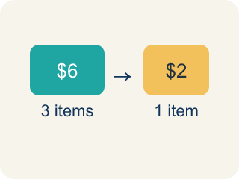
Rate (Tasa) — A ratio comparing two amounts with different units, like miles per hour.
Unit Rate (Tasa unitaria) — A rate for just 1 of something, like cost for 1 item.
Per (Por) — For each one. Example: 5 dollars per book.
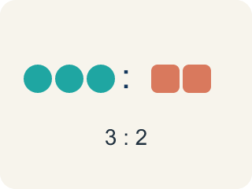
Ratio (Razón) — A way to compare two amounts.
Better Buy (Mejor compra) — The choice that costs less for each item.
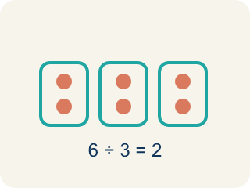
Divide (Dividir) — Splitting a total into equal groups.

Practice
Show your work. Use the blank space under each problem.
1. A booth charges $4.50 for 9 games. What is the unit rate?
A. $0.50 per game
B. $0.45 per game
C. $2.00 per game
D. $4.50 per game
______________________________________________________________________
2. A car travels 180 miles using 6 gallons of gas. What is the unit rate in miles per gallon?
A. 30 miles per gallon
B. 6 miles per gallon
C. 180 miles per gallon
D. 36 miles per gallon
______________________________________________________________________
3. Complete the table to find unit rates and determine the best deal.
Deal | Quantity | Cost | Unit Rate
Tokens Pack A | 20 tokens | $5.00
Tokens Pack B | 35 tokens | $7.00
Tokens Pack C | 50 tokens | $12.50
______________________________________________________________________
4. Which token pack from the table above is the best deal?
A. Pack A
B. Pack B
C. Pack C
D. They are all the same
______________________________________________________________________
5. Sort each situation by whether the unit rate is 'per item' or 'per time'.
Groups: Rate Per Item | Rate Per Time
• $3 per pound of apples → __________________
• 60 miles per hour → __________________
• $0.25 per token → __________________
• 15 pages per minute → __________________
• $1.50 per bottle → __________________
• 8 laps per hour → __________________
______________________________________________________________________
6. Runner A completes 4 laps in 12 minutes. Runner B completes 5 laps in 14 minutes. Who runs more laps per minute?
A. Runner B
B. Runner A
C. Same rate
D. Cannot determine
______________________________________________________________________
7. onLevel — Spot the Common Mistake
Step 1 (Read): A student is working on Rates and Unit Rates.
Step 2 (Attempt): They ignored the rule: To find a unit rate, divide the total cost by the number of items. The lower cost per item is the better buy.
Step 3 (Check): The answer does not match the math rule from class.
Which step has the mistake? Explain and fix it:
______________________________________________________________________
______________________________________________________________________
______________________________________________________________________
8. Lock 1 — Star Blaster Station: The high-score machine flashes '120 points in 4 minutes'. What is the unit rate in points per minute?
A. 30 points per minute
B. 24 points per minute
C. 40 points per minute
D. 16 points per minute
______________________________________________________________________
9. Lock 2 — Speed Door: Two racing games unlock the door. Pixel Racer scores 250 points in 5 minutes. Turbo Drift scores 180 points in 4 minutes. Which game earns points at the faster rate?
A. Pixel Racer (50 points per minute)
B. Turbo Drift (50 points per minute)
C. Pixel Racer (45 points per minute)
D. They earn points at the same rate
______________________________________________________________________
10. Lock 3 — Claw Machine Vault: Three coin deals glow on the screen. Which deal is the best value (lowest cost per play)?
A. $5.00 for 10 plays
B. $6.00 for 8 plays
C. $9.00 for 12 plays
D. $7.00 for 10 plays
______________________________________________________________________

Answer Key (Teacher)
1. A. $0.50 per game
$4.50 ÷ 9 = $0.50 per game.
Watch for: A common mistake in Rates and Unit Rates is skipping the key idea: "To find a unit rate, divide the total cost by the number of items. The lower cost per item is the better buy." — always check your work against this rule before you submit.
2. A. 30 miles per gallon
180 miles ÷ 6 gallons = 30 miles per gallon.
Watch for: A common mistake in Rates and Unit Rates is skipping the key idea: "To find a unit rate, divide the total cost by the number of items. The lower cost per item is the better buy." — always check your work against this rule before you submit.
3. Complete the table to find unit rates and determine the best deal.
Tokens Pack A — Unit Rate: $0.25 per token
Tokens Pack B — Unit Rate: $0.20 per token
Tokens Pack C — Unit Rate: $0.25 per token

4. B. Pack B
Pack B has a unit rate of $0.20 per token, which is the lowest cost per token.
Watch for: A common mistake in Rates and Unit Rates is skipping the key idea: "To find a unit rate, divide the total cost by the number of items. The lower cost per item is the better buy." — always check your work against this rule before you submit.
5. Correct groups:
$3 per pound of apples → Rate Per Item
60 miles per hour → Rate Per Time
$0.25 per token → Rate Per Item
15 pages per minute → Rate Per Time
$1.50 per bottle → Rate Per Item
8 laps per hour → Rate Per Time

6. A. Runner B
Runner A: 4÷12 ≈ 0.33 laps/min. Runner B: 5÷14 ≈ 0.36 laps/min. Runner B runs slightly more laps per minute.
Watch for: A common mistake in Rates and Unit Rates is skipping the key idea: "To find a unit rate, divide the total cost by the number of items. The lower cost per item is the better buy." — always check your work against this rule before you submit.
7. onLevel — Spot the Common Mistake
The mistake is in Step 2.
Correct work: Follow the key idea: To find a unit rate, divide the total cost by the number of items. The lower cost per item is the better buy.
8. A. 30 points per minute
Divide points by minutes: 120 ÷ 4 = 30 points per minute.
Watch for: A common mistake in Rates and Unit Rates is skipping the key idea: "To find a unit rate, divide the total cost by the number of items. The lower cost per item is the better buy." — always check your work against this rule before you submit.
9. A. Pixel Racer (50 points per minute)
Pixel Racer: 250 ÷ 5 = 50 points per minute. Turbo Drift: 180 ÷ 4 = 45 points per minute. 50 > 45, so Pixel Racer is faster.
Watch for: A common mistake in Rates and Unit Rates is skipping the key idea: "To find a unit rate, divide the total cost by the number of items. The lower cost per item is the better buy." — always check your work against this rule before you submit.
10. A. $5.00 for 10 plays
$5.00 ÷ 10 = $0.50 per play; $6.00 ÷ 8 = $0.75 per play; $9.00 ÷ 12 = $0.75 per play; $7.00 ÷ 10 = $0.70 per play. The lowest unit rate, $0.50 per play, is the best value.
Watch for: A common mistake in Rates and Unit Rates is skipping the key idea: "To find a unit rate, divide the total cost by the number of items. The lower cost per item is the better buy." — always check your work against this rule before you submit.

