Relate Fractions, Decimals, and Percents — Homework
Lesson 4-2 • Standard 6.AT.4
Name: ______________________ Period: ______ Date: ____________

Today's Goals
Content: I can write equivalent fractions, decimals, and percents for the same value.
Language: I can explain my conversions using the words percent, decimal, equivalent, and benchmark.

Key Words
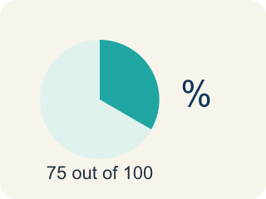
Percent (Porcentaje) — A way to compare a number to 100, shown with the % sign.
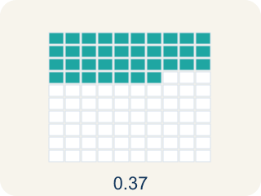
Decimal (Decimal) — A number with a dot, like 0.5, that shows a part.
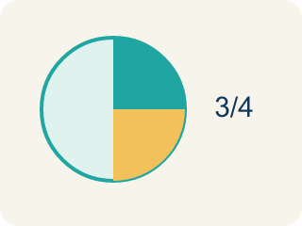
Equivalent (Equivalente) — Having the same value, just written a different way.
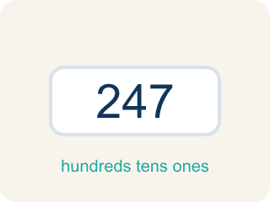
Benchmark (Referencia) — A familiar number you use to guess, like 50% or 1/2.
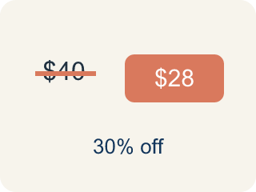
Discount (Descuento) — Money taken off the first price to make it cheaper.

Practice
Show your work. Use the blank space under each problem.
1. Sort these values — which are greater than 50% and which are less than 50%?
Groups: Greater than 50% | Less than 50%
• 3/4 → __________________
• 0.8 → __________________
• 65% → __________________
• 7/10 → __________________
• 1/3 → __________________
• 0.25 → __________________
• 40% → __________________
• 2/5 → __________________
______________________________________________________________________
2. Convert 3/5 to a percent.
A. 60%
B. 35%
C. 53%
D. 65%
______________________________________________________________________
3. A game shows your score as 7/8 complete. What percent is that?
A. 87.5%
B. 78%
C. 75%
D. 88%
______________________________________________________________________
4. Complete each row by converting to all three forms.
Fraction | Decimal | Percent
2/5
 | 0.125
 |  | 90%
5/8
______________________________________________________________________
5. Order these values from least to greatest by sorting them into the correct position.
Groups: 1st (Smallest) | 2nd | 3rd | 4th | 5th (Largest)
• 1/5 (= 0.20) → __________________
• 0.35 → __________________
• 2/5 (= 0.40) → __________________
• 55% → __________________
• 3/4 (= 0.75) → __________________
______________________________________________________________________
6. onLevel — Spot the Common Mistake
Step 1 (Read): A student is working on Relate Fractions, Decimals, and Percents.
Step 2 (Attempt): They ignored the rule: To turn a fraction into a percent, divide the top by the bottom to get a decimal, then multiply by 100.
Step 3 (Check): The answer does not match the math rule from class.
Which step has the mistake? Explain and fix it:
______________________________________________________________________
______________________________________________________________________
______________________________________________________________________
7. Your arcade scoreboard reads 0.25 of the level cleared. What percent and fraction match this score?
A. 25% and 1/4
B. 2.5% and 1/4
C. 25% and 1/5
D. 250% and 1/40
______________________________________________________________________
8. A player powered up 3/5 of the energy bar. Which decimal and percent name the same amount?
A. 0.6 and 60%
B. 0.35 and 35%
C. 0.6 and 6%
D. 0.65 and 65%
______________________________________________________________________
9. Match each arcade score tile to its equal fraction, decimal, and percent.
Item | Answer choices
____ 4/5 | D. 0.25 = 25%
____ 9/10 | C. 0.5 = 50%
____ 1/2 | B. 0.9 = 90%
____ 1/4 | A. 0.8 = 80%
______________________________________________________________________
10. Sort each arcade tile into the form it is already written in.
Groups: Fraction tiles | Decimal tiles | Percent tiles
• 2/5 → __________________
• 7/10 → __________________
• 0.3 → __________________
• 0.85 → __________________
• 70% → __________________
• 15% → __________________
______________________________________________________________________

Answer Key (Teacher)
1. Correct groups:
3/4 → Greater than 50%
0.8 → Greater than 50%
65% → Greater than 50%
7/10 → Greater than 50%
1/3 → Less than 50%
0.25 → Less than 50%
40% → Less than 50%
2/5 → Less than 50%

2. A. 60%
3 ÷ 5 = 0.6 = 60%.
Watch for: A common mistake in Relate Fractions, Decimals, and Percents is skipping the key idea: "To turn a fraction into a percent, divide the top by the bottom to get a decimal, then multiply by 100." — always check your work against this rule before you submit.
3. A. 87.5%
7 ÷ 8 = 0.875, and 0.875 × 100 = 87.5%.
Watch for: A common mistake in Relate Fractions, Decimals, and Percents is skipping the key idea: "To turn a fraction into a percent, divide the top by the bottom to get a decimal, then multiply by 100." — always check your work against this rule before you submit.
4. Complete each row by converting to all three forms.
2/5 — Decimal: 0.4
2/5 — Percent: 40%
Row 2 — Fraction: 1/8
Row 2 — Percent: 12.5%
Row 3 — Fraction: 9/10
Row 3 — Decimal: 0.9
5/8 — Decimal: 0.625
5/8 — Percent: 62.5%

5. Correct groups:
1/5 (= 0.20) → 1st (Smallest)
0.35 → 2nd
2/5 (= 0.40) → 3rd
55% → 4th
3/4 (= 0.75) → 5th (Largest)

6. onLevel — Spot the Common Mistake
The mistake is in Step 2.
Correct work: Follow the key idea: To turn a fraction into a percent, divide the top by the bottom to get a decimal, then multiply by 100.
7. A. 25% and 1/4
Move the decimal two places: 0.25 = 25%. As a fraction, 0.25 = 25/100 = 1/4.
Watch for: A common mistake in Relate Fractions, Decimals, and Percents is skipping the key idea: "To turn a fraction into a percent, divide the top by the bottom to get a decimal, then multiply by 100." — always check your work against this rule before you submit.
8. A. 0.6 and 60%
Divide 3 ÷ 5 = 0.6, then multiply by 100: 0.6 = 60%. So 3/5 = 0.6 = 60%.
Watch for: A common mistake in Relate Fractions, Decimals, and Percents is skipping the key idea: "To turn a fraction into a percent, divide the top by the bottom to get a decimal, then multiply by 100." — always check your work against this rule before you submit.
9. Matches:
4/5 → 0.8 = 80%
9/10 → 0.9 = 90%
1/2 → 0.5 = 50%
1/4 → 0.25 = 25%

10. Correct groups:
2/5 → Fraction tiles
7/10 → Fraction tiles
0.3 → Decimal tiles
0.85 → Decimal tiles
70% → Percent tiles
15% → Percent tiles

