UNIT 4 · LESSON 3 STANDARD 6.RP.3C

Percents Greater Than 100% and Less Than 1%
Student Notes Packet
Name: ______________________ Date: ____________ Period: ________

Today's Goals
Content: I can write and interpret percents greater than 100% and less than 1%.
Language: I can explain my reasoning using the words percent, greater than 100%, less than 1%, and equivalent.

Key Vocabulary
Look at the picture, read the word, then read what it means.
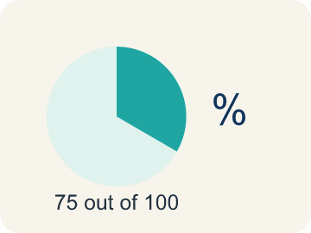 | Percent Porcentaje  A way to compare a number to 100, shown with the % sign.  Example: 45% means 45 out of 100
Greater than 100% Mayor que 100%
A percent bigger than 100%, more than the whole thing.
Example: 150% means 1.5 times the whole
Less than 1% Menor que 1%
A percent smaller than 1%, a very tiny part.
Example: 0.5% of 1,000 = only 5 items — a tiny sliver
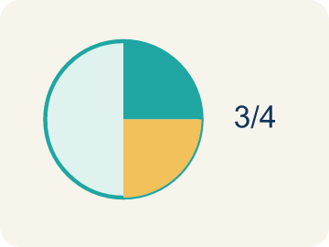 | Equivalent Equivalente  Having the same value, just written a different way.  Example: 150% = 1.5 = 3/2
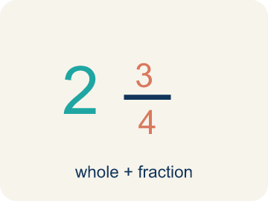 | Mixed number Número mixto  A whole number plus a fraction, like 1 1/2.  Example: 150% = 1 and 1/2 = 1.5

Guided Notes
Fill in each blank as we go. Use the Word Bank to help you.
WORD BANK
Percent • Greater than 100% • Less than 1% • Equivalent • Mixed number

1. A number out of 100, written with a % sign, is a ___.
2. A percent that represents more than one whole, like 150%, is ___.
3. A percent smaller than one out of a hundred, like 0.5%, is ___.
4. Values that name the same amount, like 0.5% and 0.005, are ___.
5. A number with a whole part and a fraction part, like 1 1/2, is a ___.

Worked Example

Watch & Read I Do — follow along with your teacher
Arcade Builder Challenge
The arcade just posted its monthly leaderboard! Some players crushed the target score — one player hit 150% of the goal! Meanwhile, a rare bonus round gives only a 0.5% point boost. You need to understand what these unusual percents really mean to read the leaderboard correctly.

Think about:
• What does it mean when a score is shown as 150% of the target?
• Can a percent be less than 1%? What would that look like?
• How do you write a percent greater than 100% as a decimal or fraction?
• When would you see a percent less than 1% in real life?

Solved Example I Do — watch each step
Problem: Which of the following is greater than 100%?
A) 0.75
B) 3/4
C) 1.25
D) 99/100
Step 1: 1.25 = 125%, which is greater than 100%.
Step 2: The other values are all less than 1 (less than 100%).
Answer: C. 1.25

Guided Practice

Solve Together We Do — work with your class
Problem: What is 200% written as a decimal?
A) 2.0
B) 0.2
C) 20.0
D) 0.02
Step 1:

Step 2:

Answer:

An arcade machine has a jackpot that pays out 250% of your tokens if you win. You inserted 40 tokens. Your friend says the jackpot is 100 tokens. Another friend says it's 60 tokens.
Who is correct, and how many tokens does the jackpot pay?

Sentence frame: The friend who said ___ tokens is correct because 250% of 40 = ___ × 40 = ___. The other friend found ___% of 40 instead.

Turn & Talk discuss with a partner
1. [Launch] The leaderboard shows one player hit 150% of the goal and a bonus round gives a 0.5% boost. How can a percent be more than the whole, and how can one be a tiny sliver?
Start with: ___% means ___ because it is more / less than 100%.
___% significa ___ porque es más / menos que 100%.
Word bank: percent, greater than 100%, less than 1%, equivalent
2. [Explore] When you wrote percents like 150% and 0.5% as decimals, what did you notice about their size compared to 1?
Start with: 150% as a decimal is ___ because ___.
150% como decimal es ___ porque ___.
Word bank: percent, equivalent, greater than 100%, less than 1%, mixed number
3. [Connect] A jackpot pays 250% of your tokens and you inserted 40 tokens. One friend says 100 tokens, another says 60. Who is right, and why does '250%' mean more than your tokens?
Start with: The friend who said ___ tokens is correct because 250% = ___ times the whole.
El amigo que dijo ___ fichas tiene razón porque 250% = ___ veces el entero.
Word bank: percent, greater than 100%, equivalent, mixed number
4. [Practice] During practice on Percents Greater Than 100% and Less Than 1%, what strategy did you use when a problem felt tricky?
Start with: 150% as a decimal is ___ because ___.
150% como decimal es ___ porque ___.
Word bank: Percent, Greater than 100%, Less than 1%, Equivalent

Independent Practice

On Your Own You Do — show your work
Solve each problem. Show your thinking in the work box.
1. What is 0.5% written as a decimal?
A) 0.005
B) 0.05
C) 0.5
D) 5.0

2. Which percent is less than 1%?
A) 0.75%
B) 7.5%
C) 75%
D) 1.5%

3. A player scored 0.4% of the bonus points. Which decimal represents this percent?
A) 0.4
B) 0.04
C) 0.004
D) 4.0

4. A power-up boosts your damage to 150% of normal. Written as a decimal and a fraction, 150% equals:
A) 1.5 = 3/2
B) 0.15 = 3/20
C) 15 = 15/1
D) 0.015 = 3/200

Exit Ticket
Answer on your own. This shows what you learned today.
★ Which statement is true about 0.25%?
A) It equals 0.0025 as a decimal
B) It equals 0.25 as a decimal
C) It equals 1/4 as a fraction
D) It is greater than 1%

