Percents Greater Than 100% and Less Than 1% — Homework
Lesson 4-3 • Standard 6.AT.4
Name: ______________________ Period: ______ Date: ____________

Today's Goals
Content: I can write and interpret percents greater than 100% and less than 1%.
Language: I can explain my reasoning using the words percent, greater than 100%, less than 1%, and equivalent.

Key Words
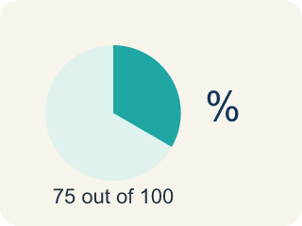
Percent (Porcentaje) — A way to compare a number to 100, shown with the % sign.
Greater than 100% (Mayor que 100%) — A percent bigger than 100%, more than the whole thing.
Less than 1% (Menor que 1%) — A percent smaller than 1%, a very tiny part.
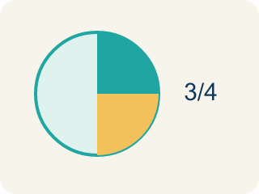
Equivalent (Equivalente) — Having the same value, just written a different way.
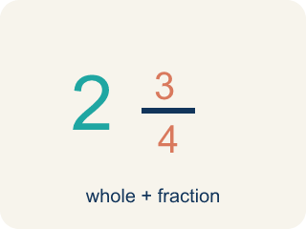
Mixed number (Número mixto) — A whole number plus a fraction, like 1 1/2.

Practice
Show your work. Use the blank space under each problem.
1. Which of the following is greater than 100%?
A. 0.75
B. 3/4
C. 1.25
D. 99/100
______________________________________________________________________
2. What is 200% written as a decimal?
A. 2.0
B. 0.2
C. 20.0
D. 0.02
______________________________________________________________________
3. Match each item on the left to its answer on the right.
Item | Answer choices
____ 1.5 | F. 0.5%
____ 0.003 | E. 150%
____ 2.75 | D. 0.8%
____ 0.008 | C. 275%
____ 3/2 | B. 0.3%
____ 1/200 | A. 150%
______________________________________________________________________
4. A player scored 0.4% of the bonus points. Which decimal represents this percent?
A. 0.4
B. 0.04
C. 0.004
D. 4.0
______________________________________________________________________
5. Convert each percent to a decimal and a fraction.
Percent | Decimal | Fraction
150% | 1.5 | 3/2
250%
0.5%
0.25%
______________________________________________________________________
6. onLevel — Spot the Common Mistake
Step 1 (Read): A student is working on Percents Greater Than 100% and Less Than 1%.
Step 2 (Attempt): They ignored the rule: To change any percent to a decimal, divide by 100 (move the decimal point two places to the left).
Step 3 (Check): The answer does not match the math rule from class.
Which step has the mistake? Explain and fix it:
______________________________________________________________________
______________________________________________________________________
______________________________________________________________________
7. Sort each arcade percent into the right bin: is it less than 1%, between 1% and 100%, or greater than 100%?
Groups: Less than 1% | Between 1% and 100% | Greater than 100%
• 0.5% bonus boost → __________________
• 0.1% rare drop chance → __________________
• 0.05% jackpot odds → __________________
• 12% combo bonus → __________________
• 85% battery left → __________________
• 100% goal reached → __________________
• 150% of high score → __________________
• 225% damage power-up → __________________
• 300% token jackpot → __________________
______________________________________________________________________
8. A power-up boosts your damage to 150% of normal. Written as a decimal and a fraction, 150% equals:
A. 1.5 = 3/2
B. 0.15 = 3/20
C. 15 = 15/1
D. 0.015 = 3/200
______________________________________________________________________
9. A rare game item has a 0.5% drop chance. What is 0.5% written as a decimal?
A. 0.005
B. 0.05
C. 0.5
D. 5
______________________________________________________________________
10. Could this really happen? Your phone shows it is charged to 0.5% — about how much of a 4,000 mAh battery is that?
A. About 20 mAh — a tiny sliver, almost empty
B. About 2,000 mAh — half full
C. About 4,200 mAh — more than full
D. About 200 mAh — a quarter full
______________________________________________________________________

Answer Key (Teacher)
1. C. 1.25
1.25 = 125%, which is greater than 100%. The other values are all less than 1 (less than 100%).
Watch for: A common mistake in Percents Greater Than 100% and Less Than 1% is skipping the key idea: "To change any percent to a decimal, divide by 100 (move the decimal point two places to the left)." — always check your work against this rule before you submit.
2. A. 2.0
200% ÷ 100 = 2.0. Percents greater than 100% become decimals greater than 1.
Watch for: A common mistake in Percents Greater Than 100% and Less Than 1% is skipping the key idea: "To change any percent to a decimal, divide by 100 (move the decimal point two places to the left)." — always check your work against this rule before you submit.
3. Matches:
1.5 → 150%
0.003 → 0.3%
2.75 → 275%
0.008 → 0.8%
3/2 → 150%
1/200 → 0.5%

4. C. 0.004
0.4% = 0.4 ÷ 100 = 0.004. Move the decimal point two places to the left.
Watch for: A common mistake in Percents Greater Than 100% and Less Than 1% is skipping the key idea: "To change any percent to a decimal, divide by 100 (move the decimal point two places to the left)." — always check your work against this rule before you submit.
5. Convert each percent to a decimal and a fraction.
250% — Decimal: 2.5
250% — Fraction: 5/2
0.5% — Decimal: 0.005
0.5% — Fraction: 1/200
0.25% — Decimal: 0.0025
0.25% — Fraction: 1/400

6. onLevel — Spot the Common Mistake
The mistake is in Step 2.
Correct work: Follow the key idea: To change any percent to a decimal, divide by 100 (move the decimal point two places to the left).
7. Correct groups:
0.5% bonus boost → Less than 1%
0.1% rare drop chance → Less than 1%
0.05% jackpot odds → Less than 1%
12% combo bonus → Between 1% and 100%
85% battery left → Between 1% and 100%
100% goal reached → Between 1% and 100%
150% of high score → Greater than 100%
225% damage power-up → Greater than 100%
300% token jackpot → Greater than 100%

8. A. 1.5 = 3/2
150% = 150 ÷ 100 = 1.5, and 150/100 simplifies to 3/2. It is more than one whole, so the decimal is greater than 1.
Watch for: A common mistake in Percents Greater Than 100% and Less Than 1% is skipping the key idea: "To change any percent to a decimal, divide by 100 (move the decimal point two places to the left)." — always check your work against this rule before you submit.
9. A. 0.005
0.5% = 0.5 ÷ 100 = 0.005. Because it is less than 1%, the decimal must be less than 0.01.
Watch for: A common mistake in Percents Greater Than 100% and Less Than 1% is skipping the key idea: "To change any percent to a decimal, divide by 100 (move the decimal point two places to the left)." — always check your work against this rule before you submit.
10. A. About 20 mAh — a tiny sliver, almost empty
0.5% = 0.005, and 0.005 × 4,000 = 20 mAh. A percent less than 1% is a tiny part, so the phone is nearly dead.
Watch for: A common mistake in Percents Greater Than 100% and Less Than 1% is skipping the key idea: "To change any percent to a decimal, divide by 100 (move the decimal point two places to the left)." — always check your work against this rule before you submit.

