Find the Percent of a Number — Homework
Lesson 4-4 • Standard 6.AT.4
Name: ______________________ Period: ______ Date: ____________

Today's Goals
Content: I can find the percent of a number using an equation or a model.
Language: I can explain my steps using the words percent, base, part, and equation.

Key Words
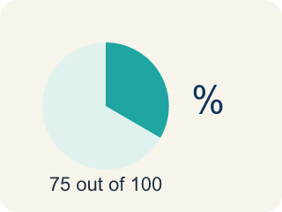
Percent (Porcentaje) — A way to compare a number to 100, shown with the % sign.
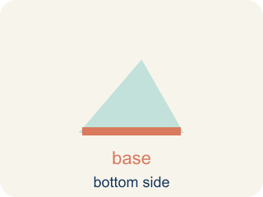
Base (Base (el todo)) — The whole amount you take a percent of.
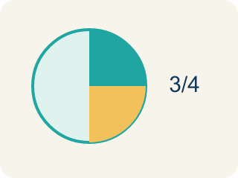
Part (Parte) — The piece you get when you take a percent of a number.
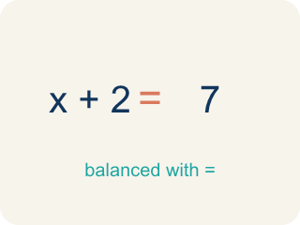
Equation (Ecuación) — A math sentence with an equal sign showing both sides are the same.
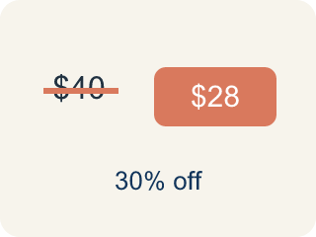
Discount (Descuento) — Money taken off the first price to make it cheaper.

Practice
Show your work. Use the blank space under each problem.
1. What is 20% of 150?
A. 30
B. 20
C. 35
D. 75
______________________________________________________________________
2. What is 50% of 84?
A. 42
B. 50
C. 34
D. 168
______________________________________________________________________
3. Complete each row to find the percent of a number.
Percent | Base | Part
10% | 250
75% | 120
35% | 200
8% | 50
______________________________________________________________________
4. An arcade prize costs 240 tickets. If you have a coupon for 15% off, how many tickets do you save?
A. 36 tickets
B. 24 tickets
C. 15 tickets
D. 204 tickets
______________________________________________________________________
5. A student scored 72 out of 90 on a test. What percent did they score?
A. 80%
B. 72%
C. 75%
D. 90%
______________________________________________________________________
6. onLevel — Spot the Common Mistake
Step 1 (Read): A student is working on Find the Percent of a Number.
Step 2 (Attempt): They ignored the rule: To find the part, change the percent to a decimal, then multiply: part = percent × base.
Step 3 (Check): The answer does not match the math rule from class.
Which step has the mistake? Explain and fix it:
______________________________________________________________________
______________________________________________________________________
______________________________________________________________________
7. The claw machine prize is 80 tickets and today it is 25% off. How many tickets do you save?
A. 20
B. 25
C. 55
D. 16
______________________________________________________________________
8. Your bowling score was 60 points. The bonus round adds 15% more points. How many bonus points is that?
A. 9
B. 15
C. 45
D. 75
______________________________________________________________________
9. A snack at the arcade costs $40. The sales tax is 5%. How many dollars is the tax?
A. $2
B. $5
C. $8
D. $20
______________________________________________________________________
10. Match each percent-of-a-number tip to its result.
Item | Answer choices
____ 20% of 70 | D. 60
____ 50% of 46 | C. 9
____ 10% of 90 | B. 23
____ 30% of 200 | A. 14
______________________________________________________________________

Answer Key (Teacher)
1. A. 30
20% = 0.20. Multiply: 0.20 × 150 = 30.
Watch for: A common mistake in Find the Percent of a Number is skipping the key idea: "To find the part, change the percent to a decimal, then multiply: part = percent × base." — always check your work against this rule before you submit.
2. A. 42
50% = 0.50. Multiply: 0.50 × 84 = 42. (Or simply divide by 2: 84 ÷ 2 = 42.)
Watch for: A common mistake in Find the Percent of a Number is skipping the key idea: "To find the part, change the percent to a decimal, then multiply: part = percent × base." — always check your work against this rule before you submit.
3. Complete each row to find the percent of a number.
10% — Part: 25
75% — Part: 90
35% — Part: 70
8% — Part: 4

4. A. 36 tickets
15% of 240 = 0.15 × 240 = 36 tickets saved.
Watch for: A common mistake in Find the Percent of a Number is skipping the key idea: "To find the part, change the percent to a decimal, then multiply: part = percent × base." — always check your work against this rule before you submit.
5. A. 80%
72 ÷ 90 = 0.80 = 80%.
Watch for: A common mistake in Find the Percent of a Number is skipping the key idea: "To find the part, change the percent to a decimal, then multiply: part = percent × base." — always check your work against this rule before you submit.
6. onLevel — Spot the Common Mistake
The mistake is in Step 2.
Correct work: Follow the key idea: To find the part, change the percent to a decimal, then multiply: part = percent × base.
7. A. 20
25% = 0.25. Multiply: 0.25 × 80 = 20 tickets saved.
Watch for: A common mistake in Find the Percent of a Number is skipping the key idea: "To find the part, change the percent to a decimal, then multiply: part = percent × base." — always check your work against this rule before you submit.
8. A. 9
15% = 0.15. Multiply: 0.15 × 60 = 9 bonus points.
Watch for: A common mistake in Find the Percent of a Number is skipping the key idea: "To find the part, change the percent to a decimal, then multiply: part = percent × base." — always check your work against this rule before you submit.
9. A. $2
5% = 0.05. Multiply: 0.05 × 40 = $2 in tax.
Watch for: A common mistake in Find the Percent of a Number is skipping the key idea: "To find the part, change the percent to a decimal, then multiply: part = percent × base." — always check your work against this rule before you submit.
10. Matches:
20% of 70 → 14
50% of 46 → 23
10% of 90 → 9
30% of 200 → 60

