UNIT 4 · LESSON 7 STANDARD 6.RP.3B

Solve Problems with Unit Rates
Student Notes Packet
Name: ______________________ Date: ____________ Period: ________

Today's Goals
Content: I can solve real-world problems by using unit rates to compare options.
Language: I can explain my comparison using the words unit rate, better buy, per unit, and rate.

Key Vocabulary
Look at the picture, read the word, then read what it means.
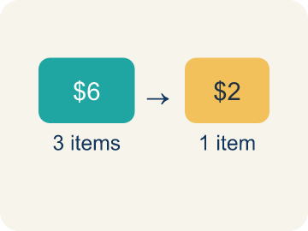 | Unit Rate Tasa unitaria  A rate for just 1 of something, like cost for 1 item.  Example: $2.50 per pound means $2.50 for every 1 pound
Better Buy Mejor compra
The choice that costs less for each item.
Example: $0.10 each vs $0.15 each — the $0.10 option is the better buy
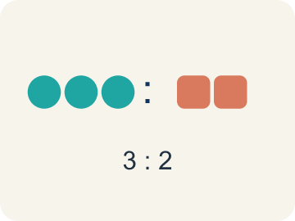 | Comparison Comparación  Looking at numbers to see which is bigger or smaller.  Example: $3 per game < $4 per game
Per Unit Por unidad
For each single item.
Example: $0.50 per token means each token costs $0.50
Rate Tasa
A ratio comparing two amounts with different units, like miles per hour.
Example: 120 miles in 3 hours is a rate (miles and hours are different units)
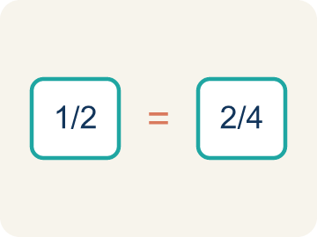 | Proportion Proporción  A math sentence saying two ratios are equal. It helps find a missing number.  Example: 5/3 = x/12 → x = 20

Guided Notes
Fill in each blank as we go. Use the Word Bank to help you.
WORD BANK
Unit Rate • Better Buy • Comparison • Per Unit • Rate • Proportion

1. A rate that gives the amount for exactly one unit is a ___.
2. The option that costs less per item, found by comparing unit rates, is the ___.
3. Showing how two amounts relate to each other is a ___.
4. The cost or amount for a single item is the cost ___.
5. A ratio comparing two quantities with different units is a ___.
6. An equation stating that two ratios are equal is a ___.

Worked Example

Watch & Read I Do — follow along with your teacher
Arcade Builder Challenge
You're the new supply manager for the arcade! You need to order tokens, prizes, and snacks from different suppliers. Each supplier offers a different package deal. Your job is to find the unit rate for each deal and figure out which supplier gives you the best value for every item you need to order.

Think about:
• How can you compare deals when the quantities are different?
• What operation helps you find the cost for just one item?
• Does the biggest package always give the best unit rate?
• How can unit rates help you make smart spending decisions?

Solved Example I Do — watch each step
Problem: Which is the better buy: 6 bouncy balls for $4.50 or 10 bouncy balls for $8.00?
A) 6 for $4.50 — $0.75 each
B) 10 for $8.00 — $0.80 each
C) They cost the same per ball
D) Not enough information
Step 1: $4.50 ÷ 6 = $0.75 each.
Step 2: $8.00 ÷ 10 = $0.80 each.
Step 3: $0.75 < $0.80, so 6 for $4.50 is the better buy.
Answer: A. 6 for $4.50 — $0.75 each

Guided Practice

Solve Together We Do — work with your class
Problem: A faucet drips 15 ounces of water in 5 minutes. What is the unit rate?
A) 3 ounces per minute
B) 5 ounces per minute
C) 15 ounces per minute
D) 0.33 ounces per minute
Step 1:

Step 2:

Step 3:

Answer:

The arcade needs 600 prize tickets printed. Printer A prints 150 tickets in 5 minutes. Printer B prints 200 tickets in 8 minutes. The manager wants to use the faster printer.
Which printer should the manager choose, and how long will it take to print all 600 tickets?

Sentence frame: Printer A prints ___ tickets per minute. Printer B prints ___ tickets per minute. The manager should use Printer ___ because it is faster. It will take ___ minutes to print 600 tickets.

Turn & Talk discuss with a partner
1. [Launch] As supply manager you compare token deals like 500 for $60 and 350 for $38.50. You can't compare totals directly, so what does finding the cost 'per unit' let you do?
Start with: I can't compare the totals because ___.
No puedo comparar los totales porque ___.
Word bank: unit rate, per unit, comparison, rate
2. [Explore] How did the unit rate help you decide the better buy between the two token suppliers in your table?
Start with: The unit rate for ___ is $___ per token.
La tasa unitaria de ___ es $___ por ficha.
Word bank: unit rate, better buy, per unit, comparison, rate
3. [Connect] Printer A makes 150 tickets in 5 minutes and Printer B makes 200 in 8 minutes. The manager needs 600 tickets fast. How do unit rates decide the faster printer and the time needed?
Start with: Printer A prints ___ tickets per minute and Printer B prints ___.
La impresora A imprime ___ boletos por minuto y la B imprime ___.
Word bank: unit rate, rate, per unit, comparison, proportion
4. [Practice] During practice on Solve Problems with Unit Rates, what strategy did you use when a problem felt tricky?
Start with: The unit rate for ___ is $___ per token.
La tasa unitaria de ___ es $___ por ficha.
Word bank: Unit Rate, Better Buy, Comparison, Per Unit

Independent Practice

On Your Own You Do — show your work
Solve each problem. Show your thinking in the work box.
1. A printer prints 42 pages in 6 minutes. How many pages does it print in 15 minutes at the same rate?
A) 105 pages
B) 90 pages
C) 70 pages
D) 120 pages

2. Store A sells 5 notebooks for $8. Store B sells 3 notebooks for $5.25. Which has the lower price per notebook?
A) Store A ($1.60 each)
B) Store B ($1.75 each)
C) Same price
D) Cannot determine

3. A machine dispenses 24 tokens in 3 minutes. At this rate, how many tokens does it dispense in 10 minutes?
A) 80 tokens
B) 60 tokens
C) 72 tokens
D) 240 tokens

4. A factory produces 360 widgets in 8 hours. At the same rate, how many widgets are produced in a 12-hour shift?
A) 540 widgets
B) 480 widgets
C) 360 widgets
D) 720 widgets

Exit Ticket
Answer on your own. This shows what you learned today.
★ A car travels 195 miles on 6 gallons of gas. What is the unit rate in miles per gallon?
A) 32.5 miles per gallon
B) 33 miles per gallon
C) 30 miles per gallon
D) 1,170 miles per gallon

