Area of Parallelograms — Homework
Lesson 5-1 • Standard 6.GR.1
Name: ______________________ Period: ______ Date: ____________

Today's Goals
Content: I can find the area of a parallelogram using base × height.
Language: I can explain how I found the area using the words base, height, area, and formula.

Key Words
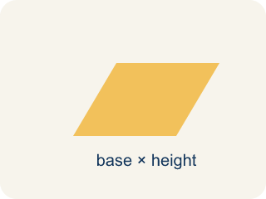
Parallelogram (Paralelogramo) — A four-sided shape with two pairs of parallel sides.
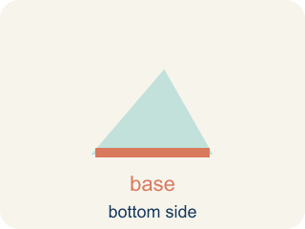
Base (Base) — A side of the shape you use to find the area.
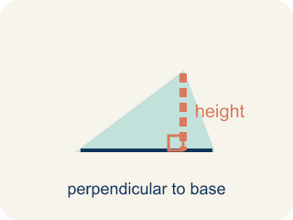
Height (Altura) — The straight-up distance from the base to the top.
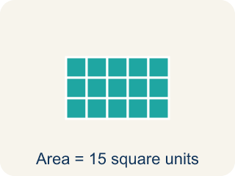
Area (Área) — How much space is inside a flat shape.
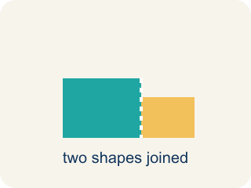
Composite figure (Figura compuesta) — A shape made by putting two or more simple shapes together.
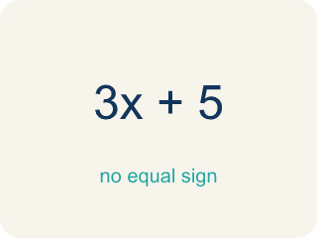
Formula (Fórmula) — A math rule written with symbols.

Practice
Show your work. Use the blank space under each problem.
1. What is the area of a parallelogram with base 10 cm and height 7 cm?
A. 70 sq cm
B. 34 sq cm
C. 17 sq cm
D. 70 cm
______________________________________________________________________
2. A parallelogram has an area of 54 sq ft and a base of 9 ft. What is the height?
A. 6 ft
B. 45 ft
C. 63 ft
D. 27 ft
______________________________________________________________________
3. Complete the table.
Parallelogram | Base | Height | Area
Patio A | 14 ft | 9 ft
Patio B | 8 ft |  | 56 sq ft
Patio C |  | 12 ft | 96 sq ft
Patio D | 15 ft | 6 ft
______________________________________________________________________
4. Match each shape to its area.
Item | Answer choices
____ Triangle 8×6 | F. 18 sq units
____ Parallelogram 5×4 | E. 36 sq units
____ Rectangle 7×3 | D. 40 sq units
____ Triangle 10×8 | C. 21 sq units
____ Square side 6 | B. 20 sq units
____ Parallelogram 9×2 | A. 24 sq units
______________________________________________________________________
5. Sort each parallelogram by whether its area is greater than 50 sq units or 50 or less.
Groups: Area > 50 sq units | Area ≤ 50 sq units
• b = 12, h = 5 → A = 60 → __________________
• b = 7, h = 6 → A = 42 → __________________
• b = 10, h = 8 → A = 80 → __________________
• b = 9, h = 4 → A = 36 → __________________
• b = 11, h = 7 → A = 77 → __________________
• b = 5, h = 10 → A = 50 → __________________
______________________________________________________________________
6. onLevel — Spot the Common Mistake
Step 1 (Read): A student is working on Area of Parallelograms.
Step 2 (Attempt): They ignored the rule: Area of a parallelogram = base × height, where the height is the straight-up (perpendicular) distance, NOT the slanted side.
Step 3 (Check): The answer does not match the math rule from class.
Which step has the mistake? Explain and fix it:
______________________________________________________________________
______________________________________________________________________
______________________________________________________________________
7. In the design lab you cut a triangle off the slanted left end of a parallelogram blueprint and slide it to the right end. What shape do you make, and why does it prove A = base x height?
A. A rectangle with the same base and height, so its area equals base x height
B. A bigger parallelogram, so the area gets larger
C. A triangle, so the area is cut in half
D. A square, so all four sides must be equal
______________________________________________________________________
8. A blueprint parallelogram has a base of 8 ft, a height of 5 ft, and a slanted side of 7 ft. What is its area?
A. 40 sq ft
B. 56 sq ft
C. 35 sq ft
D. 26 sq ft
______________________________________________________________________
9. Each label describes a segment on a parallelogram blueprint. Sort each one into 'Is the height' or 'Is NOT the height'.
Groups: Is the height | Is NOT the height
• A dashed line straight up from the base, making a 90 degree angle → __________________
• The slanted left edge of the parallelogram → __________________
• The perpendicular distance from the base to the top side → __________________
• The long tilted side that connects the bottom to the top → __________________
• The straight-up distance measured at a right angle to the base → __________________
• The leaning side that is longer than the perpendicular gap → __________________
______________________________________________________________________
10. Match each parallelogram's base and height to its correct area (A = base x height).
Item | Answer choices
____ base 6 ft, height 7 ft | D. 60 sq ft
____ base 13 ft, height 2 ft | C. 44 sq ft
____ base 4 ft, height 11 ft | B. 26 sq ft
____ base 15 ft, height 4 ft | A. 42 sq ft
______________________________________________________________________

Answer Key (Teacher)
1. A. 70 sq cm
A = b × h = 10 × 7 = 70 square centimeters.
Watch for: A common mistake in Area of Parallelograms is skipping the key idea: "Area of a parallelogram = base × height, where the height is the straight-up (perpendicular) distance, NOT the slanted side." — always check your work against this rule before you submit.
2. A. 6 ft
A = b × h → 54 = 9 × h → h = 54 ÷ 9 = 6 ft.
Watch for: A common mistake in Area of Parallelograms is skipping the key idea: "Area of a parallelogram = base × height, where the height is the straight-up (perpendicular) distance, NOT the slanted side." — always check your work against this rule before you submit.
3. Table
Patio A — Area: 126 sq ft
Patio B — Height: 7 ft
Patio C — Base: 8 ft
Patio D — Area: 90 sq ft

4. Matches:
Triangle 8×6 → 24 sq units
Parallelogram 5×4 → 20 sq units
Rectangle 7×3 → 21 sq units
Triangle 10×8 → 40 sq units
Square side 6 → 36 sq units
Parallelogram 9×2 → 18 sq units

5. Correct groups:
b = 12, h = 5 → A = 60 → Area > 50 sq units
b = 7, h = 6 → A = 42 → Area ≤ 50 sq units
b = 10, h = 8 → A = 80 → Area > 50 sq units
b = 9, h = 4 → A = 36 → Area ≤ 50 sq units
b = 11, h = 7 → A = 77 → Area > 50 sq units
b = 5, h = 10 → A = 50 → Area ≤ 50 sq units

6. onLevel — Spot the Common Mistake
The mistake is in Step 2.
Correct work: Follow the key idea: Area of a parallelogram = base × height, where the height is the straight-up (perpendicular) distance, NOT the slanted side.
7. A. A rectangle with the same base and height, so its area equals base x height
Sliding the cut triangle turns the parallelogram into a rectangle that keeps the same base and height. A rectangle's area is base x height, so the parallelogram's area is base x height too.
Watch for: A common mistake in Area of Parallelograms is skipping the key idea: "Area of a parallelogram = base × height, where the height is the straight-up (perpendicular) distance, NOT the slanted side." — always check your work against this rule before you submit.
8. A. 40 sq ft
Area = base x height = 8 x 5 = 40 sq ft. The 7 ft slanted side is not used; only the perpendicular height belongs in the formula.
Watch for: A common mistake in Area of Parallelograms is skipping the key idea: "Area of a parallelogram = base × height, where the height is the straight-up (perpendicular) distance, NOT the slanted side." — always check your work against this rule before you submit.
9. Correct groups:
A dashed line straight up from the base, making a 90 degree angle → Is the height
The slanted left edge of the parallelogram → Is NOT the height
The perpendicular distance from the base to the top side → Is the height
The long tilted side that connects the bottom to the top → Is NOT the height
The straight-up distance measured at a right angle to the base → Is the height
The leaning side that is longer than the perpendicular gap → Is NOT the height

10. Matches:
base 6 ft, height 7 ft → 42 sq ft
base 13 ft, height 2 ft → 26 sq ft
base 4 ft, height 11 ft → 44 sq ft
base 15 ft, height 4 ft → 60 sq ft

