UNIT 5 · LESSON 2 STANDARD 6.G.1

Area of Trapezoids
Student Notes Packet
Name: ______________________ Date: ____________ Period: ________

Today's Goals
Content: I can find the area of a trapezoid using the formula A = ½(b1 + b2) × h.
Language: I can explain my steps using the words trapezoid, base, height, and area.

Key Vocabulary
Look at the picture, read the word, then read what it means.
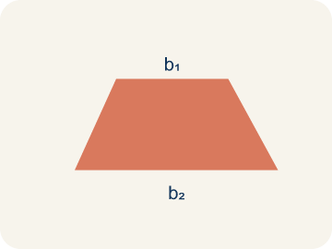 | Trapezoid Trapecio  A four-sided shape with just one pair of parallel sides.  Example: A table top wider than the bottom shelf — the top and bottom edges are parallel, the two sides slant inward
Base 1 (b1) Base 1 (b1)
One of the two parallel sides of a trapezoid.
Example: If the bottom of the trapezoid is 10 ft, then b₁ = 10 ft in the formula A = ½(b₁ + b₂) × h
Base 2 (b2) Base 2 (b2)
The other parallel side of a trapezoid.
Example: If the top of the trapezoid is 6 ft, then b₂ = 6 ft; both bases are parallel to each other
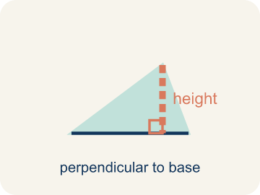 | Height Altura  The straight-up distance between the two parallel sides.  Example: A dashed vertical line from the top base straight down to the bottom base at a 90° angle — NOT the slanted side
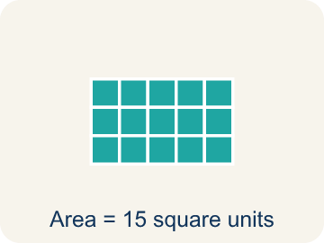 | Area Área  How much space is inside a flat shape.  Example: A trapezoid with b₁ = 10, b₂ = 6, h = 4 has area = ½(10 + 6) × 4 = 32 sq units

Guided Notes
Fill in each blank as we go. Use the Word Bank to help you.
WORD BANK
Trapezoid • Base 1 (b1) • Base 2 (b2) • Height • Area

1. A quadrilateral with exactly one pair of parallel sides is a ___.
2. One of the two parallel sides of a trapezoid is ___.
3. The other parallel side of a trapezoid is ___.
4. The perpendicular distance between the two parallel bases is the ___.
5. The amount of flat space inside the trapezoid is its ___.

Worked Example

Watch & Read I Do — follow along with your teacher
Blueprint Review
Your architecture firm is designing a trapezoidal window for a modern building. The glass supplier charges by the square foot, so the team must calculate the exact area. The window has a top edge of 4 feet, a bottom edge of 8 feet, and a height of 5 feet.

Think about:
• What shape is the window?
• How many parallel sides does it have?
• What measurements are given?
• Why does the formula use two bases instead of one?
• What would happen if both bases were the same length?

Solved Example I Do — watch each step
Problem: What is the area of a trapezoid with bases 6 cm and 10 cm, and height 4 cm?
A) 32 sq cm
B) 64 sq cm
C) 24 sq cm
D) 40 sq cm
Step 1: A = ½ × (b₁ + b₂) × h = ½ × (6 + 10) × 4 = ½ × 16 × 4 = 32 sq cm.
Answer: A. 32 sq cm

Guided Practice

Solve Together We Do — work with your class
Problem: A trapezoid has an area of 45 sq ft, bases of 7 ft and 11 ft. What is the height?
A) 5 ft
B) 9 ft
C) 3 ft
D) 10 ft
Step 1:

Step 2:

Answer:

A builder is pouring concrete for a trapezoidal driveway. The driveway has parallel edges of 20 feet and 12 feet with a height of 15 feet. One bag of concrete covers 6 square feet.
How many bags of concrete does the builder need?

Sentence frame: The driveway's area is ___ sq ft because A = 1/2 x (___ + ___) x ___. He needs ___ bags because ___ / 6 = ___.

Turn & Talk discuss with a partner
1. [Launch] The trapezoidal window has a top edge of 4 feet and a bottom edge of 8 feet. Why does the area formula use BOTH bases instead of just one?
Start with: We use both bases because the top and bottom are ___.
Usamos las dos bases porque la parte de arriba y la de abajo son ___.
Word bank: trapezoid, base 1 (b1), base 2 (b2), height, area
2. [Explore] On the grid you copied the trapezoid (bases 8 and 4, height 5), flipped it, and joined it to the original. What shape formed, and how does that explain the 1/2 in the formula?
Start with: When I flip and join the trapezoid, I make a ___.
Cuando volteo y uno el trapecio, formo un ___.
Word bank: trapezoid, parallelogram, base 1 (b1), base 2 (b2), height
3. [Connect] The builder pours concrete for a trapezoidal driveway with edges of 20 ft and 12 ft and a height of 15 ft; one bag covers 6 sq ft. Walk through finding the number of bags.
Start with: The driveway area is 1/2 times (20 plus 12) times 15, which equals ___ square feet.
El área de la entrada es 1/2 por (20 más 12) por 15, que es ___ pies cuadrados.
Word bank: trapezoid, base 1 (b1), base 2 (b2), height, area
4. [Practice] During practice on Area of Trapezoids, what strategy did you use when a problem felt tricky?
Start with: When I flip and join the trapezoid, I make a ___.
Cuando volteo y uno el trapecio, formo un ___.
Word bank: Trapezoid, Base 1 (b1), Base 2 (b2), Height

Independent Practice

On Your Own You Do — show your work
Solve each problem. Show your thinking in the work box.
1. What is the first step when finding the area of a trapezoid?
A) Add the two bases together
B) Multiply the two bases
C) Subtract the shorter base from the longer base
D) Divide the height by 2

2. A trapezoid has bases of 5 in and 9 in, and a height of 6 in. What is its area?
A) 42 sq in
B) 84 sq in
C) 27 sq in
D) 30 sq in

3. Blueprint 1: A trapezoidal lobby window has bases of 6 ft and 10 ft and a height of 4 ft. What is its area for the glass order?
A) 32 sq ft
B) 40 sq ft
C) 16 sq ft
D) 60 sq ft

4. Blueprint 2: A trapezoidal skylight has bases of 9 ft and 7 ft and a height of 6 ft. What is its area?
A) 48 sq ft
B) 96 sq ft
C) 63 sq ft
D) 44 sq ft

Exit Ticket
Answer on your own. This shows what you learned today.
★ A trapezoid has bases of 9 inches and 5 inches, and a height of 6 inches. What is its area?
A) 42 sq in
B) 84 sq in
C) 27 sq in
D) 42 in

