UNIT 5 · LESSON 3 STANDARD 6.G.1

Area of Triangles (Flagship)
Student Notes Packet
Name: ______________________ Date: ____________ Period: ________

Today's Goals
Content: I can find the area of a triangle using the formula A = ½ × base × height.
Language: I can explain my steps using the words base, height, area, and perpendicular.

Key Vocabulary
Look at the picture, read the word, then read what it means.
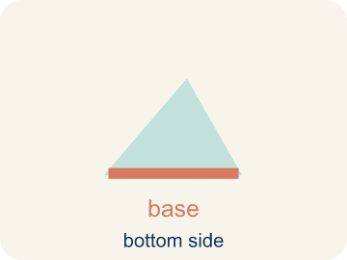 | Base Base  A side of the triangle you use to find the area.  Example: If the bottom of a triangle is 10 cm, then b = 10 cm in the formula A = ½ × b × h
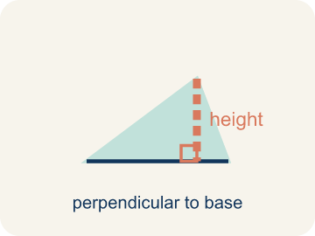 | Height Altura  The straight-up distance from the base to the top corner.  Example: A dashed vertical line from the top point straight down to the base at a 90° angle
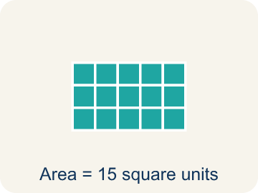 | Area Área  How much space is inside a flat shape.  Example: A triangle with b = 8 and h = 6 has area = ½ × 8 × 6 = 24 sq units
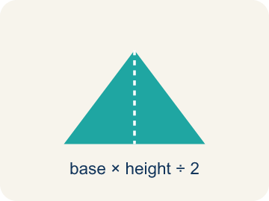 | Perpendicular Perpendicular  Two lines that meet to make a square corner (90 degrees).  Example: The corner of a book or a door frame meets at exactly 90°
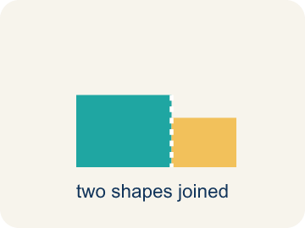 | Composite figure Figura compuesta  A shape made by putting two or more simple shapes together.  Example: A house shape = a rectangle (walls) + a triangle (roof)
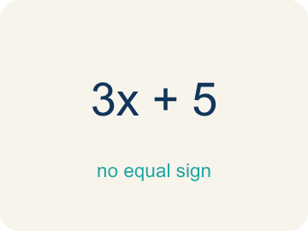 | Formula Fórmula  A math rule written with symbols.  Example: A = ½ × b × h means Area equals one-half times base times height

Guided Notes
Fill in each blank as we go. Use the Word Bank to help you.
WORD BANK
Base • Height • Area • Perpendicular • Composite figure • Formula

1. The side of a triangle used as the bottom for measuring area is the ___.
2. The perpendicular distance from the base to the opposite vertex is the ___.
3. The amount of flat space inside a triangle is its ___.
4. Two lines that meet at a 90° angle are ___.
5. A shape made of two or more basic shapes combined is a ___.
6. A math rule written with symbols, like A = ½ × b × h, is a ___.

Worked Example

Watch & Read I Do — follow along with your teacher
Blueprint Review
Your architecture firm is designing a park with triangular garden beds. The client wants to know exactly how much soil to order, which means calculating the area of each triangular section. The first garden has a base of 12 feet and a height of 8 feet.

Think about:
• What shape are the garden beds?
• What measurements do we need to find the area?
• How is the area of a triangle related to the area of a rectangle?
• Why do we divide by 2 when finding the area of a triangle?
• Does it matter which side we call the base?

Solved Example I Do — watch each step
Problem: What is the area of a triangle with base 10 cm and height 6 cm?
A) 30 sq cm
B) 60 sq cm
C) 16 sq cm
D) 30 cm
Step 1: A = ½ × b × h = ½ × 10 × 6 = 30 square centimeters.
Answer: A. 30 sq cm

Guided Practice

Solve Together We Do — work with your class
Problem: A triangle has an area of 24 sq ft and a base of 8 ft. What is the height?
A) 6 ft
B) 3 ft
C) 16 ft
D) 12 ft
Step 1:

Step 2:

Answer:

A homeowner wants to paint one triangular wall of an A-frame cabin. The wall has a base of 20 feet and a height of 14 feet. One can of paint covers 50 square feet.
How many cans of paint does the homeowner need?

Sentence frame: The wall's area is ___ sq ft because A = 1/2 × ___ × ___. She needs ___ cans because ___ ÷ 50 = ___.

Turn & Talk discuss with a partner
1. [Launch] At the build site you survey a triangular garden bed with a base of 12 feet and a height of 8 feet. Which measurement is the height, and how is it different from the slanted side?
Start with: The height is the ___ distance from the base to the top corner.
La altura es la distancia ___ desde la base hasta la esquina de arriba.
Word bank: base, height, perpendicular, area, formula
2. [Explore] Your triangular panel (base 12, height 8) fits inside a 12 by 8 rectangle. Why do we divide by 2 to find the triangle's area before cutting the glass?
Start with: A triangle is half of a ___ with the same base and height.
Un triángulo es la mitad de un ___ con la misma base y altura.
Word bank: base, height, area, perpendicular, formula
3. [Connect] At the client review, the homeowner paints a triangular A-frame wall with base 20 ft and height 14 ft; one can covers 50 sq ft. Talk through how many cans the budget needs.
Start with: The wall's area is 1/2 times 20 times 14, which equals ___ square feet.
El área de la pared es 1/2 por 20 por 14, que es ___ pies cuadrados.
Word bank: triangle, base, height, area, formula
4. [Practice] During practice on Area of Triangles, what strategy did you use when a problem felt tricky?
Start with: A triangle is half of a ___ with the same base and height.
Un triángulo es la mitad de un ___ con la misma base y altura.
Word bank: Base, Height, Area, Perpendicular

Independent Practice

On Your Own You Do — show your work
Solve each problem. Show your thinking in the work box.
1. What is the area of a triangle with base 14 ft and height 6 ft?
A) 42 sq ft
B) 84 sq ft
C) 20 sq ft
D) 42 ft

2. A triangular window pane has a base of 9 in and a height of 4 in. What is its area?
A) 18 sq in
B) 36 sq in
C) 13 sq in
D) 18 in

3. Which formula gives the area of a triangle with base b and height h?
A) A = ½ × b × h
B) A = b × h
C) A = b + h
D) A = 2 × b × h

4. A triangular sail has an area of 30 sq m and a height of 12 m. What is its base?
A) 5 m
B) 2.5 m
C) 18 m
D) 360 m

Exit Ticket
Answer on your own. This shows what you learned today.
★ A triangle has a base of 11 inches and a height of 8 inches. What is its area?
A) 44 sq in
B) 88 sq in
C) 19 sq in
D) 44 in

