UNIT 5 · LESSON 4 STANDARD 6.G.1

Area of Regular Polygons
Student Notes Packet
Name: ______________________ Date: ____________ Period: ________

Today's Goals
Content: I can find the area of a regular polygon by decomposing it into triangles.
Language: I can explain my steps using the words regular polygon, decompose, triangle, and composite.

Key Vocabulary
Look at the picture, read the word, then read what it means.
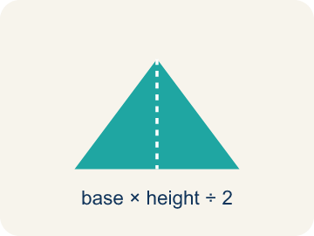 | Regular Polygon Polígono regular  A shape where all sides and all angles are equal.  Example: A stop sign is a regular octagon — all 8 sides are the same length and all 8 angles are equal
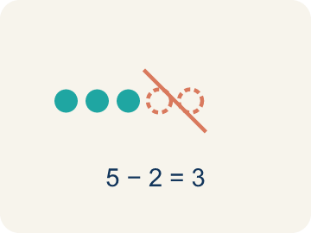 | Decompose Descomponer  To break a shape into smaller, simpler shapes.  Example: Draw lines from the center of a hexagon to each corner → you get 6 equal triangles you can find the area of
Triangle Triángulo
A shape with three sides.
Example: Each triangle inside a decomposed hexagon has a base = one side of the hexagon and height = distance from center to side
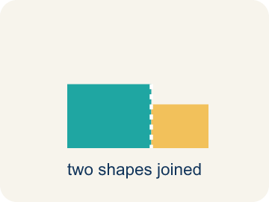 | Composite Compuesto  Made by putting two or more simple shapes together.  Example: 6 triangles, each with area 15 sq ft, combine to form a hexagon with total area = 6 × 15 = 90 sq ft
Composite figure Figura compuesta
A shape made by putting two or more simple shapes together.
Example: A house shape = rectangle (walls) + triangle (roof); find each area, then add them together
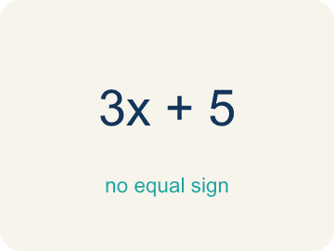 | Formula Fórmula  A math rule written with symbols.  Example: For a regular hexagon: Total Area = 6 × (½ × b × h), where b = side length and h = height of each triangle

Guided Notes
Fill in each blank as we go. Use the Word Bank to help you.
WORD BANK
Regular Polygon • Decompose • Triangle • Composite • Composite figure • Formula

1. A polygon with all sides and all angles equal is a ___.
2. To break a shape into smaller shapes is to ___ it.
3. A three-sided polygon is a ___.
4. Made of two or more shapes combined, a figure is ___.
5. A shape made of two or more basic shapes combined is a ___.
6. A math rule written with symbols is a ___.

Worked Example

Watch & Read I Do — follow along with your teacher
Blueprint Review
Your architecture firm is designing a hexagonal skylight for the lobby of a new museum. The glass fabricator needs to know the total area so they can cut the correct amount of glass. Each side of the hexagon is 6 feet, and the height of each triangle formed from the center is 5.2 feet.

Think about:
• What shape is the skylight?
• How many sides does a hexagon have?
• Can you see smaller shapes inside the hexagon?
• How can we break a hexagon into shapes whose area we already know?
• Does this strategy work for other regular polygons?

Solved Example I Do — watch each step
Problem: A regular hexagon is divided into 6 equal triangles from the center. Each triangle has a base of 6 ft and a height of 5.2 ft. What is the area of one triangle?
A) 15.6 sq ft
B) 31.2 sq ft
C) 11.2 sq ft
D) 15.6 ft
Step 1: A = ½ × b × h = ½ × 6 × 5.2 = 15.6 square feet.
Answer: A. 15.6 sq ft

Guided Practice

Solve Together We Do — work with your class
Problem: Using the triangle from the previous question, what is the total area of the hexagonal skylight?
A) 93.6 sq ft
B) 15.6 sq ft
C) 187.2 sq ft
D) 62.4 sq ft
Step 1:

Step 2:

Answer:

A city planner is building a regular octagonal gazebo in a park. Each of the 8 triangles formed from the center has a base of 5 feet and a height of 6 feet. The flooring costs $3 per square foot.
How much will the gazebo flooring cost?

Sentence frame: One triangle's area is ___ sq ft. The octagon has ___ triangles, so total area = ___ sq ft. The cost is ___ x $3 = $___.

Turn & Talk discuss with a partner
1. [Launch] The hexagonal skylight has sides of 6 feet, and each triangle from the center has a height of 5.2 feet. Why is it helpful to break a hexagon into triangles to find its area?
Start with: We decompose the hexagon into ___ because ___.
Descomponemos el hexágono en ___ porque ___.
Word bank: regular polygon, decompose, triangle, composite, formula
2. [Explore] You matched each regular polygon to its number of center triangles. What pattern connects the number of SIDES to the number of TRIANGLES, and why?
Start with: I split each polygon into ___ triangles.
Dividí cada polígono en ___ triángulos.
Word bank: regular polygon, decompose, triangle, composite, formula
3. [Connect] The octagonal gazebo has 8 center triangles, each with base 5 ft and height 6 ft, and flooring costs $3 per sq ft. Walk through finding the total cost.
Start with: One triangle's area is 1/2 times 5 times 6, which equals ___ square feet.
El área de un triángulo es 1/2 por 5 por 6, que es ___ pies cuadrados.
Word bank: regular polygon, decompose, triangle, composite, formula
4. [Practice] During practice on Area of Regular Polygons, what strategy did you use when a problem felt tricky?
Start with: I split each polygon into ___ triangles.
Dividí cada polígono en ___ triángulos.
Word bank: Regular Polygon, Decompose, Triangle, Composite

Independent Practice

On Your Own You Do — show your work
Solve each problem. Show your thinking in the work box.
1. A regular hexagon is split into 6 triangles, each with base 4 cm and height 3.5 cm. What is the total area?
A) 42 sq cm
B) 21 sq cm
C) 84 sq cm
D) 14 sq cm

2. How many triangles can you make from the center of a regular pentagon?
A) 5
B) 3
C) 6
D) 10

3. A regular hexagonal floor tile splits from its center into 6 congruent triangles, each with an area of 12 cm². What is the total area of the tile?
A) 72 cm²
B) 12 cm²
C) 36 cm²
D) 18 cm²

4. A regular pentagonal tile splits into 5 congruent triangles. Each triangle has a base of 4 in and a height of 6 in. What is the total area of the tile?
A) 60 in²
B) 12 in²
C) 24 in²
D) 120 in²

Exit Ticket
Answer on your own. This shows what you learned today.
★ A regular pentagon is decomposed into 5 triangles from its center. Each triangle has a base of 7 inches and a height of 4.8 inches. What is the total area of the pentagon?
A) 84 sq in
B) 16.8 sq in
C) 168 sq in
D) 84 in

