Area of Regular Polygons — Homework
Lesson 5-4 • Standard 6.GR.1
Name: ______________________ Period: ______ Date: ____________

Today's Goals
Content: I can find the area of a regular polygon by decomposing it into triangles.
Language: I can explain my steps using the words regular polygon, decompose, triangle, and composite.

Key Words
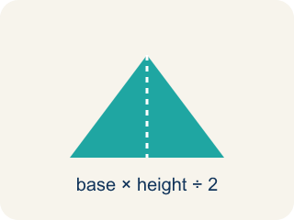
Regular Polygon (Polígono regular) — A shape where all sides and all angles are equal.
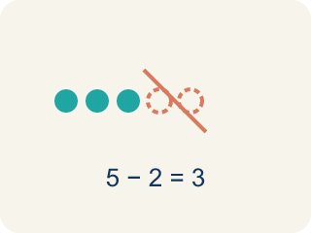
Decompose (Descomponer) — To break a shape into smaller, simpler shapes.
Triangle (Triángulo) — A shape with three sides.
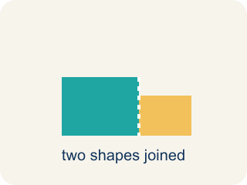
Composite (Compuesto) — Made by putting two or more simple shapes together.
Composite figure (Figura compuesta) — A shape made by putting two or more simple shapes together.
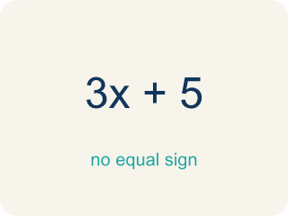
Formula (Fórmula) — A math rule written with symbols.

Practice
Show your work. Use the blank space under each problem.
1. A regular hexagon is divided into 6 equal triangles from the center. Each triangle has a base of 6 ft and a height of 5.2 ft. What is the area of one triangle?
A. 15.6 sq ft
B. 31.2 sq ft
C. 11.2 sq ft
D. 15.6 ft
______________________________________________________________________
2. Using the triangle from the previous question, what is the total area of the hexagonal skylight?
A. 93.6 sq ft
B. 15.6 sq ft
C. 187.2 sq ft
D. 62.4 sq ft
______________________________________________________________________
3. Complete the table.
Polygon | Number of Triangles | Triangle Base | Triangle Height | Area of One Triangle | Total Area
Hexagon | 6 | 6 ft | 5.2 ft
Pentagon | 5 | 8 ft | 5.5 ft
Square | 2 | 10 ft | 5 ft
Octagon | 8 | 4 ft | 4.8 ft
______________________________________________________________________
4. Match each polygon to its total area.
Item | Answer choices
____ Hexagon: 6 triangles, each ½×6×5.2 | F. 36 sq ft
____ Pentagon: 5 triangles, each ½×8×5.5 | E. 36 sq ft
____ Octagon: 8 triangles, each ½×4×4.8 | D. 50 sq ft
____ Square: 2 triangles, each ½×10×5 | C. 76.8 sq ft
____ Triangle b=12, h=6 | B. 110 sq ft
____ Parallelogram b=9, h=4 | A. 93.6 sq ft
______________________________________________________________________
5. Calculate the total area of each regular polygon, then sort from smallest to largest area.
Groups: Area ≥ 90 sq ft | Area < 90 sq ft
• Pentagon: 5 × (½×8×5.5) = 110 sq ft → __________________
• Hexagon: 6 × (½×6×5.2) = 93.6 sq ft → __________________
• Octagon: 8 × (½×4×4.8) = 76.8 sq ft → __________________
• Square: 2 × (½×10×5) = 50 sq ft → __________________
______________________________________________________________________
6. onLevel — Spot the Common Mistake
Step 1 (Read): A student is working on Area of Regular Polygons.
Step 2 (Attempt): They ignored the rule: A regular polygon splits into the same number of triangles as it has sides, so total area = (one triangle's area) × (number of sides).
Step 3 (Check): The answer does not match the math rule from class.
Which step has the mistake? Explain and fix it:
______________________________________________________________________
______________________________________________________________________
______________________________________________________________________
7. A regular hexagonal floor tile splits from its center into 6 congruent triangles, each with an area of 12 cm². What is the total area of the tile?
A. 72 cm²
B. 12 cm²
C. 36 cm²
D. 18 cm²
______________________________________________________________________
8. A regular pentagonal tile splits into 5 congruent triangles. Each triangle has a base of 4 in and a height of 6 in. What is the total area of the tile?
A. 60 in²
B. 12 in²
C. 24 in²
D. 120 in²
______________________________________________________________________
9. Each tile is made of congruent triangles. Find the area of ONE triangle, then sort it by size.
Groups: One triangle ≤ 12 sq ft | One triangle > 12 sq ft
• Square tile triangle: ½ × 4 × 4 = 8 sq ft → __________________
• Hexagon tile triangle: ½ × 6 × 4 = 12 sq ft → __________________
• Octagon tile triangle: ½ × 10 × 3 = 15 sq ft → __________________
• Pentagon tile triangle: ½ × 8 × 5 = 20 sq ft → __________________
______________________________________________________________________
10. Match each polygon tile to its total area.
Item | Answer choices
____ Square tile: 2 triangles, each ½×9×4 | D. 21 sq ft
____ Octagon tile: 8 triangles, each ½×3×4 | C. 45 sq ft
____ Hexagon tile: 6 triangles, each ½×5×3 | B. 48 sq ft
____ Equilateral triangle tile: 1 triangle, ½×7×6 | A. 36 sq ft
______________________________________________________________________

Answer Key (Teacher)
1. A. 15.6 sq ft
A = ½ × b × h = ½ × 6 × 5.2 = 15.6 square feet.
Watch for: A common mistake in Area of Regular Polygons is skipping the key idea: "A regular polygon splits into the same number of triangles as it has sides, so total area = (one triangle's area) × (number of sides)." — always check your work against this rule before you submit.
2. A. 93.6 sq ft
Total area = 6 triangles × 15.6 sq ft = 93.6 square feet.
Watch for: A common mistake in Area of Regular Polygons is skipping the key idea: "A regular polygon splits into the same number of triangles as it has sides, so total area = (one triangle's area) × (number of sides)." — always check your work against this rule before you submit.
3. Table
Hexagon — Area of One Triangle: 15.6 sq ft
Hexagon — Total Area: 93.6 sq ft
Pentagon — Area of One Triangle: 22 sq ft
Pentagon — Total Area: 110 sq ft
Square — Area of One Triangle: 25 sq ft
Square — Total Area: 50 sq ft
Octagon — Area of One Triangle: 9.6 sq ft
Octagon — Total Area: 76.8 sq ft

4. Matches:
Hexagon: 6 triangles, each ½×6×5.2 → 93.6 sq ft
Pentagon: 5 triangles, each ½×8×5.5 → 110 sq ft
Octagon: 8 triangles, each ½×4×4.8 → 76.8 sq ft
Square: 2 triangles, each ½×10×5 → 50 sq ft
Triangle b=12, h=6 → 36 sq ft
Parallelogram b=9, h=4 → 36 sq ft

5. Correct groups:
Pentagon: 5 × (½×8×5.5) = 110 sq ft → Area ≥ 90 sq ft
Hexagon: 6 × (½×6×5.2) = 93.6 sq ft → Area ≥ 90 sq ft
Octagon: 8 × (½×4×4.8) = 76.8 sq ft → Area < 90 sq ft
Square: 2 × (½×10×5) = 50 sq ft → Area < 90 sq ft

6. onLevel — Spot the Common Mistake
The mistake is in Step 2.
Correct work: Follow the key idea: A regular polygon splits into the same number of triangles as it has sides, so total area = (one triangle's area) × (number of sides).
7. A. 72 cm²
A hexagon has 6 sides, so it splits into 6 equal triangles. Total = 6 × 12 = 72 cm².
Watch for: A common mistake in Area of Regular Polygons is skipping the key idea: "A regular polygon splits into the same number of triangles as it has sides, so total area = (one triangle's area) × (number of sides)." — always check your work against this rule before you submit.
8. A. 60 in²
One triangle = ½ × 4 × 6 = 12 in². A pentagon has 5 triangles, so total = 5 × 12 = 60 in².
Watch for: A common mistake in Area of Regular Polygons is skipping the key idea: "A regular polygon splits into the same number of triangles as it has sides, so total area = (one triangle's area) × (number of sides)." — always check your work against this rule before you submit.
9. Correct groups:
Square tile triangle: ½ × 4 × 4 = 8 sq ft → One triangle ≤ 12 sq ft
Hexagon tile triangle: ½ × 6 × 4 = 12 sq ft → One triangle ≤ 12 sq ft
Octagon tile triangle: ½ × 10 × 3 = 15 sq ft → One triangle > 12 sq ft
Pentagon tile triangle: ½ × 8 × 5 = 20 sq ft → One triangle > 12 sq ft

10. Matches:
Square tile: 2 triangles, each ½×9×4 → 36 sq ft
Octagon tile: 8 triangles, each ½×3×4 → 48 sq ft
Hexagon tile: 6 triangles, each ½×5×3 → 45 sq ft
Equilateral triangle tile: 1 triangle, ½×7×6 → 21 sq ft

