UNIT 5 · LESSON 5 STANDARD 6.G.1

Area of Composite Figures
Student Notes Packet
Name: ______________________ Date: ____________ Period: ________

Today's Goals
Content: I can find the area of a composite figure by adding or subtracting the areas of basic shapes.
Language: I can explain my steps using the words composite figure, decompose, add, and subtract.

Key Vocabulary
Look at the picture, read the word, then read what it means.
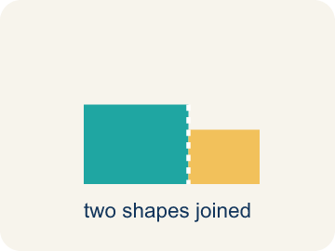 | Composite Figure Figura compuesta  A shape made by putting two or more simple shapes together.  Example: An L-shaped room = a 12×8 rectangle joined to a 6×5 rectangle; total area = 96 + 30 = 126 sq ft
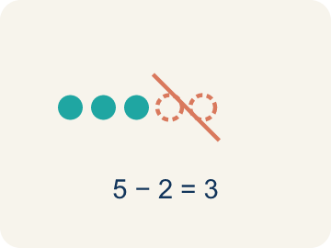 | Decompose Descomponer  To break a shape into smaller, simpler shapes.  Example: Draw a dashed line across the L-shape to split it into two rectangles — now you can find each area separately
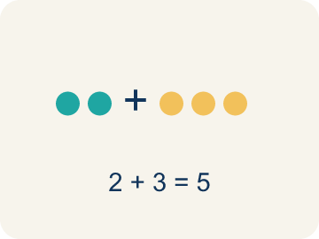 | Add Sumar  Add up the areas of the smaller shapes to get the total.  Example: T-shaped hallway: top rectangle = 30 sq ft, bottom rectangle = 28 sq ft → total = 30 + 28 = 58 sq ft
Subtract Restar
Take away the area of a missing piece from a bigger shape.
Example: A 14×10 pool with a 6×4 cutout: 140 − 24 = 116 sq ft of water surface
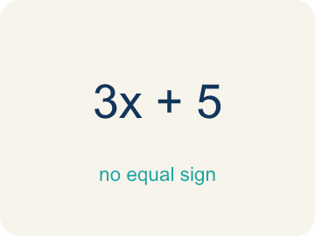 | Formula Fórmula  A math rule written with symbols.  Example: Rectangle: A = l × w; Triangle: A = ½ × b × h; use the right formula for each piece of a composite figure

Guided Notes
Fill in each blank as we go. Use the Word Bank to help you.
WORD BANK
Composite Figure • Decompose • Add • Subtract • Formula

1. A shape made of two or more basic shapes combined is a ___.
2. To break a composite figure into basic shapes is to ___ it.
3. To find the total area of separate parts, I ___ their areas.
4. To find the area of a shape with a piece removed, I ___ the missing part's area.
5. A math rule written with symbols is a ___.

Worked Example

Watch & Read I Do — follow along with your teacher
Blueprint Review
Your architecture firm is calculating the floor area of an L-shaped room for a client's new home. The contractor needs the total area to order the correct amount of flooring. The room can be split into two rectangles: one is 12 feet by 8 feet and the other is 6 feet by 5 feet.

Think about:
• What does the shape of the room look like?
• Can you see simpler shapes inside the L-shape?
• What measurements are given for each part?
• Is there more than one way to split this shape into rectangles?
• Could you use subtraction instead of addition to find the area?

Solved Example I Do — watch each step
Problem: An L-shaped room is made of two rectangles: 10 ft × 6 ft and 4 ft × 3 ft. What is the total area?
A) 72 sq ft
B) 60 sq ft
C) 12 sq ft
D) 72 ft
Step 1: Area 1 = 10 × 6 = 60 sq ft.
Step 2: Area 2 = 4 × 3 = 12 sq ft.
Step 3: Total = 60 + 12 = 72 sq ft.
Answer: A. 72 sq ft

Guided Practice

Solve Together We Do — work with your class
Problem: A rectangular patio is 15 ft × 10 ft with a 5 ft × 4 ft rectangular flower bed cut out. What is the remaining area?
A) 130 sq ft
B) 150 sq ft
C) 20 sq ft
D) 170 sq ft
Step 1:

Step 2:

Step 3:

Answer:

An architect is ordering carpet for a T-shaped conference room. The top of the T is 14 feet by 4 feet and the stem is 6 feet by 10 feet. Carpet costs $5 per square foot.
How much will the carpet cost?

Sentence frame: The top area is ___ sq ft and the stem area is ___ sq ft. Total = ___ + ___ = ___ sq ft. Cost = ___ x $5 = $___.

Turn & Talk discuss with a partner
1. [Launch] The L-shaped room splits into a 12 ft by 8 ft rectangle and a 6 ft by 5 ft rectangle. Why is it easier to find the area after you decompose the L into two rectangles?
Start with: We decompose the L-shape into ___ because ___.
Descomponemos la forma de L en ___ porque ___.
Word bank: composite figure, decompose, add, subtract, formula
2. [Explore] For the U-shaped pool you subtracted a 6 ft by 4 ft cutout from a 14 ft by 10 ft rectangle. How do you decide when to ADD areas and when to SUBTRACT?
Start with: I broke the figure into ___.
Dividí la figura en ___.
Word bank: composite figure, decompose, add, subtract, cutout
3. [Connect] The T-shaped conference room has a top of 14 ft by 4 ft and a stem of 6 ft by 10 ft, and carpet costs $5 per sq ft. Talk through finding the total cost.
Start with: The top area is ___ square feet and the stem area is ___ square feet.
El área de arriba es ___ pies cuadrados y el área del tronco es ___ pies cuadrados.
Word bank: composite figure, decompose, add, subtract, formula
4. [Practice] During practice on Area of Composite Figures, what strategy did you use when a problem felt tricky?
Start with: I broke the figure into ___.
Dividí la figura en ___.
Word bank: Composite Figure, Decompose, Add, Subtract

Independent Practice

On Your Own You Do — show your work
Solve each problem. Show your thinking in the work box.
1. Find the area of an L-shape made of a 5×3 rectangle and a 2×4 rectangle.
A) 23 sq units
B) 15 sq units
C) 8 sq units
D) 20 sq units

2. When should you subtract areas instead of adding them to find the area of a composite figure?
A) When a piece is cut out or removed from a larger shape
B) When the shapes overlap
C) When one shape is larger than the other
D) Always subtract — never add

3. Plan 1 — Office wing: the floor plan is a 7 ft by 5 ft rectangle with a triangular reading nook (base 7 ft, height 4 ft) joined on top. Decompose it and ADD the areas. What is the total floor area?
A) 49 sq ft
B) 35 sq ft
C) 14 sq ft
D) 63 sq ft

4. Plan 2 — L-shaped lobby: decompose the L into two rectangles, one 9 ft by 6 ft and one 7 ft by 3 ft, then ADD. What is the total floor area?
A) 75 sq ft
B) 63 sq ft
C) 54 sq ft
D) 21 sq ft

Exit Ticket
Answer on your own. This shows what you learned today.
★ A composite figure is made of a 9 ft x 7 ft rectangle and a 3 ft x 4 ft rectangle joined together. What is the total area?
A) 75 sq ft
B) 63 sq ft
C) 12 sq ft
D) 75 ft

