Area of Composite Figures — Homework
Lesson 5-5 • Standard 6.GR.1
Name: ______________________ Period: ______ Date: ____________

Today's Goals
Content: I can find the area of a composite figure by adding or subtracting the areas of basic shapes.
Language: I can explain my steps using the words composite figure, decompose, add, and subtract.

Key Words
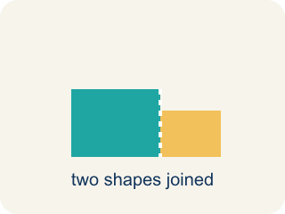
Composite Figure (Figura compuesta) — A shape made by putting two or more simple shapes together.
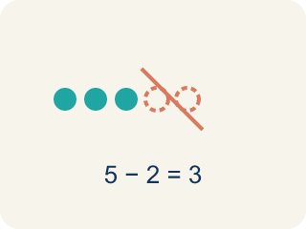
Decompose (Descomponer) — To break a shape into smaller, simpler shapes.
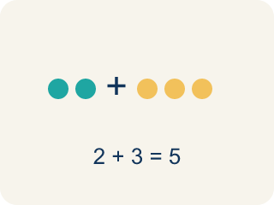
Add (Sumar) — Add up the areas of the smaller shapes to get the total.
Subtract (Restar) — Take away the area of a missing piece from a bigger shape.
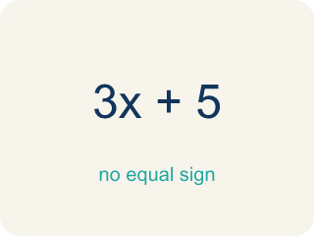
Formula (Fórmula) — A math rule written with symbols.

Practice
Show your work. Use the blank space under each problem.
1. An L-shaped room is made of two rectangles: 10 ft × 6 ft and 4 ft × 3 ft. What is the total area?
A. 72 sq ft
B. 60 sq ft
C. 12 sq ft
D. 72 ft
______________________________________________________________________
2. A rectangular patio is 15 ft × 10 ft with a 5 ft × 4 ft rectangular flower bed cut out. What is the remaining area?
A. 130 sq ft
B. 150 sq ft
C. 20 sq ft
D. 170 sq ft
______________________________________________________________________
3. Complete the table.
Figure | Shape 1 Area | Shape 2 Area | Operation | Total Area
L-shaped deck | 48 sq ft | 20 sq ft | Add
Floor with alcove | 90 sq ft | 15 sq ft | Add
Wall with window cutout | 120 sq ft | 18 sq ft | Subtract
Courtyard with fountain cutout | 200 sq ft | 36 sq ft | Subtract
______________________________________________________________________
4. Match each composite figure to its total area.
Item | Answer choices
____ L-shape: 10×6 + 4×3 | F. 90 sq ft
____ T-shape: 14×4 + 6×10 | E. 58 sq ft
____ Wall 15×10 minus window 5×4 | D. 116 sq ft
____ Pool 14×10 minus cutout 6×4 | C. 130 sq ft
____ L-shape: 8×5 + 3×6 | B. 116 sq ft
____ Floor 12×8 minus vent 2×3 | A. 72 sq ft
______________________________________________________________________
5. Calculate each composite figure's area. Sort by whether the area is more than 100 sq ft or not.
Groups: Area > 100 sq ft | Area ≤ 100 sq ft
• L-shape: 12×8 + 6×5 = 126 sq ft → __________________
• T-shape: 10×3 + 4×7 = 58 sq ft → __________________
• Wall 15×10 − window 5×4 = 130 sq ft → __________________
• L-shape: 9×7 + 3×4 = 75 sq ft → __________________
• Floor 20×8 − vent 6×3 = 142 sq ft → __________________
• U-shape: 10×8 − 4×3 = 68 sq ft → __________________
______________________________________________________________________
6. onLevel — Spot the Common Mistake
Step 1 (Read): A student is working on Area of Composite Figures.
Step 2 (Attempt): They ignored the rule: Break the figure into simple shapes. ADD the areas when shapes are joined; SUBTRACT when a piece is cut out.
Step 3 (Check): The answer does not match the math rule from class.
Which step has the mistake? Explain and fix it:
______________________________________________________________________
______________________________________________________________________
______________________________________________________________________
7. Plan 1 — Office wing: the floor plan is a 7 ft by 5 ft rectangle with a triangular reading nook (base 7 ft, height 4 ft) joined on top. Decompose it and ADD the areas. What is the total floor area?
A. 49 sq ft
B. 35 sq ft
C. 14 sq ft
D. 63 sq ft
______________________________________________________________________
8. Plan 2 — L-shaped lobby: decompose the L into two rectangles, one 9 ft by 6 ft and one 7 ft by 3 ft, then ADD. What is the total floor area?
A. 75 sq ft
B. 63 sq ft
C. 54 sq ft
D. 21 sq ft
______________________________________________________________________
9. Plan 3 — Survey the site. Drag each part of a floor plan into the correct group: do you ADD it to the total or SUBTRACT it from a larger shape?
Groups: ADD to the total | SUBTRACT from a larger shape
• Triangular entrance canopy joined to the front wall → __________________
• Square skylight opening cut out of the roof → __________________
• Rectangular wing attached to the main hall → __________________
• Elevator shaft removed from the office floor → __________________
• Triangular gable joined on top of the rectangular wall → __________________
• Circular fountain basin carved out of the courtyard → __________________
______________________________________________________________________
10. Plan 4 — Design studio: the floor is a 16 ft by 12 ft rectangle, but a 5 ft by 4 ft storage closet is cut out of one corner. Find the usable floor area.
A. 172 sq ft
B. 192 sq ft
C. 212 sq ft
D. 20 sq ft
______________________________________________________________________

Answer Key (Teacher)
1. A. 72 sq ft
Area 1 = 10 × 6 = 60 sq ft. Area 2 = 4 × 3 = 12 sq ft. Total = 60 + 12 = 72 sq ft.
Watch for: A common mistake in Area of Composite Figures is skipping the key idea: "Break the figure into simple shapes. ADD the areas when shapes are joined; SUBTRACT when a piece is cut out." — always check your work against this rule before you submit.
2. A. 130 sq ft
Patio = 15 × 10 = 150 sq ft. Cutout = 5 × 4 = 20 sq ft. Remaining = 150 − 20 = 130 sq ft.
Watch for: A common mistake in Area of Composite Figures is skipping the key idea: "Break the figure into simple shapes. ADD the areas when shapes are joined; SUBTRACT when a piece is cut out." — always check your work against this rule before you submit.
3. Table
L-shaped deck — Total Area: 68 sq ft
Floor with alcove — Total Area: 105 sq ft
Wall with window cutout — Total Area: 102 sq ft
Courtyard with fountain cutout — Total Area: 164 sq ft

4. Matches:
L-shape: 10×6 + 4×3 → 72 sq ft
T-shape: 14×4 + 6×10 → 116 sq ft
Wall 15×10 minus window 5×4 → 130 sq ft
Pool 14×10 minus cutout 6×4 → 116 sq ft
L-shape: 8×5 + 3×6 → 58 sq ft
Floor 12×8 minus vent 2×3 → 90 sq ft

5. Correct groups:
L-shape: 12×8 + 6×5 = 126 sq ft → Area > 100 sq ft
T-shape: 10×3 + 4×7 = 58 sq ft → Area ≤ 100 sq ft
Wall 15×10 − window 5×4 = 130 sq ft → Area > 100 sq ft
L-shape: 9×7 + 3×4 = 75 sq ft → Area ≤ 100 sq ft
Floor 20×8 − vent 6×3 = 142 sq ft → Area > 100 sq ft
U-shape: 10×8 − 4×3 = 68 sq ft → Area ≤ 100 sq ft

6. onLevel — Spot the Common Mistake
The mistake is in Step 2.
Correct work: Follow the key idea: Break the figure into simple shapes. ADD the areas when shapes are joined; SUBTRACT when a piece is cut out.
7. A. 49 sq ft
Rectangle = 7 x 5 = 35 sq ft. Triangle = 1/2 x 7 x 4 = 14 sq ft. The pieces are joined, so add: 35 + 14 = 49 sq ft.
Watch for: A common mistake in Area of Composite Figures is skipping the key idea: "Break the figure into simple shapes. ADD the areas when shapes are joined; SUBTRACT when a piece is cut out." — always check your work against this rule before you submit.
8. A. 75 sq ft
First rectangle = 9 x 6 = 54 sq ft. Second rectangle = 7 x 3 = 21 sq ft. Joined L-shape, so add: 54 + 21 = 75 sq ft.
Watch for: A common mistake in Area of Composite Figures is skipping the key idea: "Break the figure into simple shapes. ADD the areas when shapes are joined; SUBTRACT when a piece is cut out." — always check your work against this rule before you submit.
9. Correct groups:
Triangular entrance canopy joined to the front wall → ADD to the total
Square skylight opening cut out of the roof → SUBTRACT from a larger shape
Rectangular wing attached to the main hall → ADD to the total
Elevator shaft removed from the office floor → SUBTRACT from a larger shape
Triangular gable joined on top of the rectangular wall → ADD to the total
Circular fountain basin carved out of the courtyard → SUBTRACT from a larger shape

10. A. 172 sq ft
Large rectangle = 16 x 12 = 192 sq ft. Cutout closet = 5 x 4 = 20 sq ft. A piece is removed, so subtract: 192 - 20 = 172 sq ft.
Watch for: A common mistake in Area of Composite Figures is skipping the key idea: "Break the figure into simple shapes. ADD the areas when shapes are joined; SUBTRACT when a piece is cut out." — always check your work against this rule before you submit.

