Powers and Exponents — Homework
Lesson 6-1-flagship • Standard 6.AT.5
Name: ______________________ Period: ______ Date: ____________

Today's Goals
Content: I can write and evaluate numbers in exponent form using a base and a power.
Language: I can explain my work using the words exponent, base, power, and evaluate.

Key Words
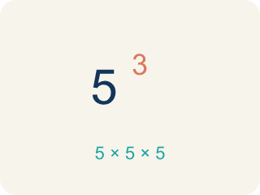
Exponent (Exponente) — A small number that tells how many times to multiply the number by itself.
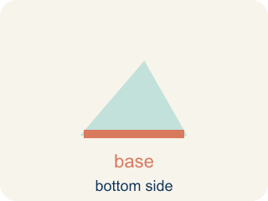
Base (Base) — The number that gets multiplied by itself.
Power (Potencia) — A number written with a base and an exponent, like 2³.
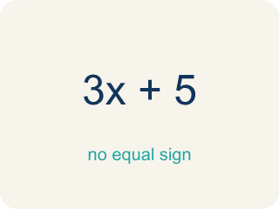
Evaluate (Evaluar) — To find the value of an expression.
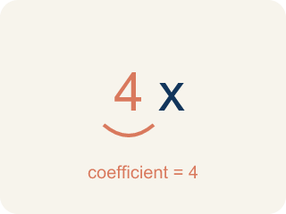
Coefficient (Coeficiente) — The number in front of a letter, like the 3 in 3x.
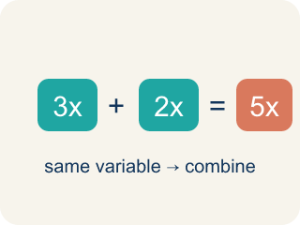
Like terms (Términos semejantes) — Terms with the same letter, like 2x and 5x.

Practice
Show your work. Use the blank space under each problem.
1. What is the value of 4³?
A. 64
B. 12
C. 43
D. 7
______________________________________________________________________
2. What is the value of 6²?
A. 36
B. 12
C. 62
D. 8
______________________________________________________________________
3. Evaluate each exponential expression. Show the repeated multiplication and the final value.
Power | Repeated Multiplication | Value
4³ | 4 × 4 × 4
2⁶ | 2 × 2 × 2 × 2 × 2 × 2
5³ | 5 × 5 × 5
10⁴ | 10 × 10 × 10 × 10
______________________________________________________________________
4. Sort each power by whether its value is greater than 50 or not.
Groups: Value > 50 | Value ≤ 50
• 2⁵ = 32 → __________________
• 3⁴ = 81 → __________________
• 7² = 49 → __________________
• 10² = 100 → __________________
• 5³ = 125 → __________________
• 4² = 16 → __________________
______________________________________________________________________
5. Match each power to its value.
Item | Answer choices
____ 2⁵ | F. 128
____ 3³ | E. 25
____ 4³ | D. 1000
____ 10³ | C. 64
____ 5² | B. 27
____ 2⁷ | A. 32
______________________________________________________________________
6. onLevel — Spot the Common Mistake
Step 1 (Read): A student is working on Powers and Exponents.
Step 2 (Attempt): They ignored the rule: A power like 2³ is a short way to write repeated multiplication: 2 × 2 × 2.
Step 3 (Check): The answer does not match the math rule from class.
Which step has the mistake? Explain and fix it:
______________________________________________________________________
______________________________________________________________________
______________________________________________________________________
7. Track 1 is locked. The keypad shows 2³. What value unlocks it?
A. 8
B. 6
C. 23
D. 9
______________________________________________________________________
8. Track 2 needs the value of 5². Which number opens the door?
A. 25
B. 10
C. 52
D. 7
______________________________________________________________________
9. The vault display reads 10⁴. In the power 10⁴, which number is the base?
A. 10
B. 4
C. 40
D. 14
______________________________________________________________________
10. Sort each studio code by whether it is written as repeated multiplication or as exponential form.
Groups: Repeated multiplication | Exponential form
• 3 × 3 × 3 × 3 → __________________
• 6² → __________________
• 2 × 2 × 2 × 2 × 2 → __________________
• 9³ → __________________
• 7 × 7 → __________________
• 8⁵ → __________________
______________________________________________________________________

Answer Key (Teacher)
1. A. 64
4³ = 4 × 4 × 4 = 64.
Watch for: A common mistake in Powers and Exponents is skipping the key idea: "A power like 2³ is a short way to write repeated multiplication: 2 × 2 × 2." — always check your work against this rule before you submit.
2. A. 36
6² = 6 × 6 = 36.
Watch for: A common mistake in Powers and Exponents is skipping the key idea: "A power like 2³ is a short way to write repeated multiplication: 2 × 2 × 2." — always check your work against this rule before you submit.
3. Evaluate each exponential expression. Show the repeated multiplication and the final value.
4³ — Value: 64
2⁶ — Value: 64
5³ — Value: 125
10⁴ — Value: 10000

4. Correct groups:
2⁵ = 32 → Value ≤ 50
3⁴ = 81 → Value > 50
7² = 49 → Value ≤ 50
10² = 100 → Value > 50
5³ = 125 → Value > 50
4² = 16 → Value ≤ 50

5. Matches:
2⁵ → 32
3³ → 27
4³ → 64
10³ → 1000
5² → 25
2⁷ → 128

6. onLevel — Spot the Common Mistake
The mistake is in Step 2.
Correct work: Follow the key idea: A power like 2³ is a short way to write repeated multiplication: 2 × 2 × 2.
7. A. 8
2³ means 2 × 2 × 2 = 8, so 8 unlocks Track 1.
Watch for: A common mistake in Powers and Exponents is skipping the key idea: "A power like 2³ is a short way to write repeated multiplication: 2 × 2 × 2." — always check your work against this rule before you submit.
8. A. 25
5² means 5 × 5 = 25, so 25 unlocks Track 2.
Watch for: A common mistake in Powers and Exponents is skipping the key idea: "A power like 2³ is a short way to write repeated multiplication: 2 × 2 × 2." — always check your work against this rule before you submit.
9. A. 10
The base is the number being multiplied repeatedly. In 10⁴ the base is 10 and the exponent is 4, so 10⁴ = 10 × 10 × 10 × 10 = 10000.
Watch for: A common mistake in Powers and Exponents is skipping the key idea: "A power like 2³ is a short way to write repeated multiplication: 2 × 2 × 2." — always check your work against this rule before you submit.
10. Correct groups:
3 × 3 × 3 × 3 → Repeated multiplication
6² → Exponential form
2 × 2 × 2 × 2 × 2 → Repeated multiplication
9³ → Exponential form
7 × 7 → Repeated multiplication
8⁵ → Exponential form

