UNIT 6 · LESSON 2 STANDARD 6.EE.2C

Evaluate Expressions
Student Notes Packet
Name: ______________________ Date: ____________ Period: ________

Today's Goals
Content: I can evaluate algebraic expressions by substituting values for the variables.
Language: I can explain my steps using the words variable, expression, evaluate, and substitute.

Key Vocabulary
Look at the picture, read the word, then read what it means.
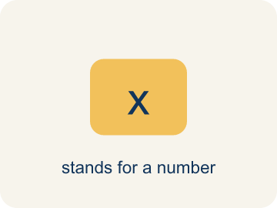 | Variable Variable  A letter that stands for an unknown number.  Example: In 3x + 5, x can be any number — if x = 2, the expression equals 11; if x = 10, it equals 35
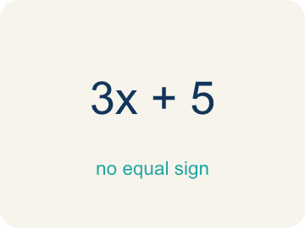 | Expression Expresión  A math phrase with numbers and letters, but no equal sign.  Example: 2n + 7 is an expression: the 2n means '2 times some number' and the + 7 means 'then add 7'
Evaluate Evaluar
To find the value by putting numbers in for the letters.
Example: Evaluate 2n + 7 when n = 4: replace n with 4 → 2(4) + 7 = 8 + 7 = 15
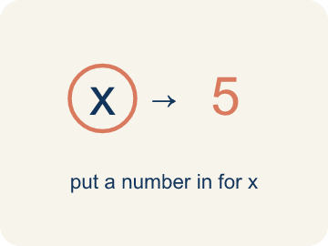 | Substitute Sustituir  To put a number in place of a letter.  Example: Substitute 3 for x in 5x: replace x with 3 → 5(3) = 15
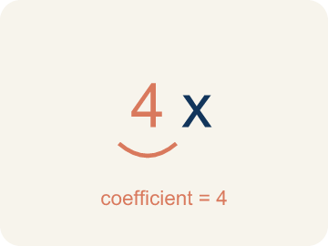 | Coefficient Coeficiente  The number in front of a letter, like the 3 in 3x.  Example: In 7m, the coefficient 7 tells you to multiply m by 7 — if m = 3, then 7m = 21
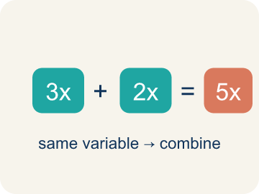 | Like terms Términos semejantes  Terms with the same letter, like 2x and 5x.  Example: 4x and 2x are like terms (both x¹); 4x and 4y are NOT (different variables)

Guided Notes
Fill in each blank as we go. Use the Word Bank to help you.
WORD BANK
Variable • Expression • Evaluate • Substitute • Coefficient • Like terms

1. A letter that stands for an unknown number, like x, is a ___.
2. A group of numbers, variables, and operations with no equal sign is an ___.
3. To find the value of an expression for given values is to ___ it.
4. To replace a variable with a number is to ___.
5. A number multiplied by a variable, like the 4 in 4y, is a ___.
6. Terms with the same variable part, like 2x and 6x, are ___.

Worked Example

Watch & Read I Do — follow along with your teacher
Mix the Track
You're a music producer setting up a concert. The total cost of the event is given by the expression 150 + 12s, where s is the number of speakers rented. The venue charges $150 as a base fee, plus $12 for each speaker. How much will it cost for different numbers of speakers?

Think about:
• What does the 150 represent in the expression?
• What does the 12s represent?
• What happens to the total cost as s gets bigger?
• What if speakers cost $15 each instead?
• How many speakers can we afford with a $300 budget?

Solved Example I Do — watch each step
Problem: Evaluate 3x + 7 when x = 4.
A) 19
B) 34
C) 12
D) 14
Step 1: 3(4) + 7 = 12 + 7 = 19.
Answer: A. 19

Guided Practice

Solve Together We Do — work with your class
Problem: Evaluate 20 − 2n when n = 6.
A) 8
B) 14
C) 32
D) 12
Step 1:

Step 2:

Answer:

A rideshare app charges $2.50 plus $1.75 per mile. The expression for the fare is 2.50 + 1.75m, where m is miles traveled. Your friend lives 8 miles away.
How much will the ride cost? How does the expression model this situation?

Sentence frame: The ride costs $___ because 2.50 + 1.75(___) = ___. The 2.50 is the ___ and 1.75 is the ___.

Turn & Talk discuss with a partner
1. [Launch] The concert cost is 150 + 12s, where s is the number of speakers. How do you find the cost for 5 speakers, and why does this one expression work for any number of speakers?
Start with: I substitute s = 5 into 150 + 12s to get ___.
Sustituyo s = 5 en 150 + 12s para obtener ___.
Word bank: Variable, Expression, Evaluate, Substitute
2. [Explore] When you evaluate an expression like 4x² + 3, what order do you follow, and why must you square before you multiply?
Start with: First I substitute, then I do ___ because of the order of operations.
Primero sustituyo, luego hago ___ por el orden de las operaciones.
Word bank: Evaluate, Substitute, Expression, Variable
3. [Connect] The rideshare fare is 2.50 + 1.75m for m miles. How much is an 8-mile ride, and what does each part of the expression represent?
Start with: I substitute m = 8: 2.50 + 1.75 × ___ = ___.
Sustituyo m = 8: 2.50 + 1.75 × ___ = ___.
Word bank: Substitute, Variable, Evaluate, Expression
4. [Practice] During practice on Evaluate Expressions, what strategy did you use when a problem felt tricky?
Start with: First I substitute, then I do ___ because of the order of operations.
Primero sustituyo, luego hago ___ por el orden de las operaciones.
Word bank: Variable, Expression, Evaluate, Substitute

Independent Practice

On Your Own You Do — show your work
Solve each problem. Show your thinking in the work box.
1. Which expression means '5 less than twice a number n'?
A) 2n − 5
B) 5 − 2n
C) 2(n − 5)
D) 2 − 5n

2. Evaluate 4m + 1 when m = 5.
A) 21
B) 20
C) 9
D) 25

3. Track 1 — The beat formula is 3x + 5, where x is the number of bass drops. Evaluate 3x + 5 when x = 4.
A) 17
B) 27
C) 12
D) 21

4. Track 2 — The volume mix is 2(n + 3), where n is the number of monitors. Evaluate 2(n + 3) when n = 5.
A) 16
B) 13
C) 20
D) 26

Exit Ticket
Answer on your own. This shows what you learned today.
★ Evaluate 5(n − 3) + 2 when n = 7.
A) 22
B) 32
C) 17
D) 36

