Evaluate Expressions — Homework
Lesson 6-2 • Standard 6.AT.6c
Name: ______________________ Period: ______ Date: ____________

Today's Goals
Content: I can evaluate algebraic expressions by substituting values for the variables.
Language: I can explain my steps using the words variable, expression, evaluate, and substitute.

Key Words
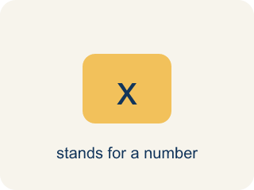
Variable (Variable) — A letter that stands for an unknown number.
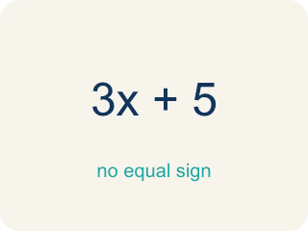
Expression (Expresión) — A math phrase with numbers and letters, but no equal sign.
Evaluate (Evaluar) — To find the value by putting numbers in for the letters.
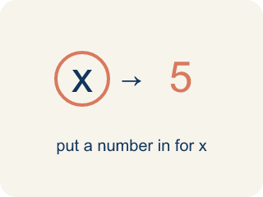
Substitute (Sustituir) — To put a number in place of a letter.
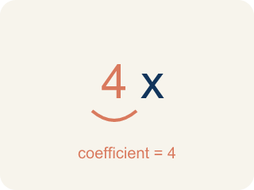
Coefficient (Coeficiente) — The number in front of a letter, like the 3 in 3x.
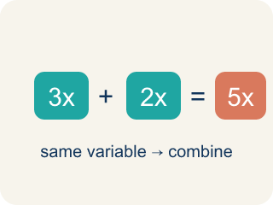
Like terms (Términos semejantes) — Terms with the same letter, like 2x and 5x.

Practice
Show your work. Use the blank space under each problem.
1. Evaluate 3x + 7 when x = 4.
A. 19
B. 34
C. 12
D. 14
______________________________________________________________________
2. Evaluate 20 − 2n when n = 6.
A. 8
B. 14
C. 32
D. 12
______________________________________________________________________
3. Evaluate each expression for the given value of the variable.
Expression | Variable Value | Substitution | Result
5n − 3 | n = 6 | 5(6) − 3
n² + 4 | n = 3 | 3² + 4
2(n + 8) | n = 5 | 2(5 + 8)
40 − 3n | n = 7 | 40 − 3(7)
______________________________________________________________________
4. Evaluate each expression when a = 3. Sort by whether the result is greater than 15 or not.
Groups: Greater than 15 | 15 or less
• 5a + 2 = 17 → __________________
• 6a = 18 → __________________
• a² + 7 = 16 → __________________
• 4a − 1 = 11 → __________________
• 2a + 5 = 11 → __________________
• 10 − a = 7 → __________________
______________________________________________________________________
5. Match each expression to its value.
Item | Answer choices
____ 3x when x=4 | F. 10
____ x² when x=5 | E. 5
____ 2x+1 when x=3 | D. 5
____ x/2 when x=10 | C. 7
____ 4x−3 when x=2 | B. 25
____ x²+1 when x=3 | A. 12
______________________________________________________________________
6. onLevel — Spot the Common Mistake
Step 1 (Read): A student is working on Evaluate Expressions.
Step 2 (Attempt): They ignored the rule: Replace the variable with its number, then follow the order of operations to find the total.
Step 3 (Check): The answer does not match the math rule from class.
Which step has the mistake? Explain and fix it:
______________________________________________________________________
______________________________________________________________________
______________________________________________________________________
7. Track 1 — The beat formula is 3x + 5, where x is the number of bass drops. Evaluate 3x + 5 when x = 4.
A. 17
B. 27
C. 12
D. 21
______________________________________________________________________
8. Track 2 — The volume mix is 2(n + 3), where n is the number of monitors. Evaluate 2(n + 3) when n = 5.
A. 16
B. 13
C. 20
D. 26
______________________________________________________________________
9. Track 3 — The speaker power is x², where x is the gain setting. Evaluate x² when x = 6.
A. 36
B. 12
C. 18
D. 30
______________________________________________________________________
10. Mixdown — match each expression (with its value plugged in) to the single number it mixes down to.
Item | Answer choices
____ 3x + 5 when x = 4 | F. 29
____ 2(n + 3) when n = 5 | E. 18
____ x² when x = 6 | D. 50
____ 10x when x = 5 | C. 36
____ 6n when n = 3 | B. 16
____ n² + 4 when n = 5 | A. 17
______________________________________________________________________

Answer Key (Teacher)
1. A. 19
3(4) + 7 = 12 + 7 = 19.
Watch for: A common mistake in Evaluate Expressions is skipping the key idea: "Replace the variable with its number, then follow the order of operations to find the total." — always check your work against this rule before you submit.
2. A. 8
20 − 2(6) = 20 − 12 = 8.
Watch for: A common mistake in Evaluate Expressions is skipping the key idea: "Replace the variable with its number, then follow the order of operations to find the total." — always check your work against this rule before you submit.
3. Evaluate each expression for the given value of the variable.
5n − 3 — Result: 27
n² + 4 — Result: 13
2(n + 8) — Result: 26
40 − 3n — Result: 19

4. Correct groups:
5a + 2 = 17 → Greater than 15
6a = 18 → Greater than 15
a² + 7 = 16 → Greater than 15
4a − 1 = 11 → 15 or less
2a + 5 = 11 → 15 or less
10 − a = 7 → 15 or less

5. Matches:
3x when x=4 → 12
x² when x=5 → 25
2x+1 when x=3 → 7
x/2 when x=10 → 5
4x−3 when x=2 → 5
x²+1 when x=3 → 10

6. onLevel — Spot the Common Mistake
The mistake is in Step 2.
Correct work: Follow the key idea: Replace the variable with its number, then follow the order of operations to find the total.
7. A. 17
Substitute x = 4: 3(4) + 5. Multiply first: 3 × 4 = 12. Then add: 12 + 5 = 17.
Watch for: A common mistake in Evaluate Expressions is skipping the key idea: "Replace the variable with its number, then follow the order of operations to find the total." — always check your work against this rule before you submit.
8. A. 16
Substitute n = 5: 2(5 + 3). Do the parentheses first: 5 + 3 = 8. Then multiply: 2 × 8 = 16.
Watch for: A common mistake in Evaluate Expressions is skipping the key idea: "Replace the variable with its number, then follow the order of operations to find the total." — always check your work against this rule before you submit.
9. A. 36
x² means x times itself. Substitute x = 6: 6² = 6 × 6 = 36.
Watch for: A common mistake in Evaluate Expressions is skipping the key idea: "Replace the variable with its number, then follow the order of operations to find the total." — always check your work against this rule before you submit.
10. Matches:
3x + 5 when x = 4 → 17
2(n + 3) when n = 5 → 16
x² when x = 6 → 36
10x when x = 5 → 50
6n when n = 3 → 18
n² + 4 when n = 5 → 29

