UNIT 6 · LESSON 3 STANDARD 6.EE.2A

Write Algebraic Expressions
Student Notes Packet
Name: ______________________ Date: ____________ Period: ________

Today's Goals
Content: I can write algebraic expressions from words and real-world situations.
Language: I can explain my expression using the words variable, coefficient, constant, and algebraic expression.

Key Vocabulary
Look at the picture, read the word, then read what it means.
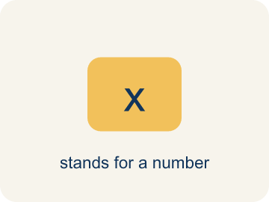 | Variable Variable  A letter that stands for a number that is unknown or can change.  Example: In 5t + 20, t could be hours worked — if t = 3, the expression equals 35; if t = 8, it equals 60
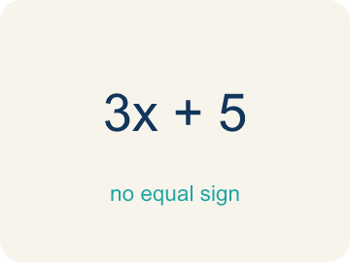 | Algebraic Expression Expresión algebraica  A math phrase that has at least one letter.  Example: 3n + 7 means 'triple a number, then add 7' — it has a variable (n), a coefficient (3), and a constant (7)
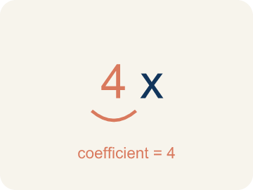 | Coefficient Coeficiente  The number in front of a letter, like the 3 in 3x.  Example: In 8x, the coefficient 8 means '8 groups of x' — if x = 3, then 8x = 8 × 3 = 24
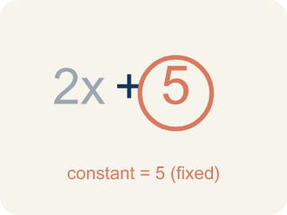 | Constant Constante  A number on its own that does not change.  Example: In 3n + 7, the 7 never changes no matter what n is — like a flat fee that stays the same
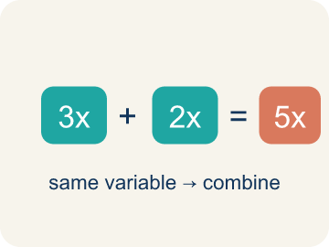 | Like terms Términos semejantes  Terms with the same letter, like 2x and 5x.  Example: 4x + 2x = 6x (like terms, same variable); but 4x + 2y cannot be combined (different variables)

Guided Notes
Fill in each blank as we go. Use the Word Bank to help you.
WORD BANK
Variable • Algebraic Expression • Coefficient • Constant • Like terms

1. A letter that stands for an unknown number is a ___.
2. A math phrase with variables, numbers, and operations but no equal sign is an ___.
3. The number multiplied by a variable, like the 7 in 7n, is the ___.
4. A term that is just a number and never changes, like the 5 in 3x + 5, is a ___.
5. Terms with the same variable part are ___.

Worked Example

Watch & Read I Do — follow along with your teacher
Concert Planner
You're planning a concert at the music studio. Tickets cost $12 each, and there's a flat $50 venue fee no matter how many people attend. If t represents the number of tickets sold, how would you write an expression for the total revenue?

Think about:
• What value changes depending on how many people come?
• What stays the same no matter the number of tickets?
• How would you calculate the total if 10 tickets are sold?
• What if there were two different ticket prices — regular and VIP?
• How many tickets would need to be sold to earn $200?

Solved Example I Do — watch each step
Problem: Which expression represents 'the product of 6 and a number n'?
A) 6n
B) 6 + n
C) n − 6
D) n ÷ 6
Step 1: 'Product' means multiplication, so the product of 6 and n is 6n.
Answer: A. 6n

Guided Practice

Solve Together We Do — work with your class
Problem: Which expression represents '9 less than a number y'?
A) y − 9
B) 9 − y
C) y + 9
D) 9y
Step 1:

Step 2:

Answer:

A music studio charges a $25 setup fee plus $8 per hour of recording time. Let h represent the number of hours.
Write an expression for the total cost. What does each part of the expression represent?

Sentence frame: The total cost is ___ + ___h. The ___ represents the ___ and ___h represents the ___.

Turn & Talk discuss with a partner
1. [Launch] Tickets cost $12 each with a flat $50 venue fee. If t is the number of tickets, how would you write an expression for total revenue, and which part changes with the crowd?
Start with: My expression is ___ because tickets cost $12 each.
Mi expresión es ___ porque los boletos cuestan $12 cada uno.
Word bank: Variable, Coefficient, Constant, Algebraic Expression
2. [Explore] How do you turn words into an expression? Why does '12 less than a number g' become g − 12 and not 12 − g?
Start with: The words '___' mean ___, so the expression is ___.
Las palabras '___' significan ___, así la expresión es ___.
Word bank: Algebraic Expression, Variable, Coefficient, Constant
3. [Connect] A studio charges a $25 setup fee plus $8 per recording hour. With h hours, what expression models the cost, and what does each part represent?
Start with: The total cost is ___ + ___h.
El costo total es ___ + ___h.
Word bank: Constant, Variable, Coefficient, Algebraic Expression
4. [Practice] During practice on Write Algebraic Expressions, what strategy did you use when a problem felt tricky?
Start with: The words '___' mean ___, so the expression is ___.
Las palabras '___' significan ___, así la expresión es ___.
Word bank: Variable, Algebraic Expression, Coefficient, Constant

Independent Practice

On Your Own You Do — show your work
Solve each problem. Show your thinking in the work box.
1. Which expression represents 'the sum of a number m and 15'?
A) m + 15
B) m − 15
C) 15m
D) m ÷ 15

2. Which key word tells you to multiply?
A) Product
B) Sum
C) Difference
D) Quotient

3. Line 1: A lyric says '7 more than a number of beats n.' Which expression matches?
A) n + 7
B) 7n
C) n − 7
D) 7 − n

4. Line 2: The chorus says '5 less than a number of tracks x.' Which expression matches?
A) x − 5
B) 5 − x
C) 5x
D) x + 5

Exit Ticket
Answer on your own. This shows what you learned today.
★ Which expression represents '3 more than twice a number n'?
A) 2n + 3
B) 3n + 2
C) 2(n + 3)
D) 2 + 3n

