Write Algebraic Expressions — Homework
Lesson 6-3 • Standard 6.AT.6a
Name: ______________________ Period: ______ Date: ____________

Today's Goals
Content: I can write algebraic expressions from words and real-world situations.
Language: I can explain my expression using the words variable, coefficient, constant, and algebraic expression.

Key Words
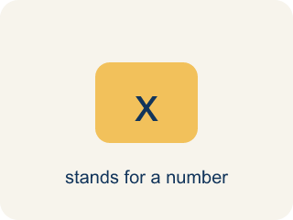
Variable (Variable) — A letter that stands for a number that is unknown or can change.
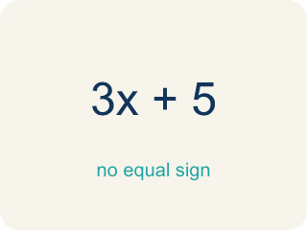
Algebraic Expression (Expresión algebraica) — A math phrase that has at least one letter.
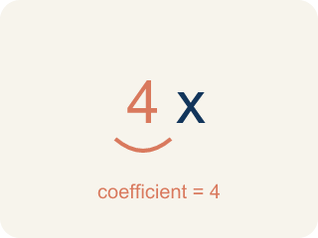
Coefficient (Coeficiente) — The number in front of a letter, like the 3 in 3x.
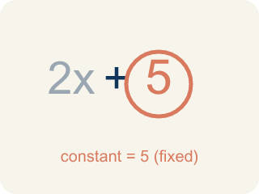
Constant (Constante) — A number on its own that does not change.
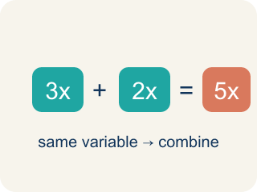
Like terms (Términos semejantes) — Terms with the same letter, like 2x and 5x.

Practice
Show your work. Use the blank space under each problem.
1. Which expression represents 'the product of 6 and a number n'?
A. 6n
B. 6 + n
C. n − 6
D. n ÷ 6
______________________________________________________________________
2. Which expression represents '9 less than a number y'?
A. y − 9
B. 9 − y
C. y + 9
D. 9y
______________________________________________________________________
3. Match each word phrase to its correct algebraic expression.
Groups: Correctly Matched
• twice a number k → 2k → __________________
• a number b divided by 5 → b ÷ 5 → __________________
• the sum of a number d and 15 → d + 15 → __________________
• 10 decreased by a number r → 10 − r → __________________
• 4 more than triple a number c → 3c + 4 → __________________
• half of a number h → h ÷ 2 → __________________
______________________________________________________________________
4. Match each word phrase to its algebraic expression.
Item | Answer choices
____ the product of 5 and n | F. z + 7
____ 8 less than a number w | E. y ÷ 4
____ a number p increased by 12 | D. 2x + 3
____ twice a number x, plus 3 | C. p + 12
____ a number y divided by 4 | B. w − 8
____ 7 more than a number z | A. 5n
______________________________________________________________________
5. Write an algebraic expression for each real-world situation.
Situation | Variable | Expression
Movie tickets cost $12 each | t = number of tickets
You had $50 and spent some money | s = dollars spent
Each student gets 3 pencils plus 2 erasers | n = number of students
A pizza is split equally among friends | f = number of friends, pizza = 24 slices
______________________________________________________________________
6. onLevel — Spot the Common Mistake
Step 1 (Read): A student is working on Write Algebraic Expressions.
Step 2 (Attempt): They ignored the rule: Words like "each" or "per" mean multiply, and "plus" or "more than" mean add.
Step 3 (Check): The answer does not match the math rule from class.
Which step has the mistake? Explain and fix it:
______________________________________________________________________
______________________________________________________________________
______________________________________________________________________
7. Line 1: A lyric says '7 more than a number of beats n.' Which expression matches?
A. n + 7
B. 7n
C. n − 7
D. 7 − n
______________________________________________________________________
8. Line 2: The chorus says '5 less than a number of tracks x.' Which expression matches?
A. x − 5
B. 5 − x
C. 5x
D. x + 5
______________________________________________________________________
9. Line 3: A verse says 'twice a number of speakers' (use s). Which expression matches?
A. 2s
B. s + 2
C. s − 2
D. s ÷ 2
______________________________________________________________________
10. Sort each studio lyric by the operation its key word names.
Groups: Addition | Subtraction | Multiplication | Division
• the sum of a number of mics m and 9 → __________________
• a number of riffs r increased by 6 → __________________
• 4 less than a number of solos j → __________________
• a number of takes k decreased by 8 → __________________
• the product of 5 and a number of loops g → __________________
• a number of verses v divided by 3 → __________________
______________________________________________________________________

Answer Key (Teacher)
1. A. 6n
'Product' means multiplication, so the product of 6 and n is 6n.
Watch for: A common mistake in Write Algebraic Expressions is skipping the key idea: "Words like "each" or "per" mean multiply, and "plus" or "more than" mean add." — always check your work against this rule before you submit.
2. A. y − 9
'Less than' means subtract from the number, so it's y − 9.
Watch for: A common mistake in Write Algebraic Expressions is skipping the key idea: "Words like "each" or "per" mean multiply, and "plus" or "more than" mean add." — always check your work against this rule before you submit.
3. Correct groups:
twice a number k → 2k → Correctly Matched
a number b divided by 5 → b ÷ 5 → Correctly Matched
the sum of a number d and 15 → d + 15 → Correctly Matched
10 decreased by a number r → 10 − r → Correctly Matched
4 more than triple a number c → 3c + 4 → Correctly Matched
half of a number h → h ÷ 2 → Correctly Matched

4. Matches:
the product of 5 and n → 5n
8 less than a number w → w − 8
a number p increased by 12 → p + 12
twice a number x, plus 3 → 2x + 3
a number y divided by 4 → y ÷ 4
7 more than a number z → z + 7

5. Write an algebraic expression for each real-world situation.
Movie tickets cost $12 each — Expression: 12t
You had $50 and spent some money — Expression: 50 − s
Each student gets 3 pencils plus 2 erasers — Expression: 3n + 2n or 5n
A pizza is split equally among friends — Expression: 24 ÷ f

6. onLevel — Spot the Common Mistake
The mistake is in Step 2.
Correct work: Follow the key idea: Words like "each" or "per" mean multiply, and "plus" or "more than" mean add.
7. A. n + 7
'More than' means addition, so '7 more than n' is n + 7.
Watch for: A common mistake in Write Algebraic Expressions is skipping the key idea: "Words like "each" or "per" mean multiply, and "plus" or "more than" mean add." — always check your work against this rule before you submit.
8. A. x − 5
'Less than' subtracts from the number: start with x and take away 5, so x − 5.
Watch for: A common mistake in Write Algebraic Expressions is skipping the key idea: "Words like "each" or "per" mean multiply, and "plus" or "more than" mean add." — always check your work against this rule before you submit.
9. A. 2s
'Twice' means two times the number, so twice s is 2s.
Watch for: A common mistake in Write Algebraic Expressions is skipping the key idea: "Words like "each" or "per" mean multiply, and "plus" or "more than" mean add." — always check your work against this rule before you submit.
10. Correct groups:
the sum of a number of mics m and 9 → Addition
a number of riffs r increased by 6 → Addition
4 less than a number of solos j → Subtraction
a number of takes k decreased by 8 → Subtraction
the product of 5 and a number of loops g → Multiplication
a number of verses v divided by 3 → Division

