UNIT 6 · LESSON 4 STANDARD 6.EE.3

Properties of Operations
Student Notes Packet
Name: ______________________ Date: ____________ Period: ________

Today's Goals
Content: I can use the commutative, associative, and identity properties to rewrite expressions.
Language: I can explain my reasoning using the words commutative property, associative property, and identity property.

Key Vocabulary
Look at the picture, read the word, then read what it means.
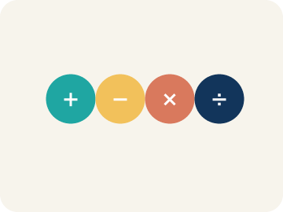 | Commutative Property Propiedad conmutativa  You can change the order and get the same answer.  Example: 3 + 7 = 7 + 3 = 10 both ways; 4 × 5 = 5 × 4 = 20 both ways — order does not matter
Associative Property Propiedad asociativa
You can change the grouping and get the same answer.
Example: (2 + 3) + 4 = 5 + 4 = 9 and 2 + (3 + 4) = 2 + 7 = 9 — same answer, different grouping
Identity Property Propiedad de identidad
Adding 0 or multiplying by 1 keeps the same value.
Example: 9 + 0 = 9 (zero is the identity for addition); 6 × 1 = 6 (one is the identity for multiplication)
Property Propiedad
A rule that is always true in math.
Example: Commutative works for + and ×, but NOT for − or ÷ (since 5 − 3 = 2 but 3 − 5 = −2)
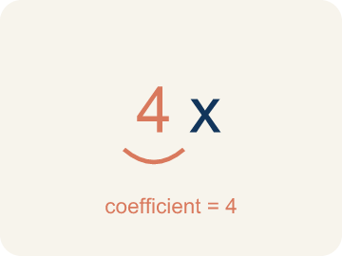 | Coefficient Coeficiente  The number in front of a letter, like the 3 in 3x.  Example: In 3x, the 3 is the coefficient — it tells you to multiply x by 3
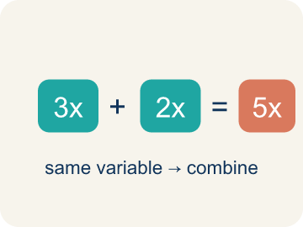 | Like terms Términos semejantes  Terms with the same letter, like 2x and 5x.  Example: 4x + 2x = 6x (like terms, both have x); 4x + 2y stays as 4x + 2y (unlike terms)

Guided Notes
Fill in each blank as we go. Use the Word Bank to help you.
WORD BANK
Commutative Property • Associative Property • Identity Property • Property • Coefficient • Like terms

1. The rule that order does not change a sum or product, like a + b = b + a, is the ___.
2. The rule that grouping does not change a sum or product, like (a + b) + c = a + (b + c), is the ___.
3. The rule that adding 0 or multiplying by 1 keeps a number the same is the ___.
4. A rule that is always true in math is a ___.
5. A number multiplied by a variable is a ___.
6. Terms with the same variable part are ___.

Worked Example

Watch & Read I Do — follow along with your teacher
Band Formation
You're a band director arranging musicians on stage. You have 3 guitarists, 5 drummers, and 2 keyboard players. Whether you seat the guitarists first or the drummers first, you still have 3 + 5 + 2 = 10 musicians. The order you arrange them doesn't change the total!

Think about:
• Does the order you add the musicians change the total?
• What if you group different sections together first — does the total change?
• What happens when you add 0 musicians to a group?
• Do these same rules work for subtraction or division?
• Can rearranging terms help make mental math easier?

Solved Example I Do — watch each step
Problem: Which property is shown? 5 + 13 = 13 + 5
A) Commutative Property
B) Associative Property
C) Identity Property
D) Distributive Property
Step 1: The order of the addends changed, so this is the Commutative Property of Addition.
Answer: A. Commutative Property

Guided Practice

Solve Together We Do — work with your class
Problem: Which property is shown? (6 × 3) × 2 = 6 × (3 × 2)
A) Associative Property
B) Commutative Property
C) Identity Property
D) Distributive Property
Step 1:

Step 2:

Answer:

A sound engineer needs to calculate 4 × 17 × 25 mentally to find the total cost of audio cables. Using the associative and commutative properties, she rearranges: 4 × 25 × 17 = 100 × 17.
What properties did the engineer use, and why does rearranging make the calculation easier?

Sentence frame: The engineer used the ___ property to change the ___ and the ___ property to change the ___. This makes it easier because 4 × 25 = ___, which is a friendly number to multiply by.

Turn & Talk discuss with a partner
1. [Launch] The band has 3 guitarists, 5 drummers, and 2 keyboard players. Whether you seat guitarists or drummers first, you still have 10 musicians. Which property explains this, and why does it work?
Start with: Changing the order still gives 10 because of the ___ property.
Cambiar el orden todavía da 10 por la propiedad ___.
Word bank: Commutative Property, Associative Property, Identity Property, Property
2. [Explore] How can you tell the commutative property from the associative property? Use 6 + 9 = 9 + 6 and (3 + 5) + 2 = 3 + (5 + 2) to explain.
Start with: The ___ property changes the order, like 6 + 9 = 9 + 6.
La propiedad ___ cambia el orden, como 6 + 9 = 9 + 6.
Word bank: Commutative Property, Associative Property, Identity Property, Property
3. [Connect] To find 4 × 17 × 25 mentally, the engineer rearranges to 4 × 25 × 17 = 100 × 17. Which properties did she use, and why does rearranging help?
Start with: She used the ___ property to change the order and the ___ property to regroup.
Usó la propiedad ___ para cambiar el orden y la propiedad ___ para reagrupar.
Word bank: Commutative Property, Associative Property, Property, Identity Property
4. [Practice] During practice on Properties of Operations, what strategy did you use when a problem felt tricky?
Start with: The ___ property changes the order, like 6 + 9 = 9 + 6.
La propiedad ___ cambia el orden, como 6 + 9 = 9 + 6.
Word bank: Commutative Property, Associative Property, Identity Property, Property

Independent Practice

On Your Own You Do — show your work
Solve each problem. Show your thinking in the work box.
1. Which property is shown? 47 + 0 = 47
A) Identity Property
B) Commutative Property
C) Associative Property
D) Distributive Property

2. Which property lets you rearrange 8 × 5 to 5 × 8?
A) Commutative Property
B) Associative Property
C) Identity Property
D) Distributive Property

3. Track 2 on the playlist plays 5(7 + 2) = 5 × 7 + 5 × 2. Which property is this?
A) Distributive Property
B) Commutative Property
C) Associative Property
D) Identity Property

4. Track 3 plays (7 + 3) + 5 = 7 + (3 + 5). Only the parentheses moved. Which property is this?
A) Associative Property
B) Commutative Property
C) Distributive Property
D) Identity Property

Exit Ticket
Answer on your own. This shows what you learned today.
★ Which property is shown? (8 + 5) + 2 = 8 + (5 + 2)
A) Associative Property
B) Commutative Property
C) Identity Property
D) Distributive Property

