UNIT 6 · LESSON 5 STANDARD 6.EE.3

The Distributive Property
Student Notes Packet
Name: ______________________ Date: ____________ Period: ________

Today's Goals
Content: I can use the distributive property to expand and factor expressions.
Language: I can explain my steps using the words distributive property, factor, expand, and equivalent.

Key Vocabulary
Look at the picture, read the word, then read what it means.
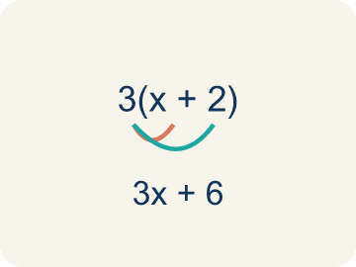 | Distributive Property Propiedad distributiva  Multiplying a number by everything inside the parentheses: a(b + c) = ab + ac.  Example: 3(4 + 5) = 3×4 + 3×5 = 12 + 15 = 27 — the 3 gets 'distributed' to both the 4 and the 5
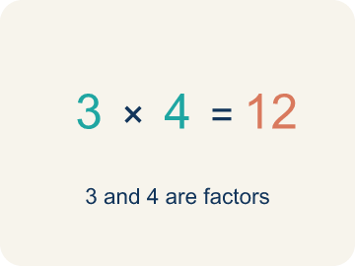 | Factor Factor  A number that gets multiplied by another number.  Example: In 3(x + 2), the 3 is the factor outside the parentheses that multiplies each term inside
Expand Desarrollar
To multiply out the parentheses in an expression.
Example: Expand 2(n + 6): multiply 2 × n = 2n and 2 × 6 = 12, so 2(n + 6) = 2n + 12
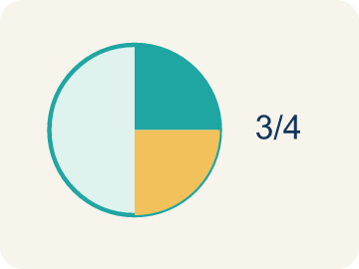 | Equivalent Equivalente  Expressions that always have the same value.  Example: 3(x + 4) and 3x + 12 always give the same answer: when x = 2, both = 18; when x = 10, both = 42
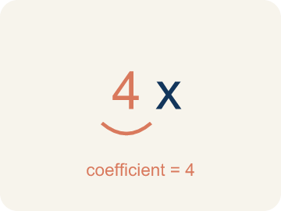 | Coefficient Coeficiente  The number in front of a letter, like the 3 in 3x.  Example: In 6x + 15, the coefficient of x is 6 — it came from distributing in 3(2x + 5)
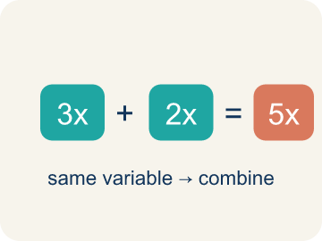 | Like terms Términos semejantes  Terms with the same letter, like 2x and 5x.  Example: 4x + 2x = 6x (combine coefficients); 4x + 2y cannot be combined (different variables)

Guided Notes
Fill in each blank as we go. Use the Word Bank to help you.
WORD BANK
Distributive Property • Factor • Expand • Equivalent • Coefficient • Like terms

1. The rule that a(b + c) = ab + ac is the ___.
2. To rewrite a sum as a product, like 3x + 12 = 3(x + 4), is to ___.
3. To multiply out a product over a sum, like 3(x + 4) = 3x + 12, is to ___.
4. Two expressions that always have the same value are ___.
5. A number multiplied by a variable is a ___.
6. Terms with the same variable part are ___.

Worked Example

Watch & Read I Do — follow along with your teacher
Ticket Pricing
You're selling concert bundles at the music studio. Each bundle includes a ticket ($15) and a snack ($5). If 3 people each buy a bundle, you can calculate the total as 3(15 + 5) OR as 3 × 15 + 3 × 5. Either way, the total is the same — $60! This is the distributive property.

Think about:
• Why do both methods give the same total?
• What does the 3 represent in 3(15 + 5)?
• How is 3(15 + 5) related to 3 × 15 + 3 × 5?
• What if 10 people bought bundles — which way would be faster to calculate?
• Does this work with subtraction too, like 4(20 − 3)?

Solved Example I Do — watch each step
Problem: Expand 6(n + 3) using the distributive property.
A) 6n + 18
B) 6n + 3
C) n + 18
D) 6n + 9
Step 1: 6(n + 3) = 6 × n + 6 × 3 = 6n + 18.
Answer: A. 6n + 18

Guided Practice

Solve Together We Do — work with your class
Problem: Expand 4(5 − 2) using the distributive property.
A) 12
B) 20 − 2
C) 9
D) 22
Step 1:

Step 2:

Answer:

A music studio is ordering supplies for 8 practice rooms. Each room needs a music stand ($12) and a stool ($9). The total cost can be written as 8(12 + 9).
Use the distributive property to find the total cost. Which way of calculating is easier for you?

Sentence frame: 8(12 + 9) = 8 × ___ + 8 × ___ = ___ + ___ = ___. I think the ___ form is easier because ___.

Turn & Talk discuss with a partner
1. [Launch] Each bundle is a ticket ($15) and a snack ($5). For 3 people, why does 3(15 + 5) give the same $60 as 3 × 15 + 3 × 5?
Start with: Both give $60 because I distribute the 3 to ___ and ___.
Las dos dan $60 porque distribuyo el 3 a ___ y ___.
Word bank: Distributive Property, Factor, Expand, Equivalent
2. [Explore] When you expand 5(2x + 4), why must the 5 multiply BOTH terms inside the parentheses?
Start with: I distribute the 5 to ___ and ___, so 5(2x + 4) = ___.
Distribuyo el 5 a ___ y ___, así 5(2x + 4) = ___.
Word bank: Distributive Property, Expand, Factor, Equivalent
3. [Connect] For 8 practice rooms each needing a music stand ($12) and a stool ($9), the cost is 8(12 + 9). How do you use the distributive property to find the total, and which form is easier for you?
Start with: 8(12 + 9) = 8 × ___ + 8 × ___ = ___.
8(12 + 9) = 8 × ___ + 8 × ___ = ___.
Word bank: Distributive Property, Factor, Expand, Equivalent
4. [Practice] During practice on The Distributive Property, what strategy did you use when a problem felt tricky?
Start with: I distribute the 5 to ___ and ___, so 5(2x + 4) = ___.
Distribuyo el 5 a ___ y ___, así 5(2x + 4) = ___.
Word bank: Distributive Property, Factor, Expand, Equivalent

Independent Practice

On Your Own You Do — show your work
Solve each problem. Show your thinking in the work box.
1. Expand 3(x + 4) using the distributive property.
A) 3x + 12
B) 3x + 4
C) x + 12
D) 7x

2. When using the distributive property with a(b + c), you must multiply 'a' by:
A) Both b and c
B) Only b
C) Only c
D) b + c first, then multiply

3. Light Cue 1: Expand 3(x + 4) for the stage-light controller.
A) 3x + 12
B) 3x + 4
C) x + 12
D) 3x + 7

4. Light Cue 2: Expand 5(2 + n) to set two spotlight banks.
A) 10 + 5n
B) 10 + n
C) 7 + 5n
D) 10 + 5

Exit Ticket
Answer on your own. This shows what you learned today.
★ Which expression is equivalent to 7(x + 3)?
A) 7x + 21
B) 7x + 3
C) x + 21
D) 7x + 10

