Equivalent Expressions — Homework
Lesson 6-6 • Standard 6.AT.7
Name: ______________________ Period: ______ Date: ____________

Today's Goals
Content: I can show that two expressions are equivalent by simplifying and combining like terms.
Language: I can explain my work using the words equivalent, simplify, like terms, and combine.

Key Words
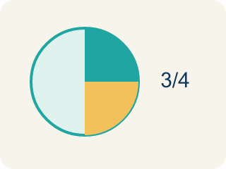
Equivalent (Equivalente) — Expressions that always have the same value.
Simplify (Simplificar) — To write an expression in a shorter, simpler way.
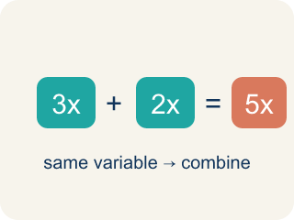
Like Terms (Términos semejantes) — Terms with the same letter, like 2x and 5x.
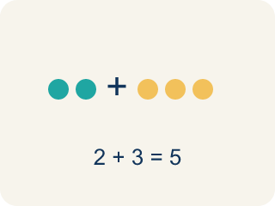
Combine (Combinar) — To add or subtract terms with the same letter.
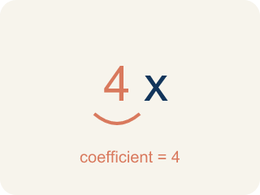
Coefficient (Coeficiente) — The number in front of a letter, like the 3 in 3x.

Practice
Show your work. Use the blank space under each problem.
1. Which expression is equivalent to 4x + 3x?
A. 7x
B. 12x
C. 7x²
D. 43x
______________________________________________________________________
2. Which expression is equivalent to 2(m + 5)?
A. 2m + 10
B. 2m + 5
C. m + 10
D. 7m
______________________________________________________________________
3. Match each expression with its simplified form.
Groups: Correctly Matched
• 8y + 2y → 10y → __________________
• 3(a + 6) → 3a + 18 → __________________
• 5n + 4 + 2n → 7n + 4 → __________________
• 9p − 3p → 6p → __________________
• 4(2x − 1) → 8x − 4 → __________________
• 6t + t → 7t → __________________
______________________________________________________________________
4. Match each expression to its simplified equivalent.
Item | Answer choices
____ 6x + 2x | F. 5x + 10
____ 3(n + 5) | E. 6m + 1
____ 4a + 7 + a | D. 6y − 8
____ 2(3y − 4) | C. 5a + 7
____ 10m − 4m + 1 | B. 3n + 15
____ 5(x + 2) | A. 8x
______________________________________________________________________
5. Simplify each expression. Then evaluate both the original and simplified form when x = 3 to verify they are equivalent.
Original | Simplified | Value when x = 3
2x + 5x + 1
4(x + 2)
3x + 4 + x − 1
______________________________________________________________________
6. onLevel — Spot the Common Mistake
Step 1 (Read): A student is working on Equivalent Expressions.
Step 2 (Attempt): They ignored the rule: Equivalent expressions give the same answer for every value of the variable.
Step 3 (Check): The answer does not match the math rule from class.
Which step has the mistake? Explain and fix it:
______________________________________________________________________
______________________________________________________________________
______________________________________________________________________
7. Producer A wrote 2(x + 3) for a beat's cost. Which expression is equivalent?
A. 2x + 6
B. 2x + 3
C. x + 6
D. 2x + 5
______________________________________________________________________
8. A track stacks 3x and then one more x. Which expression is equivalent to 3x + x?
A. 4x
B. 3x²
C. 4
D. 3x
______________________________________________________________________
9. Producer B flipped a formula to 5 + 2x. Which expression is equivalent?
A. 2x + 5
B. 7x
C. 10x
D. 5x + 2
______________________________________________________________________
10. The target beat formula is 4x + 6. Spin each expression onto the deck where it belongs: equivalent to 4x + 6, or NOT equivalent.
Groups: Equivalent to 4x + 6 | NOT Equivalent
• 2(2x + 3) → __________________
• 4x + 3 + 3 → __________________
• x + x + x + x + 6 → __________________
• 4x + 10 → __________________
• 10x → __________________
• 4(x + 6) → __________________
______________________________________________________________________

Answer Key (Teacher)
1. A. 7x
4x + 3x = 7x. Combine the coefficients: 4 + 3 = 7.
Watch for: A common mistake in Equivalent Expressions is skipping the key idea: "Equivalent expressions give the same answer for every value of the variable." — always check your work against this rule before you submit.
2. A. 2m + 10
2(m + 5) = 2m + 10 using the distributive property.
Watch for: A common mistake in Equivalent Expressions is skipping the key idea: "Equivalent expressions give the same answer for every value of the variable." — always check your work against this rule before you submit.
3. Correct groups:
8y + 2y → 10y → Correctly Matched
3(a + 6) → 3a + 18 → Correctly Matched
5n + 4 + 2n → 7n + 4 → Correctly Matched
9p − 3p → 6p → Correctly Matched
4(2x − 1) → 8x − 4 → Correctly Matched
6t + t → 7t → Correctly Matched

4. Matches:
6x + 2x → 8x
3(n + 5) → 3n + 15
4a + 7 + a → 5a + 7
2(3y − 4) → 6y − 8
10m − 4m + 1 → 6m + 1
5(x + 2) → 5x + 10

5. Simplify each expression. Then evaluate both the original and simplified form when x = 3 to verify they are equivalent.
2x + 5x + 1 — Simplified: 7x + 1
2x + 5x + 1 — Value when x = 3: 22
4(x + 2) — Simplified: 4x + 8
4(x + 2) — Value when x = 3: 20
3x + 4 + x − 1 — Simplified: 4x + 3
3x + 4 + x − 1 — Value when x = 3: 15

6. onLevel — Spot the Common Mistake
The mistake is in Step 2.
Correct work: Follow the key idea: Equivalent expressions give the same answer for every value of the variable.
7. A. 2x + 6
Distribute the 2 to each term inside: 2 · x + 2 · 3 = 2x + 6. Check x = 5: 2(5 + 3) = 16 and 2(5) + 6 = 16.
Watch for: A common mistake in Equivalent Expressions is skipping the key idea: "Equivalent expressions give the same answer for every value of the variable." — always check your work against this rule before you submit.
8. A. 4x
3x + x is 3 groups of x plus 1 more group of x = 4x. Add the coefficients: 3 + 1 = 4. Check x = 3: 3(3) + 3 = 12 and 4(3) = 12.
Watch for: A common mistake in Equivalent Expressions is skipping the key idea: "Equivalent expressions give the same answer for every value of the variable." — always check your work against this rule before you submit.
9. A. 2x + 5
Order of addition does not change the value (commutative property): 5 + 2x = 2x + 5. Check x = 10: 5 + 2(10) = 25 and 2(10) + 5 = 25.
Watch for: A common mistake in Equivalent Expressions is skipping the key idea: "Equivalent expressions give the same answer for every value of the variable." — always check your work against this rule before you submit.
10. Correct groups:
2(2x + 3) → Equivalent to 4x + 6
4x + 3 + 3 → Equivalent to 4x + 6
x + x + x + x + 6 → Equivalent to 4x + 6
4x + 10 → NOT Equivalent
10x → NOT Equivalent
4(x + 6) → NOT Equivalent

