UNIT 6 · LESSON 7 STANDARD 6.EE.3

Simplify Algebraic Expressions
Student Notes Packet
Name: ______________________ Date: ____________ Period: ________

Today's Goals
Content: I can simplify algebraic expressions by combining like terms.
Language: I can explain my steps using the words like terms, combine, simplify, and coefficient.

Key Vocabulary
Look at the picture, read the word, then read what it means.
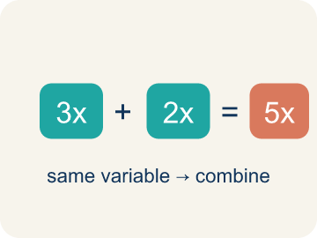 | Like Terms Términos semejantes  Terms with the same letter, like 2x and 5x.  Example: 5x and 3x are like terms (both x); 5x and 5y are NOT (different variables); 2x and 2x² are NOT (different powers)
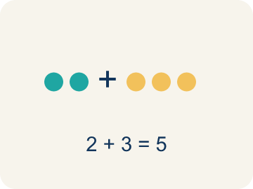 | Combine Combinar  To add or subtract terms with the same letter into one.  Example: 8m + 3m = 11m — add the coefficients (8 + 3 = 11) and keep the variable (m)
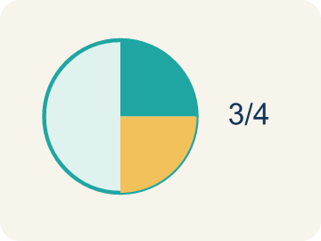 | Simplify Simplificar  To write an expression in its shortest form.  Example: 2a + 5a + 3 simplifies to 7a + 3 — the two a-terms combine, the constant stays
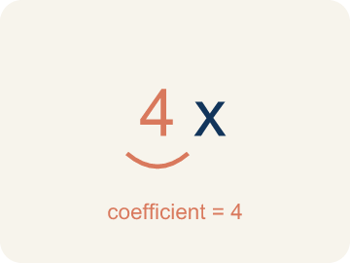 | Coefficient Coeficiente  The number in front of a letter, like the 3 in 3x.  Example: In 9x, the coefficient is 9 — it tells you 'nine groups of x'; if x = 2, then 9x = 18
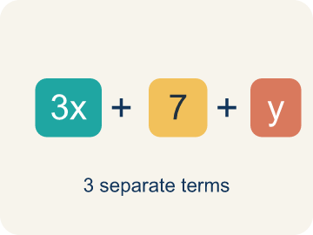 | Term Término  A single number, variable, or product of them, separated by + or − signs.  Example: In 3x + 5 − 2x, the terms are 3x, 5, and 2x.
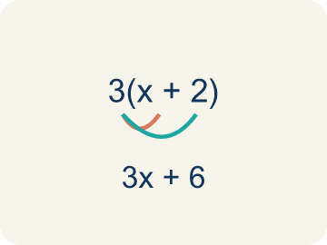 | Distributive property Propiedad distributiva  Multiplying a sum by a number means multiplying each part by that number.  Example: 3(x + 4) = 3·x + 3·4 = 3x + 12.

Guided Notes
Fill in each blank as we go. Use the Word Bank to help you.
WORD BANK
Like Terms • Combine • Simplify • Coefficient • Term • Distributive property

1. Terms with the same variable part, like 3y and 8y, are ___.
2. To add or subtract like terms into a single term is to ___ them.
3. To write an expression in its shortest equal form is to ___ it.
4. The number multiplied by a variable is the ___.
5. A number or variable separated by + or − signs is a ___.
6. Multiplying each part of a sum by a number uses the ___ property.

Worked Example

Watch & Read I Do — follow along with your teacher
Equipment Order
The music studio is placing supply orders for three rehearsal rooms. Room A needs 4 microphones and 3 stands. Room B needs 2 microphones and 5 stands. Room C needs 6 microphones and 1 stand. Instead of ordering separately, you can combine: (4 + 2 + 6) microphones and (3 + 5 + 1) stands = 12 microphones and 9 stands. That's simplifying by combining like items!

Think about:
• Why can you add the microphones together but not mix microphones with stands?
• What makes microphones and stands 'different types' of items?
• How is this like combining like terms in algebra?
• What if some rooms returned equipment — would you subtract?
• Can you always simplify an expression, or are some already as simple as possible?

Solved Example I Do — watch each step
Problem: Simplify 7x + 3x.
A) 10x
B) 10x²
C) 21x
D) 73x
Step 1: 7x + 3x = 10x.
Step 2: Add the coefficients: 7 + 3 = 10.
Answer: A. 10x

Guided Practice

Solve Together We Do — work with your class
Problem: Simplify 9n + 4 + 2n.
A) 11n + 4
B) 15n
C) 11n² + 4
D) 92n + 4
Step 1:

Step 2:

Answer:

A music festival needs supplies for 3 stages. Stage 1 needs 8m + 5 cables, Stage 2 needs 3m + 7 cables, and Stage 3 needs 4m + 2 cables, where m represents the number of microphones per stage. The total order is (8m + 5) + (3m + 7) + (4m + 2).
Simplify the total order expression. What does each part of the simplified expression tell you?

Sentence frame: The total order simplifies to ___m + ___. The ___ tells us ___ and the ___ tells us ___.

Turn & Talk discuss with a partner
1. [Launch] Three rooms need microphones and stands. Why can you add all the microphones together (4 + 2 + 6) but not mix microphones with stands?
Start with: I can add the microphones because they are the ___ type.
Puedo sumar los micrófonos porque son del ___ tipo.
Word bank: Like Terms, Combine, Simplify, Coefficient
2. [Explore] To simplify 6x + 4 + 2x + 7, which are the like terms, and how do you combine them?
Start with: The like terms are ___ and ___.
Los términos semejantes son ___ y ___.
Word bank: Like Terms, Combine, Simplify, Coefficient
3. [Connect] The festival order is (8m + 5) + (3m + 7) + (4m + 2), where m is microphones per stage. What does the simplified expression tell you?
Start with: The total simplifies to ___m + ___.
El total se simplifica a ___m + ___.
Word bank: Like Terms, Combine, Simplify, Coefficient
4. [Practice] During practice on Simplify Algebraic Expressions, what strategy did you use when a problem felt tricky?
Start with: The like terms are ___ and ___.
Los términos semejantes son ___ y ___.
Word bank: Like Terms, Combine, Simplify, Coefficient

Independent Practice

On Your Own You Do — show your work
Solve each problem. Show your thinking in the work box.
1. Which pair are like terms?
A) 6x and 2x
B) 6x and 6y
C) 6x and 6
D) 6x and 2x²

2. Simplify 5a + 3 + 2a.
A) 7a + 3
B) 10a
C) 7a² + 3
D) 52a + 3

3. The board shows 3x + 5x on one channel. Simplify it.
A) 8x
B) 15x
C) 8x²
D) 35x

4. Simplify the track: 4a + 2 + a.
A) 5a + 2
B) 7a
C) 5a²+ 2
D) 6a

Exit Ticket
Answer on your own. This shows what you learned today.
★ Simplify 6x + 3 + 2x + 5.
A) 8x + 8
B) 8x² + 8
C) 62x + 35
D) 16x

