Write Equations — Homework
Lesson 7-1-flagship • Standard 6.AT.8
Name: ______________________ Period: ______ Date: ____________

Today's Goals
Content: I can write an equation to represent a real-world situation.
Language: I can explain my equation using the words equation, variable, equal sign, and expression.

Key Words
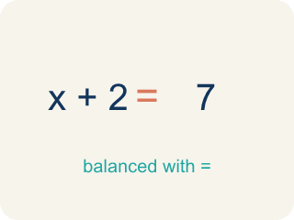
Equation (Ecuación) — A math sentence with an equal sign showing both sides are the same.
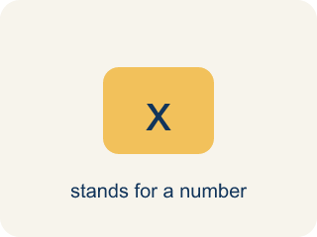
Variable (Variable) — A letter that stands for an unknown number.
Equal sign (Signo igual) — The = sign, showing both sides are the same.
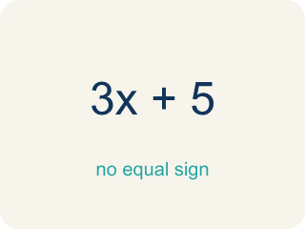
Expression (Expresión) — A math phrase with numbers and letters, but no equal sign.

Practice
Show your work. Use the blank space under each problem.
1. Which equation represents: 'A number plus 12 equals 30'?
A. n + 12 = 30
B. n − 12 = 30
C. 12n = 30
D. n / 12 = 30
______________________________________________________________________
2. Which equation represents: 'Seven less than a number is 18'?
A. n − 7 = 18
B. 7 − n = 18
C. n + 7 = 18
D. n / 7 = 18
______________________________________________________________________
3. For each situation, identify what the variable represents and write the equation.
Situation | Variable Represents | Equation
A box holds some files. After removing 5, there are 13 left. | Number of files in the box | n − 5 = 13
A detective split 48 photos equally into folders. Each folder has 6 photos. | Number of folders | 48 / n = 6
______________________________________________________________________
4. A detective found some fingerprints on Monday and 14 more on Tuesday, for a total of 30. Which equation represents this?
A. f + 14 = 30
B. f − 14 = 30
C. 14f = 30
D. f / 14 = 30
______________________________________________________________________
5. onLevel — Spot the Common Mistake
Step 1 (Read): A student is working on Write Equations.
Step 2 (Attempt): They ignored the rule: Find the unknown, choose a variable, then turn the words into symbols around an equal sign.
Step 3 (Check): The answer does not match the math rule from class.
Which step has the mistake? Explain and fix it:
______________________________________________________________________
______________________________________________________________________
______________________________________________________________________
6. Witness statement: 'The number of suspects, plus 7 more, is 22.' Which equation models this clue?
A. s + 7 = 22
B. s − 7 = 22
C. 7s = 22
D. s / 7 = 22
______________________________________________________________________
7. Ledger note: 'Six times the number of stolen coins equals 54.' Which equation models this clue?
A. 6c = 54
B. c + 6 = 54
C. c − 6 = 54
D. c / 6 = 54
______________________________________________________________________
8. Vault log: 'A number of gold bars shared equally into 5 cases puts 4 bars in each case.' Which equation models this clue?
A. b / 5 = 4
B. 5b = 4
C. b − 5 = 4
D. b + 5 = 4
______________________________________________________________________
9. Sort each case clue by the kind of equation it would become.
Groups: Addition equation (+) | Subtraction equation (−) | Multiplication equation (×)
• 11 more fingerprints than yesterday is 40 → __________________
• A sum of clues and 9 equals 25 → __________________
• 9 fewer alibis than before leaves 14 → __________________
• 8 less than the tip count is 12 → __________________
• Triple the number of footprints is 27 → __________________
• The product of suspects and 4 is 32 → __________________
______________________________________________________________________
10. Match each case clue to the equation that models it
Item | Answer choices
____ A detective had some leads. After 10 more arrived, she had 26. | D. n / 6 = 9
____ After crossing out 5 false leads, 18 leads remained. | C. 7n = 42
____ Seven identical evidence boxes hold 42 clues in all. | B. n − 5 = 18
____ A pile of photos split evenly into 6 folders gives 9 photos each. | A. n + 10 = 26
______________________________________________________________________

Answer Key (Teacher)
1. A. n + 12 = 30
'Plus' means addition, so the equation is n + 12 = 30.
Watch for: A common mistake in Write Equations is skipping the key idea: "Find the unknown, choose a variable, then turn the words into symbols around an equal sign." — always check your work against this rule before you submit.
2. A. n − 7 = 18
'Seven less than a number' means start with the number and subtract 7: n − 7 = 18.
Watch for: A common mistake in Write Equations is skipping the key idea: "Find the unknown, choose a variable, then turn the words into symbols around an equal sign." — always check your work against this rule before you submit.
3. For each situation, identify what the variable represents and write the equation.
(See completed table.)

4. A. f + 14 = 30
The detective's Monday fingerprints (f) plus 14 more equals 30: f + 14 = 30.
Watch for: A common mistake in Write Equations is skipping the key idea: "Find the unknown, choose a variable, then turn the words into symbols around an equal sign." — always check your work against this rule before you submit.
5. onLevel — Spot the Common Mistake
The mistake is in Step 2.
Correct work: Follow the key idea: Find the unknown, choose a variable, then turn the words into symbols around an equal sign.
6. A. s + 7 = 22
Let s be the number of suspects. 'Plus 7 more' means + 7 and 'is 22' means = 22, so s + 7 = 22.
Watch for: A common mistake in Write Equations is skipping the key idea: "Find the unknown, choose a variable, then turn the words into symbols around an equal sign." — always check your work against this rule before you submit.
7. A. 6c = 54
Let c be the number of stolen coins. 'Six times' means multiply by 6, so the equation is 6c = 54.
Watch for: A common mistake in Write Equations is skipping the key idea: "Find the unknown, choose a variable, then turn the words into symbols around an equal sign." — always check your work against this rule before you submit.
8. A. b / 5 = 4
Let b be the total gold bars. Sharing equally into 5 cases means b / 5, and each case has 4, so b / 5 = 4.
Watch for: A common mistake in Write Equations is skipping the key idea: "Find the unknown, choose a variable, then turn the words into symbols around an equal sign." — always check your work against this rule before you submit.
9. Correct groups:
11 more fingerprints than yesterday is 40 → Addition equation (+)
A sum of clues and 9 equals 25 → Addition equation (+)
9 fewer alibis than before leaves 14 → Subtraction equation (−)
8 less than the tip count is 12 → Subtraction equation (−)
Triple the number of footprints is 27 → Multiplication equation (×)
The product of suspects and 4 is 32 → Multiplication equation (×)

10. Matches:
A detective had some leads. After 10 more arrived, she had 26. → n + 10 = 26
After crossing out 5 false leads, 18 leads remained. → n − 5 = 18
Seven identical evidence boxes hold 42 clues in all. → 7n = 42
A pile of photos split evenly into 6 folders gives 9 photos each. → n / 6 = 9

