UNIT 7 · LESSON 2 STANDARD 6.EE.7

Solve One-Step Addition and Subtraction Equations
Student Notes Packet
Name: ______________________ Date: ____________ Period: ________

Today's Goals
Content: I can solve one-step addition and subtraction equations using inverse operations.
Language: I can explain my steps using the words equation, inverse operation, isolate, and solution.

Key Vocabulary
Look at the picture, read the word, then read what it means.
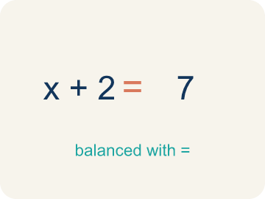 | Equation Ecuación  A math sentence with an equal sign showing both sides are the same.  Example: x + 5 = 12 — both sides equal 12 when x = 7
Inverse operation Operación inversa
Two math actions that undo each other, like × and ÷.
Example: Addition undoes subtraction: if x − 3 = 10, add 3 to get x = 13
Isolate Despejar
To get the letter by itself on one side.
Example: x + 5 = 12 → subtract 5 from both sides → x = 7 (x is isolated)
Solution Solución
The number that makes the equation true.
Example: x = 7 is the solution to x + 5 = 12 because 7 + 5 = 12 ✓
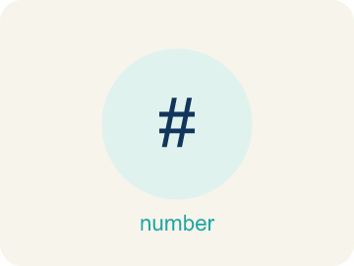 | One-step equation Ecuación de un paso  An equation you can solve in a single step using one inverse operation.  Example: x + 4 = 9 is solved in one step: subtract 4 from both sides, so x = 5.
Balance Equilibrio
Keeping both sides of an equation equal by doing the same thing to each side.
Example: If you subtract 4 from the left side, you must subtract 4 from the right to keep balance.

Guided Notes
Fill in each blank as we go. Use the Word Bank to help you.
WORD BANK
Equation • Inverse operation • Isolate • Solution • One-step equation • Balance

1. A math sentence with an equal sign showing two equal amounts is an ___.
2. An operation that undoes another, like subtraction undoing addition, is an ___.
3. To get the variable alone on one side of the equation is to ___ it.
4. The value of the variable that makes the equation true is the ___.
5. An equation solved in a single step is a ___.
6. Doing the same thing to both sides to keep them equal keeps the equation in ___.

Worked Example

Watch & Read I Do — follow along with your teacher
Case File: The Missing Number
Detective Chen found a coded message: 'The suspect's locker number plus 23 equals 58.' She needs to figure out the locker number to crack the case. The equation is n + 23 = 58. What is n?

Think about:
• What operation connects the locker number and 23?
• What does n represent in the equation?
• How could you undo the addition to find n?
• What if the message said 'the number minus 23 equals 58' instead?
• Can you check your answer by putting it back in the equation?

Solved Example I Do — watch each step
Problem: Solve: x + 9 = 15
A) x = 6
B) x = 24
C) x = 9
D) x = 15
Step 1: Subtract 9 from both sides: x = 15 − 9 = 6.
Step 2: Check: 6 + 9 = 15 ✓
Answer: A. x = 6

Guided Practice

Solve Together We Do — work with your class
Problem: Solve: y − 7 = 20
A) y = 27
B) y = 13
C) y = 7
D) y = 140
Step 1:

Step 2:

Answer:

A hiker has walked some distance and still has 4.5 miles left on a 12-mile trail. The equation d + 4.5 = 12 represents her situation, where d is the distance already walked.
How far has the hiker walked? How did you use inverse operations?

Sentence frame: The hiker walked ___ miles because d + 4.5 = 12 means d = 12 − ___ = ___.

Turn & Talk discuss with a partner
1. [Launch] Detective Chen's clue is n + 23 = 58, where n is a locker number. Why can't she just 'know' n by looking, and what could she do to both sides to find it?
Start with: The variable n is added to ___, so to find n I can ___.
La variable n está sumada a ___, así que para hallar n puedo ___.
Word bank: equation, inverse operation, isolate, solution
2. [Explore] What inverse operation did you use to solve n + 23 = 58, and why must you do it to BOTH sides of the balance?
Start with: I used ___ to undo ___, so the variable equals ___.
Usé ___ para deshacer ___, así que la variable es igual a ___.
Word bank: inverse operation, isolate, solution, equation
3. [Connect] Where might solving a one-step equation help you find a missing amount in real life?
Start with: A one-step equation would help me find ___ when I know ___.
Una ecuación de un paso me ayudaría a hallar ___ cuando sé ___.
Word bank: equation, inverse operation, isolate, solution
4. [Practice] During practice on Solve One-Step Addition and Subtraction Equations, what strategy did you use when a problem felt tricky?
Start with: I used ___ to undo ___, so the variable equals ___.
Usé ___ para deshacer ___, así que la variable es igual a ___.
Word bank: Equation, Inverse operation, Isolate, Solution

Independent Practice

On Your Own You Do — show your work
Solve each problem. Show your thinking in the work box.
1. Solve: n + 15 = 42
A) n = 27
B) n = 57
C) n = 15
D) n = 42

2. Solve: m − 11 = 25
A) m = 36
B) m = 14
C) m = 25
D) m = 275

3. A shirt costs $d. After a $15 discount, it costs $38. What is d?
A) $53
B) $23
C) $38
D) $45

4. Unlock Card 1: Solve x + 7 = 15.
A) x = 8
B) x = 22
C) x = 7
D) x = 105

Exit Ticket
Answer on your own. This shows what you learned today.
★ Solve: p + 2.8 = 9.1
A) p = 6.3
B) p = 11.9
C) p = 6.8
D) p = 3.25

