UNIT 7 · LESSON 3 STANDARD 6.EE.7

Solve Multiplication and Division Equations
Student Notes Packet
Name: ______________________ Date: ____________ Period: ________

Today's Goals
Content: I can solve one-step multiplication and division equations using inverse operations.
Language: I can explain my steps using the words inverse operation, multiply, divide, and isolate.

Key Vocabulary
Look at the picture, read the word, then read what it means.
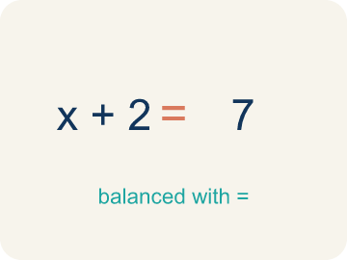 | Inverse operation Operación inversa  Two math actions that undo each other, like × and ÷.  Example: Multiplication and division are inverses: 3 × 7 = 21, so 21 ÷ 3 = 7
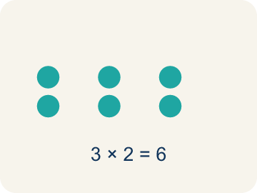 | Multiply Multiplicar  To add equal groups again and again.  Example: 3 × 7 = 21 means 3 groups of 7 equals 21
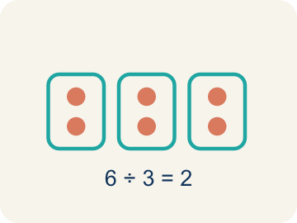 | Divide Dividir  To split into equal groups.  Example: 36 ÷ 4 = 9 means 36 split into 4 equal groups gives 9 per group
Isolate Despejar
To get the letter by itself on one side.
Example: 3x = 21 → divide both sides by 3 → x = 7 (x is alone)
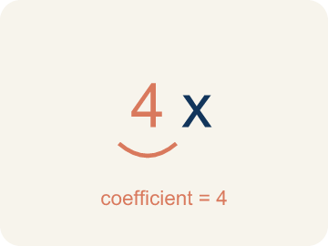 | Coefficient Coeficiente  The number multiplied by a variable.  Example: In 6x = 18, the coefficient is 6; divide both sides by 6 to get x = 3.
Solution Solución
The value of the variable that makes the equation true.
Example: x = 3 is the solution of 6x = 18 because 6 × 3 = 18.

Guided Notes
Fill in each blank as we go. Use the Word Bank to help you.
WORD BANK
Inverse operation • Multiply • Divide • Isolate • Coefficient • Solution

1. An operation that undoes another, like division undoing multiplication, is an ___.
2. To undo dividing by a number, I ___ both sides by that number.
3. To undo multiplying by a number, I ___ both sides by that number.
4. To get the variable alone on one side is to ___ it.
5. The number multiplied by a variable is the ___.
6. The value of the variable that makes an equation true is the ___.

Worked Example

Watch & Read I Do — follow along with your teacher
Case File: The Multiplied Evidence
Detective Park discovered that 3 identical locked boxes contain a total of 21 pieces of evidence. She writes the equation 3x = 21 to find how many pieces are in each box. How can she solve for x?

Think about:
• What does the 3 represent in the equation?
• What does x represent?
• What operation connects 3 and x?
• What if there were 5 boxes instead of 3?
• How is solving 3x = 21 different from solving x + 3 = 21?

Solved Example I Do — watch each step
Problem: Solve: 6x = 42
A) x = 7
B) x = 48
C) x = 36
D) x = 252
Step 1: Divide both sides by 6: x = 42 ÷ 6 = 7.
Step 2: Check: 6 × 7 = 42 ✓
Answer: A. x = 7

Guided Practice

Solve Together We Do — work with your class
Problem: Solve: n / 3 = 8
A) n = 24
B) n = 11
C) n = 5
D) n = 3
Step 1:

Step 2:

Answer:

A detective ordered fingerprint kits for her team. Each kit costs $7, and the total bill was $63. The equation 7k = 63 represents this situation, where k is the number of kits.
How many kits did the detective order? How did inverse operations help you solve this?

Sentence frame: The detective ordered ___ kits because 7k = 63 means k = 63 ÷ ___ = ___.

Turn & Talk discuss with a partner
1. [Launch] Detective Park has 3 identical boxes holding 21 pieces of evidence total, written as 3x = 21. What does each part of the equation mean, and how is solving this different from solving x + 3 = 21?
Start with: The 3 means ___ and x means ___.
El 3 significa ___ y x significa ___.
Word bank: inverse operation, multiply, divide, isolate
2. [Explore] How did you undo the multiplication in 3x = 21 (or the division in x / 4 = 9) to isolate the variable?
Start with: I divided / multiplied both sides by ___, so the answer is ___.
Dividí / multipliqué ambos lados por ___, así que la respuesta es ___.
Word bank: inverse operation, multiply, divide, isolate
3. [Connect] When would you solve a multiplication or division equation in real life?
Start with: I would use this kind of equation to find ___.
Usaría este tipo de ecuación para hallar ___.
Word bank: inverse operation, multiply, divide, isolate
4. [Practice] During practice on Solve Multiplication and Division Equations, what strategy did you use when a problem felt tricky?
Start with: I divided / multiplied both sides by ___, so the answer is ___.
Dividí / multipliqué ambos lados por ___, así que la respuesta es ___.
Word bank: Inverse operation, Multiply, Divide, Isolate

Independent Practice

On Your Own You Do — show your work
Solve each problem. Show your thinking in the work box.
1. Solve: 9m = 63
A) m = 7
B) m = 54
C) m = 72
D) m = 567

2. Solve: y / 7 = 5
A) y = 35
B) y = 12
C) y = 2
D) y = 7

3. A detective splits 54 clues equally among 9 case files. The equation 9c = 54 represents this. What is c?
A) c = 6
B) c = 63
C) c = 45
D) c = 9

4. Vault A is sealed with 4x = 32. Crack the lock: what is x?
A) x = 8
B) x = 128
C) x = 28
D) x = 36

Exit Ticket
Answer on your own. This shows what you learned today.
★ Solve: w / 8 = 6
A) w = 48
B) w = 14
C) w = 0.75
D) w = 2

