Solve Multiplication and Division Equations — Homework
Lesson 7-3 • Standard 6.AT.8
Name: ______________________ Period: ______ Date: ____________

Today's Goals
Content: I can solve one-step multiplication and division equations using inverse operations.
Language: I can explain my steps using the words inverse operation, multiply, divide, and isolate.

Key Words
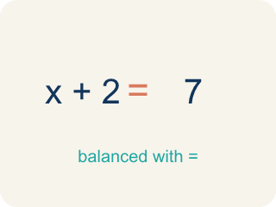
Inverse operation (Operación inversa) — Two math actions that undo each other, like × and ÷.
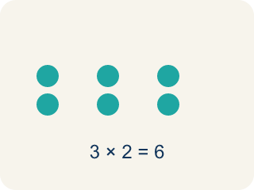
Multiply (Multiplicar) — To add equal groups again and again.
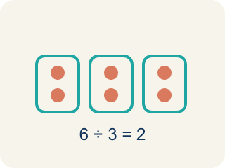
Divide (Dividir) — To split into equal groups.
Isolate (Despejar) — To get the letter by itself on one side.
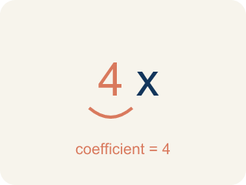
Coefficient (Coeficiente) — The number multiplied by a variable.
Solution (Solución) — The value of the variable that makes the equation true.

Practice
Show your work. Use the blank space under each problem.
1. Solve: 6x = 42
A. x = 7
B. x = 48
C. x = 36
D. x = 252
______________________________________________________________________
2. Solve: n / 3 = 8
A. n = 24
B. n = 11
C. n = 5
D. n = 3
______________________________________________________________________
3. Solve each equation, show your work, and check.
Equation | Work | Solution | Check
8m = 56 | 56 ÷ 8 | m = 7 | 8 × 7 = 56 ✓
y / 6 = 11 | 11 × 6 | y = 66 | 66 / 6 = 11 ✓
12k = 96 | 96 ÷ 12 | k = 8 | 12 × 8 = 96 ✓
______________________________________________________________________
4. A detective splits 54 clues equally among 9 case files. The equation 9c = 54 represents this. What is c?
A. c = 6
B. c = 63
C. c = 45
D. c = 9
______________________________________________________________________
5. onLevel — Spot the Common Mistake
Step 1 (Read): A student is working on Solve Multiplication and Division Equations.
Step 2 (Attempt): They ignored the rule: Divide to undo multiplying, and multiply to undo dividing — always on both sides.
Step 3 (Check): The answer does not match the math rule from class.
Which step has the mistake? Explain and fix it:
______________________________________________________________________
______________________________________________________________________
______________________________________________________________________
6. Vault A is sealed with 4x = 32. Crack the lock: what is x?
A. x = 8
B. x = 128
C. x = 28
D. x = 36
______________________________________________________________________
7. Vault B is sealed with x / 3 = 6. Crack the lock: what is x?
A. x = 18
B. x = 2
C. x = 9
D. x = 3
______________________________________________________________________
8. Vault C is sealed with 5n = 45. Crack the lock: what is n?
A. n = 9
B. n = 225
C. n = 40
D. n = 50
______________________________________________________________________
9. Level 2 Extension - Match each locked vault to the solution that opens it.
Item | Answer choices
____ 7x = 56 | D. p = 18
____ x / 5 = 4 | C. m = 3
____ 11m = 33 | B. x = 20
____ p / 2 = 9 | A. x = 8
______________________________________________________________________
10. Detective, decide which key opens each vault: do you MULTIPLY or DIVIDE to unlock the variable?
Groups: Divide both sides | Multiply both sides
• 6x = 48 → __________________
• 9k = 27 → __________________
• x / 8 = 2 → __________________
• n / 4 = 5 → __________________
______________________________________________________________________

Answer Key (Teacher)
1. A. x = 7
Divide both sides by 6: x = 42 ÷ 6 = 7. Check: 6 × 7 = 42 ✓
Watch for: A common mistake in Solve Multiplication and Division Equations is skipping the key idea: "Divide to undo multiplying, and multiply to undo dividing — always on both sides." — always check your work against this rule before you submit.
2. A. n = 24
Multiply both sides by 3: n = 8 × 3 = 24. Check: 24 / 3 = 8 ✓
Watch for: A common mistake in Solve Multiplication and Division Equations is skipping the key idea: "Divide to undo multiplying, and multiply to undo dividing — always on both sides." — always check your work against this rule before you submit.
3. Solve each equation, show your work, and check.
(See completed table.)

4. A. c = 6
Divide both sides by 9: c = 54 ÷ 9 = 6 clues per file.
Watch for: A common mistake in Solve Multiplication and Division Equations is skipping the key idea: "Divide to undo multiplying, and multiply to undo dividing — always on both sides." — always check your work against this rule before you submit.
5. onLevel — Spot the Common Mistake
The mistake is in Step 2.
Correct work: Follow the key idea: Divide to undo multiplying, and multiply to undo dividing — always on both sides.
6. A. x = 8
The 4 is multiplying x, so divide both sides by 4: x = 32 / 4 = 8. Check: 4 x 8 = 32.
Watch for: A common mistake in Solve Multiplication and Division Equations is skipping the key idea: "Divide to undo multiplying, and multiply to undo dividing — always on both sides." — always check your work against this rule before you submit.
7. A. x = 18
x is divided by 3, so multiply both sides by 3: x = 6 x 3 = 18. Check: 18 / 3 = 6.
Watch for: A common mistake in Solve Multiplication and Division Equations is skipping the key idea: "Divide to undo multiplying, and multiply to undo dividing — always on both sides." — always check your work against this rule before you submit.
8. A. n = 9
The 5 is multiplying n, so divide both sides by 5: n = 45 / 5 = 9. Check: 5 x 9 = 45.
Watch for: A common mistake in Solve Multiplication and Division Equations is skipping the key idea: "Divide to undo multiplying, and multiply to undo dividing — always on both sides." — always check your work against this rule before you submit.
9. Matches:
7x = 56 → x = 8
x / 5 = 4 → x = 20
11m = 33 → m = 3
p / 2 = 9 → p = 18

10. Correct groups:
6x = 48 → Divide both sides
9k = 27 → Divide both sides
x / 8 = 2 → Multiply both sides
n / 4 = 5 → Multiply both sides

